**FABRICATION OF MOTOR-LESS BEACH-SAND CLEANING MACHINE FOR BEACH RESORT OWNERS**

Tze Ching ONG1*, Chung Mee TIONG2, Dillon Kim Kiat VOON3, Vyner Delton Anak PETER4, Hairil Azwan Bin HAFIZUDDIN5, Mohammad Zulirfan Bin NORUL6, Ai Tie YAP7

tze@poliku.edu.my, Politeknik Kuching Sarawak, Malaysia, https://orcid.org/0000-0002-7126-33211

tchung_mee@yahoo.com, SJK Chung Hua Sungai Tapang Batu Kawa, Malaysia2

dillonvoon4@gmail.com, Politeknik Kuching Sarawak, Malaysia3

vynerbeatbox20@gmail.com, Politeknik Kuching Sarawak, Malaysia4

hairilazwan@gmail.com, Politeknik Kuching Sarawak, Malaysia5

mohdzulirfan@yahoo.com, Politeknik Kuching Sarawak, Malaysia6

atyap@poliku.edu.my, Politeknik Kuching Sarawak, Malaysia7

Modern technologies related to beach cleaning activities remain a niche and unpopular industry even in the 21st Century. Until now, beach cleaning activity is an exhausting and time-consuming process. Most of the time, the rubbish collector will need to bend down or stretch their body to pick up rubbish which may cause injury. Furthermore, they may have to carry the rubbish bag or bin as they move from one location to another. This project aims to fabricate a motor-less beach sand cleaning machine that reduces the time taken needed to collect rubbish by 50% and eliminates the need for the rubbish collector to bend their body in an unnatural way to pick up rubbish. This project also eliminates the need for the rubbish collector to carry the rubbish bin or bag as the machine has a built-in rubbish collection compartment. The motorless beach-sand cleaning machine works by a self-fabricated rake with protruding prongs that is lifted by a lever located above the pushing handle. When the lever is pushed forward, the rake is lifted into the mesh where the solid litter will be stored. The mechanism to actuate the lifting of the rake is connected by a pair of pulley systems on both sides of the machine. For the post-testing, it is found that this machine reduced the rubbish collecting time by half as compared to conventional manual rubbish picking using hands. It is also noted that the rubbish collection compartment of the machine has a bigger capacity than the standard rubbish bin and offers various advantages too. In the end, the objectives of fabricating a motor-less beach-sand cleaning machine are achieved and can be utilized by the beach resort owners to clean beaches towards a more sustainable environment for marine life.

Keywords: motor-less, sand-cleaning machine, beach resort, clean beach

**INTRODUCTION**

Beaches are recreational areas and attract many local and international visitors. Recreational activities such as swimming, walking, sunbathing, and surfing are some of the most common activities carried out by visitors. Furthermore, coastal tourism activities contribute to a large facet of our economy (Loomis & Santiago, 2013). As tourism is one of the main revenues in Malaysia, with over 57.1 million domestic tourists alone generated RM 37.4 billion in tourist receipts in 2014 (Tourism Malaysia, 2021). Therefore, a polluted beach or coastline may significantly impact Malaysia's tourism industry negatively. The polluted beach has always been an international dilemma since the age of industrialization (Bergmann et al., 2015, Wyles et al., 2016 & Shim & Thomposon, 2015). Lately, there is an increasing trend and abundance of beach littering that bring a negative impact on marine and land life.

The Sustainable Development Goals (SDG) is a collection of 17 global goals designed by the United Nations Educational, Scientific and Cultural Organization (UNESCO) to be a blueprint to achieve a better and more sustainable future for humankind. Among the two of the 17 goals are life below water and life on land (United Nations, 2015). According to a UNESCO report (United Nation, 2015), approximately three billion people depend on marine and coastal biodiversity for their income and are estimated to generate up to 5 percent of global GDP. On the other hand, our earth's ecosystem for humanity such as oxygen, drinking water, weather, food, rainwater, and others are provided and regulated by the ocean itself. Due to its significant impacts on mother earth, careful management and preservation are imperative to ensure a sustainable future. Hence, it is the responsibility of everyone to keep the earth whether on land or underwater clear of any pollution.

Beach cleaning is among the activity to support and achieve the SDG. Most beach cleaning activities still use the conventional ways that have been used since the existence of civilizations. The most typical method is picking up rubbish using hands and discarding the rubbish into rubbish bins or throwing the rubbish into large bags temporarily and to be disposed of into the proper rubbish bins once the temporary rubbish bag is full. Therefore, the drawback of such a method is it requires a lot of manpower and time as can be seen in Figure 1 where volunteers carried out beach cleaning activities (Zielinski et al., 2019).

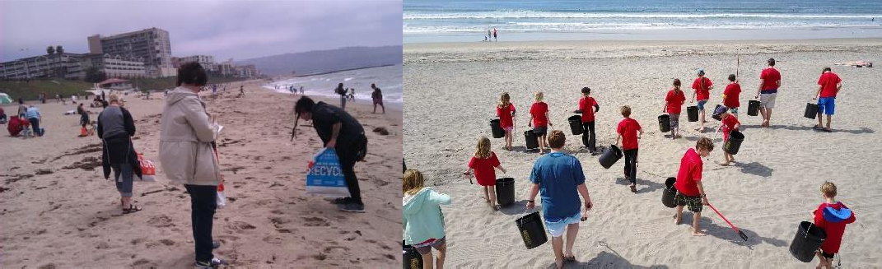**Figure 1: Beach cleaning manually**

A better alternative to the hand collection method is using tools that can be found in the market such as rakes or customized hand tools similar to rakes (Figure 2) to escalate the sand cleaning process. These tools separate debris or rubbish from sand by having the user pull the tools across the sand surface. Despite it being relatively cheap products, the beach cleaning process still can be daunting and inefficient as only a short distance of single rake or hand tool pulling can be done. One must stop very frequently to dispose of the collected rubbish when using such tools as the user keeps moving from one place to another until the whole process is completed.

**Figure 2: Hand tool (Montez, 1988)**

The evolution of the beach cleaning process has been modernized with some semi-automated or fully automated machines available in the market. Among the popular ones is the motorized beach cleaning machine (Figure3). The machine uses a front spinning cylinder that has flaps to "sweep" the sand that is mixed with solid litter. The sand mixture is swept into a vibrating screen to sift solid debris from the sand. There is a 20-liter collector located at the end of the vibrating screen where only solid litter is kept, and sand has been sifted out in the vibrating screen. The machine can be operated from the back of the machine which is equipped with the throttle, brake, and steering capability. The machine is powered by a 5.5-horsepower air-cooled 4-stroke gasoline engine. With a travel speed between 1.8 to 5.5 km/h, the machine can clean an area between 1400 to 3200 square meters per hour (Barber, 2022).

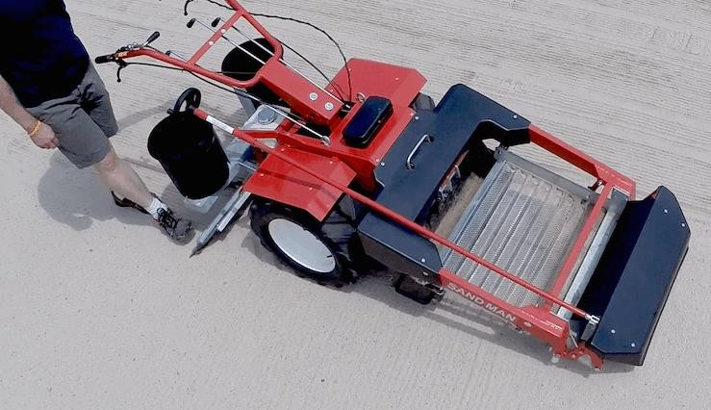

**Figure 3: Motorized beach cleaning machine**

Meanwhile, mega machines for large-scale beach cleaning are also available and ready in the market such as hydraulic-operated beach cleaning machines in figure 4. The systems work by conveyor belt system that is mounted with individual stainless steel tine whose role is to rake towards the moldboard deflector plate, removing surface and submerged debris. The conveyor is spun by the hydraulic drive and solid litter that is picked up is then carried upwards on the inclined conveyor belt section which leads to the drop into the hopper which serves as the rubbish collector (Barber & Barber, 2009). The drawback to this method is it would require a 4-wheel drive agricultural-type tractor with 76cm wheels and a minimum of 60 PTO horsepower to tow the beach cleaning machines as shown in figure 4. Besides that, all modern machines require burning fuel to turn chemical energy into mechanical energy for the operation and processes. The effects of burning fuels, especially carbon dioxide, are having bad effects on the climate and ecosystems themselves.

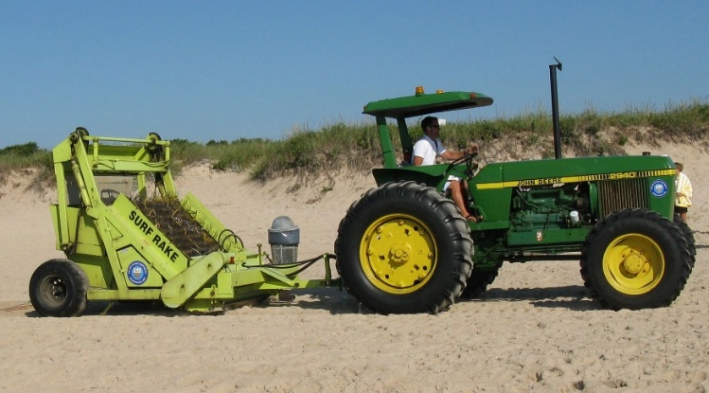

**Figure 4: Hydraulic-operated beach cleaning machine**

Despite several machines available on the market that can clean the beach in more effective ways, most of the people in Kuching, Sarawak is still using the conventional method to collect solid litter. Though using the conventional method can be tiring and take very long, it is the only method that requires little to no budget to carry out such activity. Since the establishment of the business, workers of Dynawood Beach Stay at Trombol beach, Kuching still cleans the beach manually. Their activities involved manually picking up the rubbish piece by piece using either their hands. The types and sizes of rubbish commonly found on the beach range from the small plastic bottle cap to regular-sized rubbish like plastic bags and water bottles. Some of these rubbishes are buried under a thin layer of sand which may usually be overlooked by the worker causing some buried rubbish to stay on the beach after the cleaning process. Moreover, with a large area of beach that needs to be covered and rubbish located on feet height, the worker often complains of frequent lower back pains and sore muscles due to excessive bending down movement. Therefore, this project intends to solve the aforementioned problems for the beach cleaning process. The objectives of this applied research aim to fabricate a motorless beach-sand beach cleaning machine for resort owners. A pre-testing of conventional methods used to collect rubbish will be conducted and post-testing to evaluate the performance in comparison to the duration taken will also be executed upon the completion of the machine.

* 1. **Methodology**

The development of the beach cleaning machine is based on the flow chart in Figure 5.**Figure 5. Flow chart of Beach Cleaning Machine**

Start

End

Design

Fabrication of main body, rake and lever handle

Assembly process

Finishing

Testing

Yes

No

The first process is the design process using Autodesk Inventor. Figure 6 shows the final design of the machine. Various sketches have been developed during the design process referring to several designs available during the literature review conducted and selection of the final design is selected based on the morphology chart taking into consideration elements such as mobility, effectiveness, cost, and technical aspect.

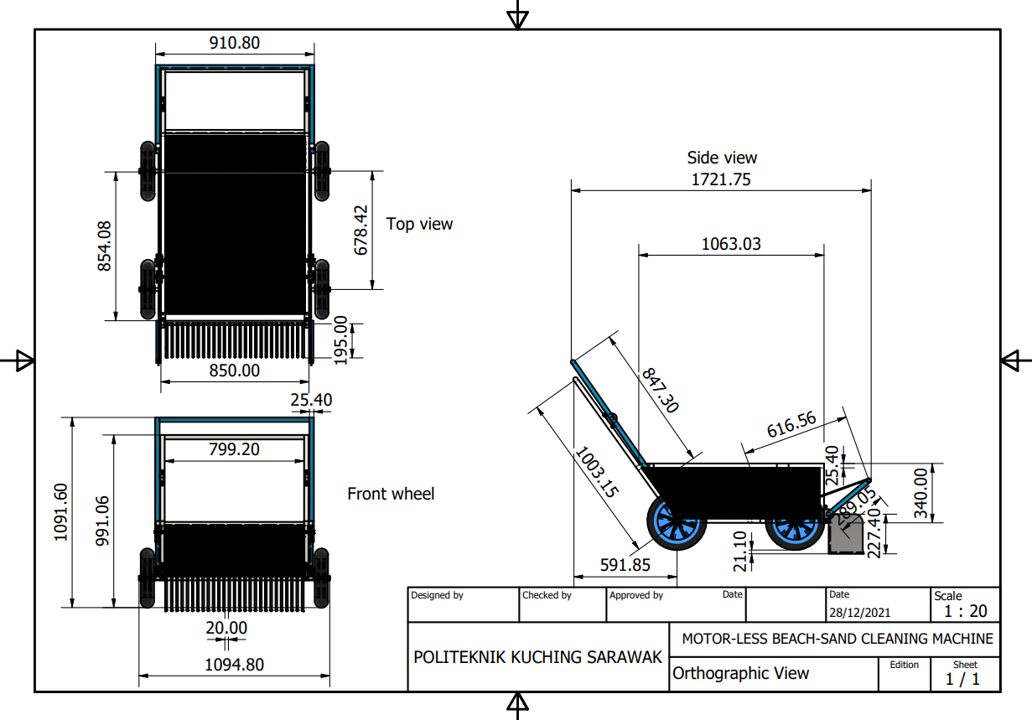

**Figure 6: Orthographic view of Beach Cleaning Machine using Autodesk Inventor**

Next, the fabrication process started with the cutting process of 1 x 1-inch square mild steel tubes using a miter saw, and all edges are deburred using a power grinder and angle grinder. Then, these tubes are attached as the main body using arc welding. The weldment of the main body is imperative as it will sustain the rubbish load and facilitate the smooth movement of the machine. The completed main body is shown in figure 7.

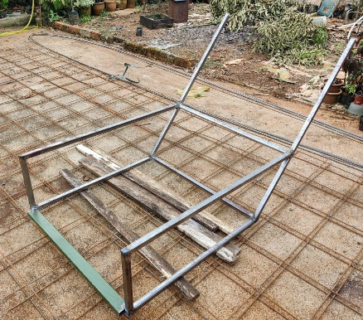

**Figure 7: Main body of the machine**

Subsequently, a threaded round bar with a diameter of 16mm is cut into four parts with a length of 6.5inch and welded to the edges of the main body. The four parts are the shaft to attach the wheel with the washers and nuts. Later, the wheels are fitted to the shaft on the main body as shown in figure 8.

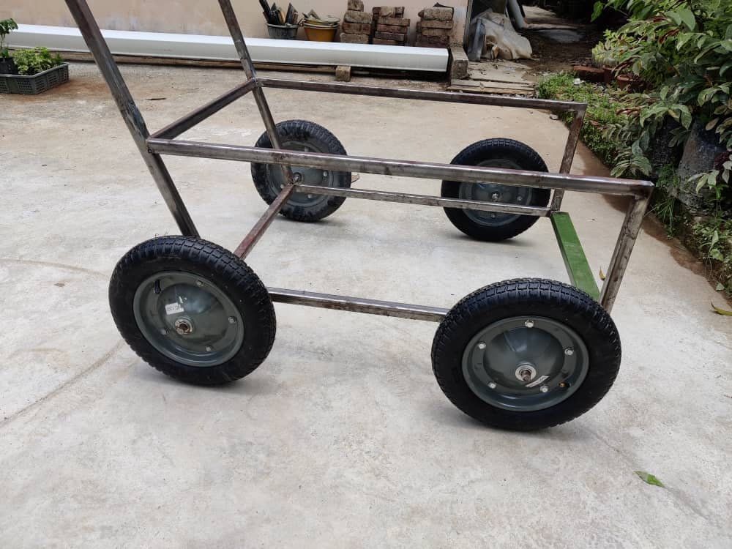

**Figure 8: Wheels attached to main body**

Then, the fabrication of the rake part began and rods of 5mm diameter with a length of 40mm each are utilized to act as the "teeth" and a 1x1-inch square tube as the holder. The process involved MIG welding of the 5mm diameter mild steel rod to the square tube holder one at a time with a gap of 15mm between each rod (Figure 9).

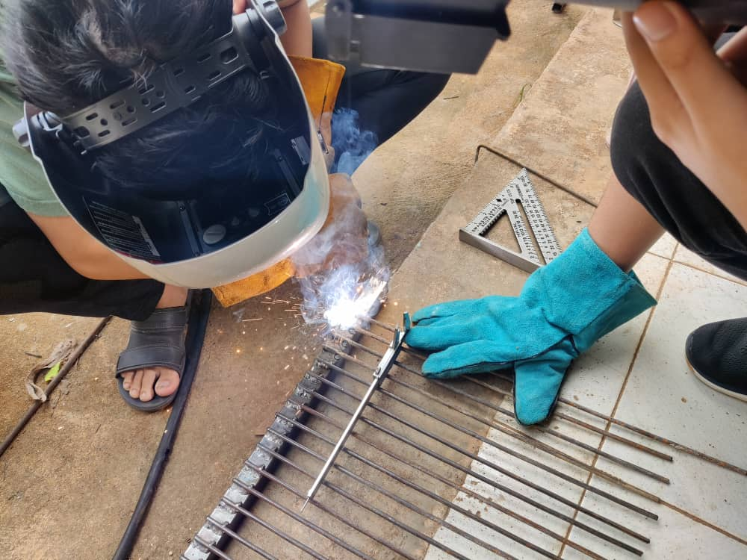

**Figure 9: Weldment process of rake**

Once the steel rods are attached to the holder, the crucial step is to bend the steel rod to 90 degrees. This is achieved by heating the rods using an oxy-acetylene torch and slowly bending them using a brick edge as the guide. Later braces are added to the rake so that it can be properly aligned and act as the reinforcement.

Then, the shafts are attached on either end of the rake to prepare it for pillow block bearings insertion (Figure 10). Later, two steel plates are welded to both sides of the rake for a better rubbish collection process.

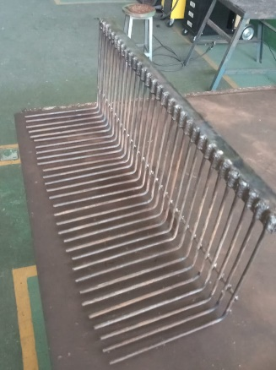

**Figure 10: Rake**

The final fabrication work of the parts involved a level handle (Figure 11) which this part acts to lift the rake for the rubbish collection process. The previous items of hollow mild steel tubes are used, cut, and assembled in accordance with the main body specification.

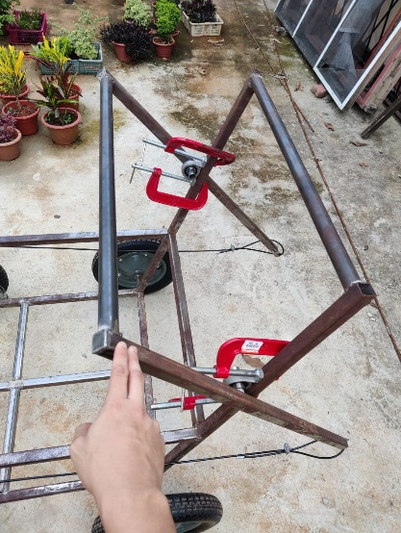

**Figure 11: Level handle**

Eventually, the rake and level handle parts are attached using the cables to work as the control mechanism for rubbish collection. A pair of pulley systems are welded to both sides of the machine to actuate the lifting mechanism of the rake. Additionally. the torsion springs are welded behind the rake to return the rake to the initial position after each cycle of the lifting process. The finishing process involved removing the rust using sand papers and applying an undercoat before spraying the machine. Finally, the 6mm PVC mesh is cut accordingly and fitted around the main body excluded the front side to act as the rubbish storage tank.

As for the pre-testing process, a person is assigned to collect rubbish manually using hand in an area of 8x2meter with rubbish randomly scattered within the test area. A digital stopwatch is used to record the duration of the rubbish-collecting process and the procedure is repeated three times before the average time is taken as the final result. Subsequently, for the post-testing, a similar site is chosen and the machine is operated by a single user only. The time needed to pick up the rubbish using the machine is recorded and considered as the final data for the post-testing. A simple post-testing survey is also conducted using questionnaire distribution to six samples which consist of beach resort owners and Non-Governmental Organizations (NGOs) in Kuching, Sarawak.

* 1. **Results and discussion**

The completed beach cleaning machine is shown in figure 12. The machine is motor-less and therefore the machine is environmentally friendly as compared to modern and large-scale machines which are available in the market. On the other hand, the design is relatively simple for the replication by the community and industry to achieve clean beaches and life on land to support the SDG activities.

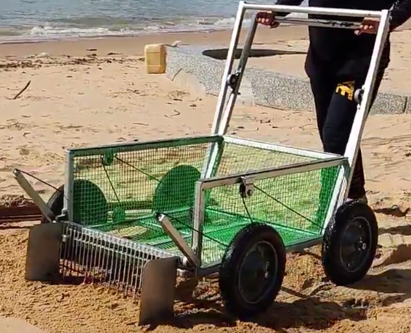

**Figure 12. Completed beach cleaning machine**

The operation of the beach cleaning machine is easy and simple. First, a single user is adequate to operate the machine and the user needs to push the machine forward toward the direction of the rubbish on the beach. Once the quantity of rubbish accumulated at the rake is sufficient, the user is required to push the lever handle to lift the rubbish to the storage compartment as shown in figure 13. The volume of rubbish that can be collected at the storage compartment is approximately 0.50m3 or 500 liters. The PVC mesh selection as the storage compartment wall then allows the sand to drop back to the beach and therefore able to filter the sand.

|  |  |
| --- | --- |
| A picture containing ground, outdoor, beach, sandy  Description automatically generated  (a) | A picture containing ground, outdoor, beach, sandy  Description automatically generated  (b) |

**Figure 13: Operation of the machine ;(a) User pushes the machine (b) User pushes the lever to lift the rubbish to the storage compartment**

Subsequently, the pre-testing and post-testing data are obtained and the comparison is recorded in table 1. Figure 14 shows the photo taken during pre and post-testing respectively. It is obvious from table 1 that the current machine can trim the duration of the rubbish collection process by almost half as the machine only recorded a mean time of one minute. Therefore, this machine is clearly the best method to clean up the beach and the impact can be significant when it involves a large beach area and the duration taken will be substantially reduced when using the machine as compared to traditionally manually picking by hand. During the post-testing also, it is found that the motor-less beach-sand cleaning machine performs smoothly on dry and flat sand surfaces. Meanwhile, the user felt a higher resistance in pushing the machine on moist and uneven sand surfaces and the condition led to difficulty in picking long and stiff rubbish such as long tree branches.

**Table 1: Duration for pre and post testing**

|  |  |
| --- | --- |
| **Method** | **Time taken** |
| Manually by hands | 2 minutes 17 seconds |
| Machine | 1 minutes 0 seconds |

|  |  |
| --- | --- |
| A person digging in the sand  Description automatically generated with low confidence  (a) | A picture containing ground, outdoor, cart, old  Description automatically generated  (b) |

**Figure 14: Pre and post testing ;(a) Pre-testing using manually by hand (b) Post-testing using machine**

As for the quantitative post-testing survey, it is found that samples which consist of beach resort owners and NGOs agreed the machine is a better method and offers a competitive alternative when compared to the machines that are available in the market. The main advantages of the current machine are it does not require any fuel or electric power to operate, has minimal maintenance, easy control system and has a small dimension that enables easy storage, and can be fitted nicely into a pick-up vehicle for transportation. Lastly, the cost of this machine is approximately RM 543.00 (Table 2) which is a relatively cheaper option when compared to the machines sold in the market and offers good durability and a single-user operating system. Hence this machine is very affordable and recommended for small and medium beach resort owners.

**Table 2: Cost of the machine**

|  |  |  |  |  |
| --- | --- | --- | --- | --- |
| **No.** | **Material** | **Quantity** | **Price Per Unit (RM)** | **Total Cost**  **(RM)** |
| 1 | 1 × 1-inch square mild steel | 2 | 40 | 80 |
| 2 | 5mm diameter mild steel round bar | 1 | 25 | 25 |
| 3 | 10mm diameter mild steel round bar | 1 | 30 | 30 |
| 4 | 16mm diameter threaded round bar | 1 | 40 | 40 |
| 5 | 6mm PVC mesh | 1 | 28 | 28 |
| 6 | Spray paint | 3 | 11 | 33 |
| 7 | Mild steel plate | 1 | 25 | 25 |
| 8 | Flat mount pulley block | 4 | 15 | 60 |
| 9 | Pillow block bearings | 4 | 12 | 48 |
| 10 | Rubber insulated steel cable | 2 | 37 | 74 |
| 11 | Wheelbarrow wheel | 4 | 25 | 100 |
|  |  |  |  | 543 |

**CONCLUSION**

The objective of this project is successfully achieved as the beach cleaning machine is produced. Then, post-testing also is conducted to ensure its operation. The control system using the level handle to lift the rubbish collected to the storage compartment functions well and the machine is able to move smoothly in a dry and flat beach. The post-testing results also produced positive outcomes when the duration of the rubbish collection is shorter by almost 50% when compared to the traditional way. A qualitative survey also obtained positive feedback from the beach resort owners and NGO. Lastly, the cost of this machine is RM543.00 and this makes it very affordable in the market when compared to modern motorized machines. In the end, the aforementioned features and benefits of this machine can be utilized in activities to achieve a better ocean and land life for the sustainability of the earth in long-term prospects. As for the suggestion or recommendations to improve the current design, the post-testing observation shows the specific sand type of wheel can enable the machine to maneuver better without getting stuck when it is under the full capacity of rubbish. In addition, a fabrication of a trap door mechanism can help user to discharge the rubbish from the machine effectively. Lastly, the replacement of the torsion spring with a more reliable and effective mechanism can aid the rake to return to its collecting position after it is lifted.

**REFERENCES**

Barber, J. H. & Barber, J. P. (2009). *Tine Raking Device.* (United Sates Patent No. US 7506692B2).United States Patent. <https://patents.google.com/patent/US7506692B2/en>

Barber & Sons Inc., H. (2022). *Sand Man 850 Specifications*. Retrieved from <http://www.hbarber.com/Cleaners/SandMan/Specifications.html>

Bergmann, M., Gutow, L., & Klages, M. (2015). Marine Anthropogenic Litter. Spring Open.

DOI 10.1007/978-3-319-16510-3

Loomis, J., & Santiago, L. (2013). Economic Valuation of Beach Quality Improvements: Comparing Incremental Attribute Values Estimated from Two Stated Preference Valuation Methods, *Coastal Management,* *41*(1), 75–86. DOI: 10.1080/08920753.2012.749754

Montez, O. (1988). *Hand tool for sifting debris from sand and soil.* (United States Patent No. US4828690A). United States Patent. [https://patents.google.com/patent/US4828690?oq=sand+rake](https://patents.google.com/patent/US4828690?oq=sand%2Brake)

Shim, W. J., & Thomposon, R. C. (2015). Microplastics in the Ocean. *Archives of Environmental Contamination and Toxicology*, *69*(3), 265–268. https://doi.org/10.1007/S00244-015-0216-X

Tourism Malaysia. (2021). Malaysia Tourism Statistics in Brief. Retrieved from https://www.tourism.gov.my/statistics

United Nations. (2015). *Transforming our world: the 2030 Agenda for Sustainable Development Transforming our world.* Retrieved from https://sdgs.un.org/2030agenda

Wyles, K. J., Pahl, S., Thomas, K., & Thompson, R. C. (2016). Factors That Can Undermine the Psychological Benefits of Coastal Environments: Exploring the Effect of Tidal State, Presence, and Type of Litter. *Environment and Behavior*, *48*(9), 1095–1126. <https://doi.org/10.1177/0013916515592177>

Zielinski, S., Botero, C. M., & Yanes, A. (2019). To clean or not to clean? A critical review of beach cleaning methods and impacts. *Marine Pollution Bulletin*, *139*, 390–401. https://doi.org/10.1016/J.MARPOLBUL.2018.12.027