**An Evaluation of Dynamic Compaction: Limits and Effects on**

**Geotechnical Performance**

***Mehmet Salih YILDIZ1,***[[1]](#footnote-1)\****[C:\Users\Abdullah\AppData\Local\Microsoft\Windows\INetCache\Content.Word\ORCID-iD_icon-16x16.gif](https://orcid.org/0000-0002-0754-1577), İnan KESKİN[C:\Users\Abdullah\AppData\Local\Microsoft\Windows\INetCache\Content.Word\ORCID-iD_icon-16x16.gif](https://orcid.org/0000-0003-2977-4352)***

*1 Vocational School of Social Sciences, Cankiri Karatekin University, Cankiri, Türkiye*

*2Faculty of Engineering, Civil Engineering Department,* *Karabük Üniversitesi, Karabük, Türkiye*

|  |
| --- |
| **Abstract**  Dynamic Compaction (DC) is a soil improvement method used to increase the bearing capacity and stability of soils. This method is based on the principle of repeatedly dropping a weight into the ground from a certain height and compacting the soil particles after the drops. This method offers higher efficiency in cohesionless soils such as sand and gravel, but is not effective for water-saturated and cohesive soils. DC has a wide range of applications from motorways and airports to coastal and harbour areas. In addition to its advantages, DC also has some disadvantages. The main disadvantages are noise and the danger posed by the vibration effect for the surrounding structures. However, these disadvantages can be overcome with proper planning, environmental precautions and working with expert teams. DC plays an important role in ground improvement projects by providing a fast and economical solution. |
| Keywords: Dynamic compaction, Soil improvement, Geotechnical performance |

1. **Introduction**

The limited land resources are one of the main obstacles to the development of cities. Opening up more land for construction is inevitable for socio-economic development (Wei et al. 2023). Opening up land for construction is not only a matter of zoning planning, but also the structure to be built on it must be strong enough to meet the design criteria. Ground improvement methods are used to make limited zoning lands suitable for design criteria. Dynamic Compaction (DC) application is one of the ground improvement methods in civil engineering. This method; It provides the removal of air in the ground by repeatedly releasing a certain weight from a certain height, especially on weak and heterogeneous soils, and compaction of soil grains by positioning them closer to each other with this impact energy.

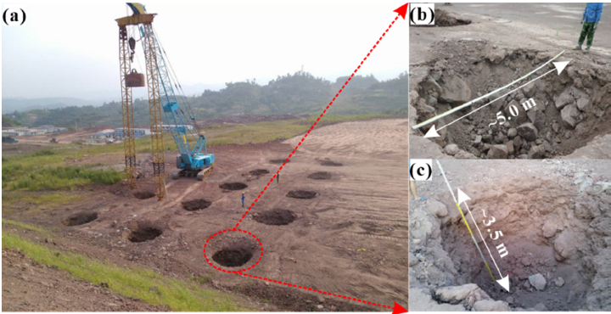

**Figure 1.** (a) A view of the DC application process and the application site (b) crater width and (c) crater depth (Wei et al. 2023)

DC is an effective soil improvement method applied in the field of soil engineering to increase the bearing capacity of soils and reduce the liquefaction potential. This method is based on the principle of reducing air voids within the soil and compacting soil particles more tightly by applying high-energy impacts to the soil surface (Figure 1). The basic principle of DC is the rearrangement of soil particles by the impact effect of a heavy mass falling on the soil. This process leads to the reduction of voids within the soil and the densification of the soil structure. DC is particularly effective in stabilizing cohesionless soils, but under certain conditions it has limited effects on cohesive soils (Akan and Keskin 2018; Kundu and Viswanadham 2015; Pinarci, Taşçi, and Çetin 2017).

The DC method was introduced by Menard in the 1970s. Menard presented the healing depth as a metric energy data and formulated it as follows: (Eq. 1) (Ménard and Broise 1975).

$D=(W∙{H)}^{0,5}$ (1)

*Here; (D) represents the healing depth, (W) represents the weight of the dropped object, and (H) represents the drop height.*

After field tests carried out with this formula, it was stated in some studies that a coefficient defined by n in the improvement depth formula expressed by Eq. 1 (Eq. 2) and selected according to the soil type would be more representative in the calculations. It is stated that this coefficient can vary between 0.3 and 1.00 depending on the soil type. (Table 1) (Şengezer 2010).

$D=n∙(W∙{H)}^{0,5}$ (2)

**Table 1.** Evaluation of the relationship between soil type and n coefficient (Nashed 2005)

|  |  |  |
| --- | --- | --- |
| Reference | N value | Deposit |
| Menard and Broise (1975) | 1.0 | General |
| Leonards et al. (1980) | 0.5 | Dry fine to medium sand |
| Lukas (1980) | 0.65 – 0.8 | Miscellaneous fill |
| Bhandari (1981) | 0.51 | Saturated Sands |
| Charles et al. (1981) | 0.35 | Loose fills and alluvial soil |
| Bjolgerud and Haug (1983) | 1.0 | Sands |
| Smoltczyk (1983) | 0.5 0.67 1.0 | Soils with unstable structure Silts and sands Purely frictional soils |
| Mayne (1984) | 0.3 – 0.8 | Sands and miscellaneous fill |
| Rollins and Kim (1994) | 0.4 0.586(W H)0,5 – 0.009 W H | Collapsible soils |

DC is based on two main processes: instantaneous compression due to the effect of impact loads and compression due to the dynamic effect of vibrations caused by the impact of the falling load on the ground (Jia et al. 2018).

When the literature on DC is analysed, 3 types of studies are encountered. These are field studies, model tests in the laboratory and numerical studies. These studies can be evaluated individually or they can be used together in some studies.

DC increases the bearing capacity of the soil and enables safer construction and utilisation of the structures. By reducing the total settlement, it accelerates the consolidation process and prevents non-uniform settlements during the use of the structure. It can be considered as a more economical option compared to other ground improvement methods. It increases the building safety against seismic movements by reducing the liquefaction potential of the soil.

DC is a soil improvement method that has a current literature from the 1970s to the present, and still has some limitations that are waiting to be explained. The aim of this study is to discuss the advantages and limitations of the DC method and its effects on geotechnical performance.

1. **Application Areas and Technical Details of DC**

Menard and Broise defined DC as the compaction of soils to a depth of 10-30 metres by repeatedly releasing loads weighing tens of tonnes from heights of 15-40 metres (Ménard and Broise 1975). In DC, an energy is transferred to the soil by releasing the weight from a certain height a certain number of times. This energy brings the soil grains closer to each other, reduces the voids and compresses the soil over a large area. Repeated impacts continue this compaction towards deeper layers of the ground. The water content in the soil is dispersed with these impacts, accelerating the total consolidation and preventing non-uniform settlements within the life of the structure. In addition, physical properties of the soil such as shear strength and free compressive strength are also improved during DC. With these improvements, the soil becomes more resistant to structural loads.

The processes of the DC application can be followed as follows: preparation phase, determination of weight amount and drop heights, realisation of impacts, control and measurements. In the first stage, which is the preparation stage, a suitable land is determined and the surface is prepared by drawing the grids of the points to be dropped. Then, depending on the soil type of the land and the desired degree of compaction, the weight to be dropped and the drop height are designed. On the determined grid, the soil is compacted by performing drops from the weight and drop height in accordance with the design criteria. Finally, the efficiency of the improvement is evaluated by comparing the measurements made in the initial state of the soil with the strength values of the land after the falls.

DC applications have a very common usage area such as strengthening the infrastructure in constructions such as highways and railways, strengthening the foundation soils of large structures such as industrial facilities, improving the runway and apron areas of airports, ensuring the ground stabilization of areas such as coasts and ports, and improving the pre-construction ground properties of residential areas.

There are some advantages and limitations in DC application. These limits, which will be discussed below, determine the effectiveness and applicability of the method. The main limits are; soil type, depth of effect of improvement, environmental factors, underground structures, control and measurements, weather conditions. DC can generally be applied in granular and non-saturated soil types. Compaction efficiency decreases in fine-grained soils and high water contents.

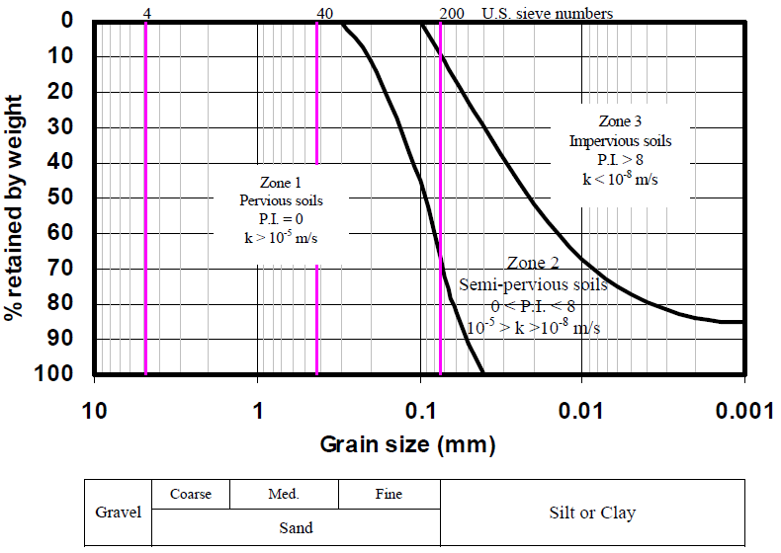

**Figure 2.** Grouping of soils for dynamic compaction (Lukas 1995)

Zone 1, shown in Figure 2 consists of highly permeable granular soils which are considered to be the most suitable for dynamic compaction. In this zone, as the load falls on the soil, the increasing pore water pressure dissipates almost immediately and densification occurs very quickly. (Lukas 1995).

Zone 3, contains soil types unfavourable for DC. Since the permeability in this zone is lower than 1x10-8 m/s, the damping of excessive pore water pressures during dynamic compaction takes a very long time, which is not practical for the application (Lukas 1995).

Zone 2, covers the area between the most favourable and unfavourable soils for DC. Silts, clayey silts and sandy silts are located in this zone. The permeability in this zone is between 10-5 and 10-8 m/s and time is needed to stabilise the excessive pore water pressure between the drops. In some projects, wick drains are installed for soils in this zone (Fig. 3) (Lukas 1995).

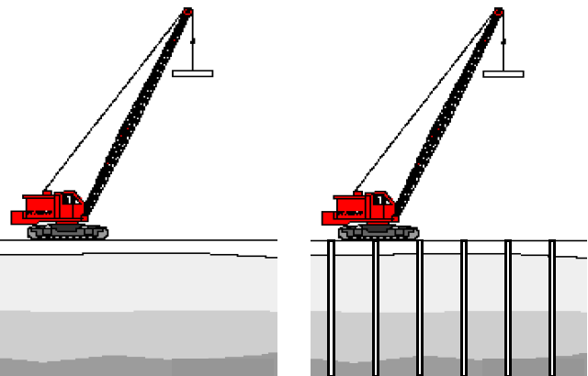

**Figure 3.** Example of DC with wick drain (Nashed 2005)

In previous studies, the depth of impact of DC was assessed as 10-12 meters. In places where deeper improvement is expected, sufficient compaction cannot be achieved. As an environmental effect, high noise and vibrations occurring during DC can be disturbing for neighboring structures and people. In addition, underground structures near the area where DC is performed can be negatively affected by the settlements and vibrations. Regular control and expert opinion are required for the degree of soil compaction and strength before and after DC. This may also require additional time and cost. In case of cold and rainy weather conditions, the DC process may become difficult. It can be said that the application will be more efficient in suitable weather conditions.

1. **Results and Discussion**

Studies on DC have revealed the following results. There are many factors affecting DC efficiency. The depth of the ground improved with DC does not depend only on the load, drop height and soil type. The most efficient improvement cannot always be achieved by dropping the heaviest load from the longest distance, and ground properties, number of drops, time between two drops, distance between drop points, shape and size of the dropped load, energy applied to the ground, ground water level and environmental conditions are also considered as parameters that need to be taken into consideration (Taghizadeh Valdi et al. 2018; Kim 2023; Kundu and Viswanadham 2018; Zhang, Wang, and Han 2021).

The parameters affecting DC can be summarized as soil properties; density (Dr), hydraulic conductivity (k), fines ratio (FC) and damping ratio. Studies have shown that the improvement depth of soils with high initial density decreases. Since it takes a long time to balance the excessive pore water pressure when the hydraulic conductivity decreases, more effective improvement is possible in soils with high hydraulic conductivity. The increase in the fines ratio will again create excessive pore water pressure, which negatively affects the improvement. Since the high damping ratio of the soil may cause the effects of the reduced load not to be seen at the desired level in the soil, it is one of the parameters that should be taken into consideration (Nashed 2005).

Since the number of falls increases the energy applied to the soil, it has a positive contribution to the improvement. However, since the improvement in the soil will remain constant after a certain number of falls, continuing to make falls is inefficient both in terms of time and economy. The effect of the time between two falls is a parameter that becomes important especially in soils with fine grains. The reason for this is waiting for the excessive pore water pressure to balance, that is, for the water to drain and for the settlement to be complete (Lukas 1995).

In the DC application, the distance between the drop points is determined by the field grid. This is an application made in order to ensure that the improvement is carried out homogeneously within the ground and to prevent non-uniform settlements. Each drop is carried out in a certain number of times to the specified points on this grid. Here, the drop distance, the weight of the falling object and the number of drops determine the energy applied to the ground. Again, control tests are carried out at certain points determined on the grid (Feng et al. 2013).

The shape and size of the dropped load also play a decisive role in the effectiveness of the DC process. These two parameters establish the pressure that the weight of the load exerts on the ground (Arslan, Baykal, and Ertas 2009).

In order to analyze the effects of groundwater level on DC, experiments were carried out on model tests at different water levels and as the groundwater level deepens, there were increases in the improvement. However, it is not suitable for compaction in completely dry soils. The optimum water content at maximum dry density for DC was determined as the value that provides the most suitable compaction (Hamid, Al-Amoudi, and Aiban 2019; Jia et al. 2021).

Another factor affecting the DC is the environmental conditions. The vibrations and sound that occur during the DC application can have negative consequences for the environment. Especially in areas where underground structures are located, vibrations can cause large lateral displacements and damage the structures. In order to eliminate this problem, there are studies on the creation of vibration isolation trenches between the areas where DC is applied and the surrounding structures (Wang, Yin, and Wang 2023; Zheng et al. 2023). At the same time, the resulting sound can exceed the limit conditions related to noise. For this reason, the relationship with the surrounding structures and people should also be taken into consideration in the area where DC will be applied (Abedini, Rafiee-Dehkharghani, and Laknejadi 2022; Gürkaynak 2012; Hwang and Tu 2006).

1. **Conclusion**

In this study, the advantages, limits and factors affecting the efficiency of the DC method are discussed in detail. It has been determined that DC has an important place in soil improvement projects and has a widespread use. It has been determined that the method has high efficiency especially in cohesionless and water-unsaturated soils, and that it contributes to the safer and more durable structures by increasing the soil bearing capacity and reducing the liquefaction potential. The improvement method, which also has some limits, has aspects that need to be clarified or resolved with the studies conducted. This study aims to shed light on future projects by addressing various aspects of DC application.

**References**

Abedini, Farzaneh, Reza Rafiee-Dehkharghani, and Karim Laknejadi. 2022. “Mitigation of Vibrations Caused by Dynamic Compaction Considering Soil Nonlinearity.” *International Journal of Civil Engineering* 20(7):809–26. doi: 10.1007/s40999-022-00700-9.

Akan, Recep, and Sıddıka Nilay Keskin. 2018. “KOMPAKSİYOYöntemi̇ni̇n KohezyonlZemi̇nleri̇n Serbest BasinçMukavemeti̇nEtki̇si̇.” *Mühendislik Bilimleri ve Tasarım Dergisi* 6(2):250–57. doi: 10.21923/jesd.383872.

Arslan, H., G. Baykal, and O. Ertas. 2009. “Discussion: Influence of Tamper Weight Shape on Dynamic Compaction.” *Proceedings of the Institution of Civil Engineers: Ground Improvement* 162(3):153–54. doi: 10.1680/grim.2009.162.3.153.

Feng, Shi Jin, Ke Tan, Wei Hou Shui, and Yan Zhang. 2013. “Densification of Desert Sands by High Energy Dynamic Compaction.” *Engineering Geology* 157:48–54. doi: 10.1016/j.enggeo.2013.01.017.

Gürkaynak, Ömer. 2012. “Dinamik Kompaksiyon Sonucu Oluşan Titreşim Verilerin Değerlendiriilmesi.” İstanbul Teknik Üniversitesi.

Hamid, Abdulrahman M., Omar S. Baghabr. Al-Amoudi, and Saad A. Aiban. 2019. “Assessing the Effect of Density and Water Level on the Degree of Compaction of Sand Using Dynamic Cone Penetration Test.” *Arabian Journal for Science and Engineering* 44(5):4921–30. doi: 10.1007/s13369-018-3641-0.

Hwang, J. H., and T. Y. Tu. 2006. “Ground Vibration Due to Dynamic Compaction.” *Soil Dynamics and Earthquake Engineering* 26(5):337–46. doi: 10.1016/j.soildyn.2005.12.004.

Jia, Mincai, Ye Yang, Bo Liu, and Shaohai Wu. 2018. “PFC/FLAC Coupled Simulation of Dynamic Compaction in Granular Soils.” *Granular Matter* 20(4):1–15. doi: 10.1007/s10035-018-0841-y.

Jia, Mincai, Ye Yang, Bo Liu, and Shaohai Wu. 2021. “Densification Mechanism of Granular Soil under Dynamic Compaction of Proceeding Impacts.” *Granular Matter* 23(3):1–15. doi: 10.1007/s10035-021-01136-z.

Kim, Myeonghwan. 2023. “Enhancing Ground Improvement of Dredging Landfill in South Korea’s Western Coastal Region: Insights into Dynamic Compaction Characteristics.” *Buildings* 13(7). doi: 10.3390/buildings13071830.

Kundu, Saptarshi, and B. V. S. Viswanadham. 2015. “Studies to Evaluate the Impact of Tamper on the Depth of Improvement in Dynamic Compaction.” *15th Asian Regional Conference on Soil Mechanics and Geotechnical Engineering, ARC 2015: New Innovations and Sustainability* (2011):2033–37. doi: 10.3208/jgssp.IND-20.

Kundu, Saptarshi, and B. V. S. Viswanadham. 2018. “Numerical Studies on the Effectiveness of Dynamic Compaction in Loose Granular Deposits Using Shear Wave Velocity Profiling.” *Indian Geotechnical Journal* 48(2):305–15. doi: 10.1007/s40098-018-0298-2.

Lukas, Robert G. 1995. “Geotechnical Engineering Circular No. 1, DYNAMIC COMPACTION.” *Grouting, Soil Improvement, and Geosynthetics (Eds R. H. Borden, R. D. Holtz and I. Juran), ASCE Geotechnical Special Publication No. 30, Vol. 2, Pp. 940-953. New York: ASCE.*

Ménard, L., and Y. Broise. 1975. “Theoretical and Practical Aspect of Dynamic Consolidation.” *Geotechnique* 25(1):3–18. doi: 10.1680/geot.1975.25.1.3.

Nashed, Rafeek. 2005. “Liquefaction Mitigation of Silty Soils.” 6(4):5381.

Pinarci, Emre, Meltem Taşçi, and Hasan Çetİn. 2017. “Changes of Permeability and Effective Stress Compacted Clayey Soils Depending on the Compaction Energy.” *Çukurova University Journal of the Faculty of Engineering and Achitecture* 32(3)(September):197–204.

Şengezer, Levent. 2010. “GRANÜLER ZEMİNLERDE DİNAMİK KOMPAKSİYON UYGULAMASI.” İstanbul Teknik Üniversitesi.

Taghizadeh Valdi, Mohammad Hossein, Mohammad Reza Atrechian, Ata Jafary Shalkoohy, and Elham Chavoshi. 2018. “Numerical Investigation of Water Entry Problem of Pounders with Different Geometric Shapes and Drop Heights for Dynamic Compaction of the Seabed.” *Geofluids* 2018. doi: 10.1155/2018/5980386.

Wang, Guobo, Yao Yin, and Jianning Wang. 2023. “Vibration Safety Evaluation and Vibration Isolation Control Measures for Buried Oil Pipelines under Dynamic Compaction: A Case Study.” *Soil Dynamics and Earthquake Engineering* 167(November 2022):107783. doi: 10.1016/j.soildyn.2023.107783.

Wei, Yingjie, Yuyou Yang, Jintai Wang, Huancun Liu, Jianguang Li, and Yuxin Jie. 2023. “Performance Evaluation of High Energy Dynamic Compaction on Soil-Rock Mixture Geomaterials Based on Field Test.” *Case Studies in Construction Materials* 18(November 2022):e01734. doi: 10.1016/j.cscm.2022.e01734.

Zhang, Xiaoshuang, Min Wang, and Yunshan Han. 2021. “Model Test Study on the Effect of Dynamic Compaction under Low Water Content.” *PLoS ONE* 16(6 June):1–14. doi: 10.1371/journal.pone.0253981.

Zheng, Yonglai, Xin Lan, Tanbo Pan, Dingding Cui, Guangxin Li, Longyin Shen, and Xubing Xu. 2023. “Field Testing and Numerical Simulation of the Effectiveness of Trench Isolation for Reducing Vibration Due to Dynamic Compaction.” *Applied Sciences (Switzerland)* 13(17). doi: 10.3390/app13179744.

1. \* Corresponding author. *e-mail address: msalihyldz@gmail.com* [↑](#footnote-ref-1)