

REPUBLIC OF TÜRKİYE

ALTINBAŞ UNIVERSITY

Institute of Graduate Studies

Electrical Engineering

**NOVEL NUMERICAL APPROACHES FOR ACTIVE FAULTS DETECTION AND PERFORMANCE OPTIMIZATION IN HIGH-VOLTAGE TRANSMISSION**

**Shaymaa Hameed Majeed SUWAILIH**

Master Thesis

Supervisor

Prof. Dr. Osman Nuri UÇAN

Istanbul, 2022

**NOVEL NUMERICAL APPROACHES FOR ACTIVE FAULTS DETECTION AND PERFORMANCE OPTIMIZATION IN HIGH-VOLTAGE TRANSMISSION**

**Shaymaa Hameed Majeed SUWAILIH**

Electrical and computer Engineering

Master Thesis

ALTINBAŞ UNIVERSITY

2022

The thesis titled NOVEL NUMERICAL APPROACHES FOR ACTIVE FAULTS DETECTION AND PERFORMANCE OPTIMIZATION IN HIGH-VOLTAGE TRANSMISSION, prepared by Shaymaa Hameed Majeed and submitted on 11/03/2023 has been **accepted unanimously** for the degree of Master of Science in Electrical and computer Engineering.

|  |  |  |
| --- | --- | --- |
| Thesis Defense Committee Members: |  | Prof. Dr. Osman Nuri UÇAN |

|  |  |  |
| --- | --- | --- |
| Prof. Dr. Osman Nuri UCAN | School of engineering and natural sience  ALTINBAS UNIVERSITY | __________________ |
| Asst. Prof. Dr. |  | __________________ |
| Asst. Prof. Dr. | ALTINBAS UNIVERSITY | __________________ |
|  |  |  |
|  |  |  |
|  |  |  |

I hereby declare that this thesis meets all format and submission requirements of a Master’s thesis.

Submission date of the thesis to Institute of Graduate Studies: ___/___/___

I hereby declare that all information presented in this graduation project has been obtained in full accordance with academic rules and ethical conduct. I also declare all unoriginal materials and conclusions have been cited in the text and all references mentioned in the Reference List have been cited in the text, and vice versa as required by the abovementioned rules and conduct.

Shaymaa Hameed Majeed

Signature

**DEDICATION**

This master’s thesis is dedicated to my amazing parents, who have been greatly supportive and encouraging during all of my years of master’s schooling and the writing of this thesis. Likewise, I would like to acknowledge and express gratitude to the Altinbas University electrical engineering department, specifically my advisor Prof. Dr. Osman Nuri UÇAN and the other outstanding professors and doctors in this department for all of their help, advice, and extensive knowledge throughout the course of my work on this thesis. It is also important to note that my supervisor provided me with much guidance and support as I analyzed this master’s thesis publication.

In addition, I would like to offer my most profound appreciation to everyone at Altinbas University who helped me in conducting the work associated with my thesis.

**ACKNOWLEDGMENT**

I humbly bow before you, God Allah, for endowing me with the skills, strength, and resolve to finish this master’s thesis.

In addition, I would want to show my appreciation to the electrical engineering department faculty and the finishing materials experts who helped me immensely with the documentation of my research and the completion of my thesis prof. Dr. Osman Nuri UÇAN the associate professor who serves as my supervisor, has been tremendously kind and helpful. Without his great support and inspiration, I would never have accomplished my numerical analysis and software simulation work in finalizing the materials. Additionally, I believe my supervisor will endorse the results of my research.

In addition, I appreciate the assistance of the members of the evaluation committee, who offered insightful feedback and suggestions. I would also like to express gratitude to the Altinbas University electrical engineering department for their constant support and guidance.

# ABSTRACT

**NOVEL NUMERICAL APPROACHES FOR ACTIVE FAULTS DETECTION AND PERFORMANCE OPTIMIZATION IN HIGH-VOLTAGE TRANSMISSION**

Shaymaa Hameed Majeed SUWAILIH

M.Sc, Electrical Engineering, Altınbaş University

Supervisor: Prof. Dr. Osman Nuri UÇAN

Date: 03/2023

Pages: 133

This master’s thesis aims to examine and evaluate the critical roles and vital contributions of ML principles in executing practical predictions of electrical faults, outages, threats, and other types of problems in high-voltage power transmission networks. Numerical simulations and mathematical work were conducted using four ML algorithms (Gradient Boosting Classifier (GBC), modified GBC, Light GBC (LGBC), and modified LGBC). The research outputs revealed that the LGBM classifier offered the most considerable accuracy proportion (100.00%). But this value was attained in the training phase. The training process provides no active comparative data associated with the effectiveness of ML algorithms in making high-performance predictions. Thus, the testing process was accomplished, and it was confirmed that the modified LGBC offered the highest accuracy (85.23%). Also, the maximum and minimum accuracy in the training process ranged between 100.00% and 92.55% for the LGBM classifier and modified LGBC, respectively. Meanwhile, the maximum and minimum accuracy of the testing phases were 85.23% and 82.95%, knowing that the largest was for the modified LSTM. In comparison, the smallest proportion was for the LGBM classifier. This indicates that the testing results gave oppositive findings to the training phase.

**Keywords:** Transmission network, Fault detection, Gradient boosting, Modified gradient boosting, Light gradient boosting, Accuracy.

# TABLE OF CONTENTS

ABSTRACT vii

TABLE OF CONTENTS ix

LIST OF TABLES xii

LIST OF FIGURES xiii

ABBREVIATIONS xv

1. INTRODUCTION 1

1.1 RESEARCH BACKGROUND 1

1.2 PROBLEM STATEMENT 4

1.3 RESEARCH SIGNIFICANCE 5

1.4 RESEARCH MAJOR AIM AND MINOR OBJECTIVES 6

1.5 THESIS STATEMENT 7

1.6 RESEARCH QUESTION 7

1.7 RESEARCH HYPOTHESES 8

1.8 RESEARCH ORGANIZATION 9

2. LITERATURE REVIEW 11

2.1 GENERAL 11

2.2 MAJOR CHARACTERISTICS AND CONTRIBUTION OF DETECTING FAULTS TECHNIQUE IN HIGH-VOLTAGE TRANSMISSIONS 11

2.3 LITERATURE REVIEW SUMMARY 24

2.4 CHAPTER SUMMARY 34

3. RESEARCH METHODOLOGY 35

3.1 CHAPTER GOAL 35

3.2 THE RESEARCH APPROACH 35

3.3 DATA COLLECTION METHODS 36

3.4 THE RESEARCH DATASET DESCRIPTION 38

3.5 INTELLIGENT ML MODELS USED IN THIS WORK 44

3.5.1 Description of GBC 45

3.5.2 Illustration of LGBM 46

3.6 PERFORMANCE EVALUATION OF THE ML ALGORITHMS USED IN THIS WORK 48

3.7 CHAPTER SUMMARY 49

4. RESULTS AND DISCUSSIONS 50

4.1 CHAPTER GOAL 50

4.2 NUMERICAL SIMULATION OUTPUTS OF THE FIRST MODEL (GBC) 50

4.3 NUMERICAL SIMULATION OUTPUTS OF THE SECOND MODEL (MGBC) 51

4.4 NUMERICAL SIMULATION OUTPUTS OF THE THIRD MODEL (LGBM CLASSIFIER) 53

4.5 NUMERICAL SIMULATION OUTPUTS OF THE FOURTH MODEL (MLGBM Model) 55

4.6 COMPARATIVE ANALYSIS BETWEEN THE FOUR EMPLOYED MODELS 57

4.7 DISCUSSIONS 59

5. CONCLUSIONS AND RECOMMENDATIONS 61

5.1 CHAPTER GOAL 61

5.2 CONCLUSIONS 61

5.3 RECOMMENDATIONS 62

REFERENCES 63

APPENDIX A 73

APPENDIX B 91

APPENDIX C 99

APPENDIX D 117

# LIST OF TABLES

Table 2.1: The significant results and relevance of all publications reviewed in the second chapter. 24

Table 3.1: The critical techniques executed in the primary and secondary data collection processes in this work. 37

Table 4.1: The numerical findings of the accuracy evaluation of GBC training and testing processes. 50

Table 4.2: The numerical findings of the accuracy evaluation of MGBC training and testing processes. 52

Table 4.3: The numerical findings of the accuracy evaluation of LGBM classifier training and testing processes. 54

Table 4.4: The numerical findings of the accuracy evaluation of LGBM classifier training and testing processes. 56

Table 4.5: The results of the comparative analysis between the four ML algorithms. 57

LIST OF FIGURES

Figure 1.1: Major components of pylons used in the high-voltage electrical power transmission process [7], [8]. 2

Figure 1.2: Types of pylons employed in high-voltage electrical power transmission in terms of voltage and elevation values [9]. 3

Figure 1.3: The steps of electricity generation, transmission, and distribution [10]. 4

Figure 2.1: The PNN topology diagram [39]. 11

Figure 2.2: The research method flowchart employed in the work of [39]. 12

Figure 2.3: The Precision-Recall curves (PR-curves) associated with their proposed network and the four compared networks [53]. 19

Figure 2.4: An example of images containing defects in the power transmission network linked to the dataset. 20

Figure 2.5: The proposed and implemented research method adopted in the work of [57]. 22

Figure 3.1: Details on the research approach adopted in this work. 36

Figure 3.2: Details on the research dataset associated with the number of intentional attacks between 2000 and 2016 in the electrical power transmission network. 38

Figure 3.3: Details on the research dataset pertaining to the number of intentional attacks in the electrical power transmission network based on the category of attack. 39

Figure 3.4: Details on the research dataset linked to the number of power outage events between 2000 and 2016 in the electrical power transmission network. 40

Figure 3.5: Details on the research dataset linked to the number of power outage events according to the duration in the electrical power transmission network. 41

Figure 3.6: Details on the research dataset linked to the number of power outage events according to the season in the electrical power transmission network. 42

Figure 3.7: Details on the research dataset linked to the number of power outage events according to the month in the electrical power grid. 43

Figure 3.8: Details on the research dataset linked to the number of power outage events according to the month in the electrical power grid. 44

Figure 3.9: The gradient boosting and light gradient boosting algorithms classification under the ensemble methods [65]. 45

Figure 3.10: The decision tree associated with GBC implementation in different prediction and detection applications using ML principles [64]. 46

Figure 3.11: The decision tree and operating principles of the LGBM model [70]. 48

Figure 4.1: The numeric code employed to conduct performance evaluation associated with the GBC model related to training and testing processes. 50

Figure 4.2: The examination metrics of the GBC model related to the accuracy. 51

Figure 4.3: The numeric code employed to conduct performance evaluation associated with the MGBC model related to training and testing processes. 52

Figure 4.4: The examination metrics of the MGBC scheme associated with the accuracy. 53

Figure 4.5: The numeric code employed to conduct the performance evaluation for the LGBM classifier related to training and testing processes. 54

Figure 4.6: The examination metrics of the LGBM classifier associated with the accuracy. 55

Figure 4.7: The numeric code employed to conduct the performance evaluation for the MLGBM model related to training and testing processes. 56

Figure 4.8: The examination metrics of the MLGBM model associated with the accuracy. 57

Figure 4.9: The comparative analysis results between the four ML algorithms implemented in this thesis. 59

ABBREVIATIONS

|  |  |  |
| --- | --- | --- |
| AI | : | Artificial Intelligence |
| CEEMD | : | Complementary Ensemble Empirical Mode Decomposition |
| CSC | : | Current Source Converter |
| CNSF | : | Capsule Network with Scattered Filtering |
| DT | : | Decision Tree |
| DWT | : | Discrete Wavelet transition |
| EMTDC/PSCAD | : | Energy Systems software/Electromagnetic Transients containing DC |
| FDC | : | Fault Detection and Classification |
| GB | : | Gradient Boosting |
| GBC | : | Gradient Boosting Classifier |
| LSTM | : | Long Short-Term Memory |
| LGBM | : | Light Gradient-Boosting Machine |
| MMC-HVDC | : | Multilevel Converters in High Voltage Direct Current |
| MGBC | : | Modified GBC |
| Modified LGBM | : | MLGBM |
| NB | : | Naive Bayes |
| PR | : | Precision-Recall |
| PSO | : | Particle Swarm Optimization |
| PNN | : | Probabilistic Neural Network |
| PD | : | Partial Discharge |
| R&D | : | Research and Development |
| RMSE | : | Root Mean Square Error |
| RF | : | Random Forest |
| STATCOM | : | Shunt-Compensated Static Synchronous Compensator |
| SD | : | Standard Deviation |
| SVM | : | Support Vector Machines |
| UAV | : | Unmanned Aerial Vehicle |

# 1. INTRODUCTION

## RESEARCH BACKGROUND

Over the last century, the electrical power transmission process of electrical power witnessed significant degrees of development, research, and growth in terms of the technology involved, performance, electrical power efficiency, and power factor. One example of innovative trends adopted in the transmission process is the employment of high values of voltage to transmit electricity more flexibly [1]–[4]. Scientists reported that using high-voltage transmission could achieve different advantageous effects and relevances to the electricity transfer between two locations. Those benefits include the achievement of significant rates of efficiency. In addition, transmitting electrical power through very long distances may contribute to diverse causes of (A) Power losses along the transmission lines, (B) An increasing number of faults, errors, and issues of electrical power taking place in cables, resistors, transformers, pylons (high-voltage electrical power towers), and other critical components in the transmission process, (C) Elevated temperature values of cables due to the reactive power losses, which are paid by customers daily without consumption, and (D) Faults appeared due to cyber threats and electrical power terrorist attacks [4]–[6]. To overcome these problems and other types of issues that may happen in the electrical power transmission grid, scholars and electrical engineering researchers recommended the adoption of electrical power decentralization through which the electricity generated from utility and large-scale power plants can be produced from small power plants that are closer to the customers and commercial and residential facilities without using large pylons (described in Figures 1.1 and 1.2, illustrating the major components of high-voltage pylons and extra-high-voltage pylons, and various types of power transmission towers depending on their classification of voltage values and elevation) that may contribute to numerous categories of faults and power issues starting from the exporting point (large power plants) ending to the clients (including hospitals, hostels, dwellings, factories, shopping centers, and other buildings), as shown in Figure 1.3. However, building new small power plants would cost a significant budget to overcome these challenging obstacles. Hence, other methods that are cost-effective, intelligent, practical, and fast should be considered and applied.

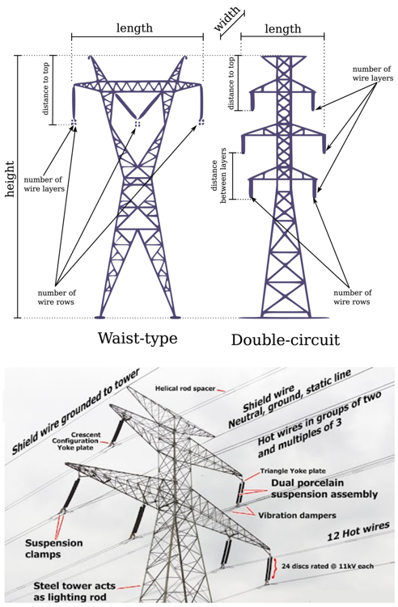

Figure 1.1: Major components of pylons used in the high-voltage electrical power transmission process [7], [8].

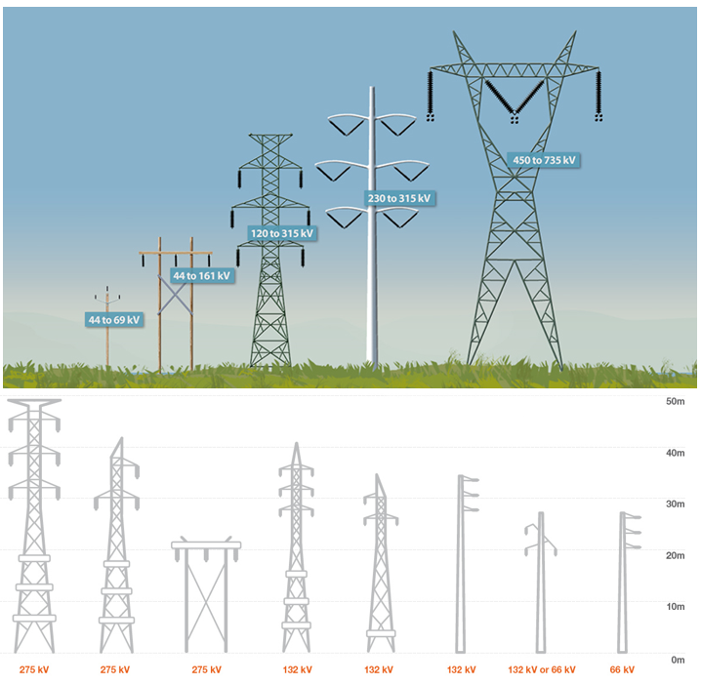

**Figure 1.2:** Types of pylons employed in high-voltage electrical power transmission in terms of voltage and elevation values [9].

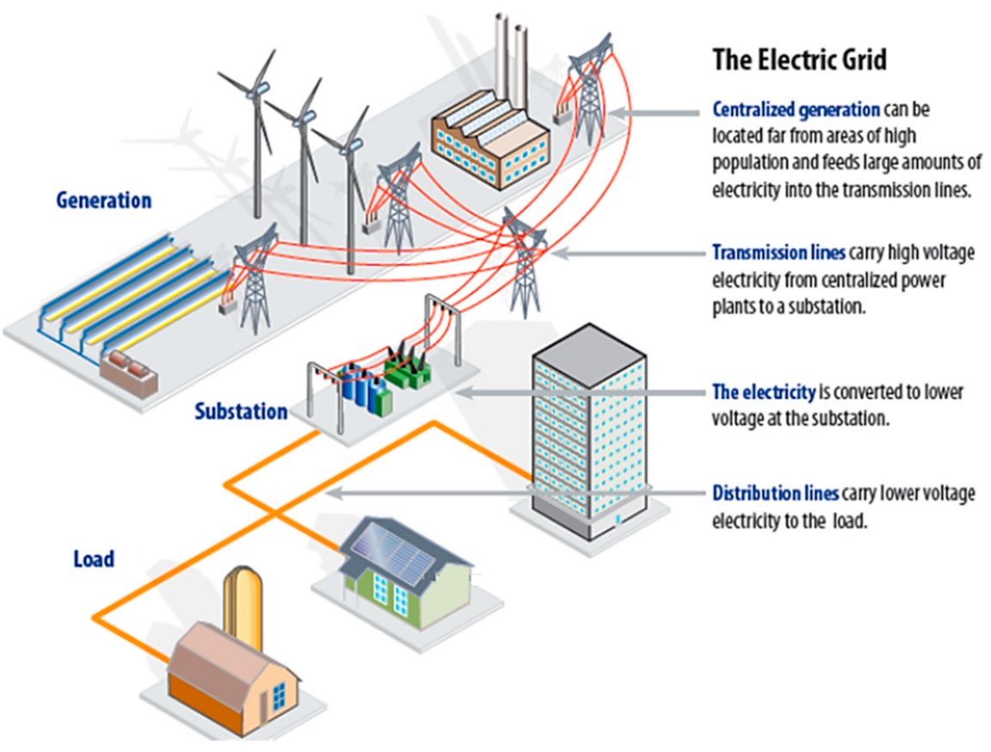

**Figure 1.3:** The steps of electricity generation, transmission, and distribution [10].

## 1.2 PROBLEM STATEMENT

Elevating the voltage to a hundred thousand volts to help reduce losses during the power transmission process of electrical power is considered a critical step and vital contribution to the electrical engineering discipline. Notwithstanding, there are still some issues and considerable troubles occurring in the electrical power network, particularly in high-voltage power transmission grids, mirrored by a large number of errors, faults, and issues that take place continuously, requiring a massive number of laborers, control engineers, and maintenance team to manage, track, and resolve all these problems. Furthermore, those issues may increase when the network is very long and extensive [5], [6], [11], [12]. In this context, different electrical power engineers, scientists, and scholars have dedicated significant extent of efforts to the Research and Development (R&D) to develop, formulate, and design new approaches and functional tactics that could save significant amounts of cost, time, and effort for electrical engineers and workers spent in detecting the error and classifying the type, time, and location of the fault, especially in high-voltage power transmission lines. One of the unique perspectives and innovative techniques developed in this context are intelligent algorithms, like Particle Swarm Optimization (PSO), Decision Tree (DT), and other novel algorithms that have evolved over the last decades. These modern algorithms can operate according to AI, ANN, and DL principles. They rely on Python/ MATLAB codes developed and prepared to forecast some vital data based on defined historical information [13]–[16]. Hence, in this work, this master’s study will employ those new concepts and exploit ANN, AI, and DL basics by proposing new/ novel algorithms that comprise one modified algorithm or more than two algorithms. The implementation of a new algorithm that relies on ANN, AI, and DL principles is remarkably beneficial and effective in making accurate and fast identification of different types of problems and faults in high-voltage transmission power networks [17]–[38]. This numerical approach to error classification could help electrical power engineers, control supervisors, and maintenance workers resolve various obstacles and overcome different challenges consuming minimal levels of budget, period, and effort.

## 1.3 RESEARCH SIGNIFICANCE

This master’s thesis is carried out by bringing some contributions to the scientific society and electrical engineers. The major relevances of this study include:

(I) Practical significance, and

(II) Theoretical significance.

The practical relevance of this master’s thesis is reflected in providing important numerical results and simulation work outputs that could help electrical power decision-makers and electrical transmission networks professionals, electrical power specialists, and policymakers select intelligent approaches and practical policies through which active ANN and AI algorithms can be employed to detect different categories of problems and faults in transformers, cables, and other high-voltage transmission network components, contributing to significant savings in time, effort, and cost, and facilitating the complexity of the detection process of faults in the transmission networks flexibly in terms of accurate identification of problems’ location and time when they happen in the power transmission grid. Furthermore, this work is vital as it contributes to a theoretical significance, translated by the expansion of the available literature and international knowledge associated with the substantial benefits and practical roles of modern ANN algorithms in forecasting faults and errors in electrical power grids, especially in high-voltage electrical transmission networks with higher levels of accuracy, speed, and effectiveness. Currently, there are various peer-reviewed articles and research publications that address the vital advantages and contributions of intelligent AI and DL algorithms in detecting different parameters in mechanical, computer, software, and industrial engineering. Nonetheless, the global literature faces a lack of research articles that discuss and investigate the beneficial impacts of these modern algorithms in forecasting faults in power transmission grids. For all these reasons, this work is guided by trying to broaden all these research gaps.

## 1.4 RESEARCH MAJOR AIM AND MINOR OBJECTIVES

The primary objective of this study is to examine and pinpoint the crucial benefits of some novel smart algorithms operating based on ANN, AI, and DL fundamentals to offer functional approaches to errors and problems classification in high-voltage power transmission networks. Several supporting objectives were established and carried out to accomplish the primary goal of this effort, including:

To review various peer-reviewed articles that address the beneficial features and significance of numerical forecasting methods depending on intelligent algorithms and modern ANN, AI, and DL principles.

To choose a case study of a high-voltage electrical power transmission network in Turkey.

To conduct a numerical analysis, modeling, and simulation through which real faults are identified and accurately determined using Python/ MATLAB code.

To modify, confirm, and validate the numerical research outputs according to a panel of electrical engineering experts and electrical power and transmission specialists.

## 1.5 THESIS STATEMENT

The title of this research is “NOVEL NUMERICAL APPROACHES FOR ACTIVE FAULTS DETECTION AND PERFORMANCE OPTIMIZATION IN HIGH-VOLTAGE TRANSMISSION.” This title is developed and revised based on the opinion of academicians and experts to validate the substantial role of modern intelligent algorithms that operate under the ANN, AI, and DL principles to help detect different types of faults and issues that take place in high-voltage power transmission networks, contributing to substantial rates of accuracy, simplicity, and speed.

## 1.6 RESEARCH QUESTION

This thesis seeks to answer the following research questions:

1. Could the employment of ANN algorithms provide accurate and high-performance detection of faults and errors occurring in high-voltage power transmission networks?
2. Could recently-innovated algorithms and ANN and AI principles offer delicate identification of the type of faults and errors in high-voltage power transmission networks?
3. Would the use of new models pertaining to intelligent algorithms facilitate the forecasting process of problems and faults related to the high-voltage power transmission networks can help save significant amounts of costs, time, and effort required by workers and maintenance teams to detect the same error?
4. Does employing state-of-the-art intelligent algorithms enable active prediction and identification of issues and faults in the high-voltage power transmission networks, offering considerable precision and effectiveness regarding the location of fault and time when it happened to save significant inspection efforts and durations?
5. Are creative ANN, AI, and DL algorithms capable of helping electrical power and control engineers manage the operation and maintenance of large-scale high-voltage power transmission networks flexibly?
6. Does implementing novel fault and error forecasting techniques under ANN algorithms offer significant contributions in terms of simplicity, fewer calculation procedures, high speed, and a reliable mechanism to determine the location and time of fault in large-scale high-voltage power transmission networks quickly and accurately?

## 1.7 RESEARCH HYPOTHESES

To offer more clarification regarding the goals of this thesis, a set of research hypotheses are considered. This master’s work will be executed to provide the validity or invalidity of these hypotheses, which are illustrated in the following paragraphs:

(I) Null Hypothesis, $H_{o}$– which presumes that: “Using ANN, DL, and AI principles with the help of intelligent algorithms would not offer any positive contributions or significant benefits in terms of accurate and high-performance detection of faults and errors occurred in the high-voltage power transmission network.”

(II) Sub Hypothesis, $H_{1}$– which assumes that: “Employing intelligent new algorithms that take into account ANN, AI, and DL fundamentals can help offer delicate identification of the type of faults and errors in the high-voltage power transmission networks.”

(III) Sub Hypothesis, $H_{2}$– which considers that: “Exploiting new models of intelligent algorithms in forecasting problems and faults related to the high-voltage power transmission networks can help save significant amounts of costs, time, and effort required by workers and maintenance teams to detect the same error.”

(IV) Sub Hypothesis, $H_{3}$– which presumes that: “Using new intelligent algorithms in predicting issues and faults in the high-voltage power transmission networks could contribute to considerable precision and effectiveness in identifying the location of fault and time when it happened to save significant inspection efforts and durations.”

(V) Sub Hypothesis, $H_{4}$– which assumes that: “Adopting intelligent algorithms that rely on ANN, DL, and AI principles can help electrical power and control engineers manage the operation and maintenance of large-scale high voltage power transmission networks flexibly.”

(VI) Sub Hypothesis, $H_{5}$– which considers that: “Implementing novel fault and errors forecasting techniques by virtue of ANN algorithms would offer significant contributions in terms of simplicity, fewer calculation procedures, high speed, and a reliable mechanism to determine the location and time of fault in large-scale high-voltage power transmission networks easily and accurately.”

## 1.8 RESEARCH ORGANIZATION

The architecture of this thesis is organized and considered based on the following consequence:

1. **Chapter One** has the title **INTRODUCTION**. The research background, problem statement, significance, primary and secondary goals, hypotheses, questions, and thesis statement are all laid out in great detail in this chapter.
2. **Chapter Two** has the title **LITERATURE REVIEW**.This chapter represents detailed information and addresses critical roles, relevances, and beneficial contributions pertaining to the adoption and implementation of novel and modern forecasting methods and intelligent prediction techniques to determine the faults and errors in high-voltage electrical power transmission networks. The information related to this chapter is gathered based on a secondary data collection method depending on the data available in various web journals, which include Academia, MDPI, ScienceDirect, Semantic-Scholar, and ResearchGate. In addition, the ANN, DL, and AI databases will be investigated and addressed, relying on variant master and PhD dissertations and conference proceedings existing in international universities and academic institutes.
3. **Chapter Three** has the title **RESEARCH METHODOLOGY**. This chapter depicts the major research methods, important numerical procedures, and vital simulation and modeling analysis steps adopted and followed in conducting this master’s study. Further, the research parameters, numerical tools, and other critical variables of the numerical forecasting approach used in this work are defined and identified.
4. **Chapter Four** has the title **RESULTS AND DISCUSSIONS**. It describes the factual findings and significant research outcomes indicated by the numerical analysis, modeling, and simulation after considering some boundary conditions and some vital indices related to the high-voltage power transmission lines. Moreover, this chapter describes the discussions and connects the current outcomes with the outputs linked to other scholars worldwide.
5. **Chapter Five** has the title **CONCLUSIONS AND RECOMMENDATION**. It presents the critical study’s conclusions obtained from the numerical analysis, modeling, and simulation process through which the contributions and benefits of innovative and functional detection methods are addressed. Further, this chapter offers some vital recommendations to support scientists, students, and electrical engineers in conducting further improvements and modifications on the design and development of new approaches to enhance the performance and accuracy of faults detection in the high-voltage power transmission of electrical networks.

# 2. LITERATURE REVIEW

## 2.1 GENERAL

This chapter specializes in presenting recent previous studies and a literature review of the most prominent methods and techniques contributing to the detection of defects in high-voltage transmissions. Moreover, this study provides extensive information on the experimental and simulation methods and techniques used in the detection of defects to be a basic reference that is used in this study.

## 2.2 MAJOR CHARACTERISTICS AND CONTRIBUTION OF DETECTING FAULTS TECHNIQUE IN HIGH-VOLTAGE TRANSMISSIONS

[39] suggested a novel technique for HVSR case characteristics extraction and smart diagnosis. To increase the potential neural grid simulation, the strategies integrate a Complementary Ensemble Empirical Mode Decomposition (CEEMD) method, fuzzy entropy, exchange information theory, and an improved grasshopper improvement algorithm. Figure 2.1 represents the Probabilistic Neural Network (PNN) topology diagram employed in their work.

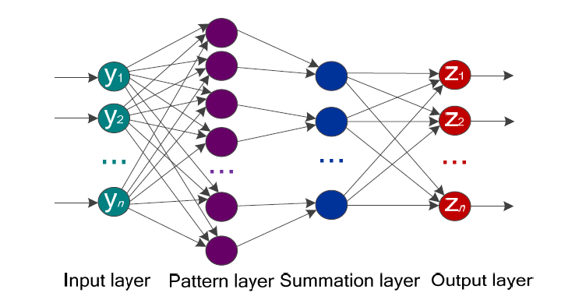

Figure 2.1: The PNN topology diagram [39].

The authors provided MCPCEEMD as an initial step to muffle modalities and analyze the HVSR raw shaking signals. The level of correlation between the HVSR fundamental shaking signals and the obtained significant pattern function components is then assessed by MI, and the IMF with the highest correlation is selected for characteristic extraction.

Figure 2.2 indicates the research method flowchart employed in their research.

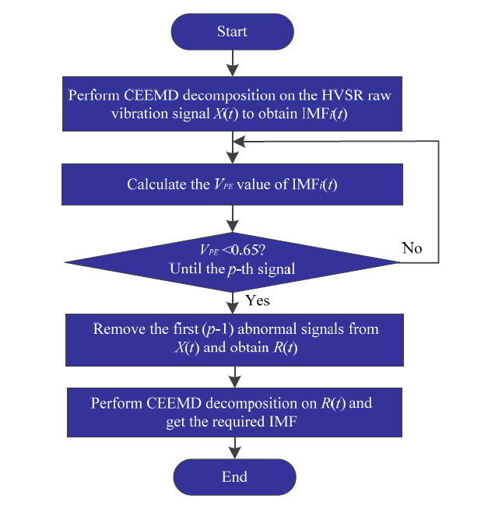

Figure 2.2: The research method flowchart employed in the work of [39].

Moreover, this research utilizes MFE to determine the quantity of the chosen IMF. In the end, piecewise inertial weights are used to develop GOA to select the optimal softening factor for PNN and utilize the enhanced IGOA-PNN simulation to determine characteristics subgroups. The study proved that the suggested way successes in diagnosing various kinds and levels of HVSR mechanical defects and the determination precision ratio higher than 98%. The excellent realization precision of the proposed technique is a benefit for the state exploration and practical field of HVSRs.

The significant contribution of research [40] was to utilize a novel technique for defect exploration in HVDC systems, utilizing the gray wolf improvement technique and synthetic neural grids. The properties of the current and voltage signals were determined using this technique in a significantly shorter time by combining defective and non-defected data. Following that, variants are investigated with the use of a synthetic neural grid. The rectifier’s operation and its necessary controller filters are accurately recreated in the study case HVDC system. This study tested alternative methods and contrasted them with the suggested approach. These methods included vector basis function, syndic neural grid, teaching self-coordinating, and radial quantization map. Precision, Jaccard, F1, and sensitivity results were computed and obtained to demonstrate the effectiveness of the suggested technique. All of the results obtained values greater than 97%. In the end, it was clear from the results of the model that this technique could be an appropriate method for defect exploration in HVDC systems.

As for the Partial discharge method, which is considered the most hopeful solution in order observing and diagnosing possible issues in isolation systems, noise is a central problem in analyzing and exploring faults when utilizing this mensuration. [41] published a paper that contributed to obtaining PD signals utilizing a data decomposition technique, enhanced complete group experimental style decomposition by using a noise algorithm, united with an important statistical index to improve noise minimization affectivity and to conclude and visualize the Hilbert spectrum of the entered signal in frequency range after filtrating the noise. As for PD analysis, synthetic and empirical signals were utilized as entered signals in the decomposition techniques. This research offered improved enhancement in the decreasing noise and the PD exploring procedure specified using statistical analysis. Consequently, the signal decomposition utilizing the suggested approach is valuable for diagnosing PD on elevated voltage instruments.

[42] suggested a novel technique for defect exploration and position depending on bidirectional Gated frequent Units, owing to inadequate traditional defect diagnosis techniques of MMC-HVDC system, like manual-designed defect thresholds and complicated data pre-treatment. The suggested process has clear benefits of characteristics obtained on the bi-oriented composition and facilitates the pre-treatment of defect data. The pre-treatment prevents the absence of correct information in the data and contributes to removing defect features, consequently enhancing the precision of the technique. Expanded model experiments illustrated that the suggested method meets the velocity demands of MMC-HVDC preservation (2 ms) and the precision percentage ratio up to 99.99%. Moreover, the technique is not influenced by noise and has excellent probabilities for suitable employment.

Boosting flexibility in an energy grid system is one of the primary tasks of electrical distribution firms to offer elevated-degree service. The energy flexibility research community has suggested different charts to explore, sort, and localize defect events. Anyway, the previous studies still suffer a shortage of comprehensive taxonomy of these charts that can contribute to improving future research. [43] conducted a literature review that offered a combined review of the advanced solutions to defect analysis in transition energy systems. The researchers addressed defect kinds and various defect-analysis techniques selected using related research works, suggested a new flowchart to categorize these works, and shed light on their advantages and weaknesses. The researcher predicted that this study review would benefit the researcher in the future in selecting proper methods for defect analysis.

To immediately assort the unprocessed sensor data with no specific characteristic obtain and designing classifier, [44] suggested a long short-period memory neural grid and utilized for 7 cases of the MMC-HVDC transition energy system modeled using energy Systems software /Electromagnetic Transients. It was noted that the LSTM technique could explore defects with 100% precision and assort several flaws in addition to offering hopeful defect classification performance. The LSTM technique can gain better classification precision around the middle of the experimenting data ratio, although it requires more practice duration.

Ghashghaei and Akhbari(2021) offered a comparison study multi-Machine Learning system approach to protect bipolar HVDC transition line in which several ML modes of Support Vector Machine and K-Nearest were utilized for defect exploration and sortation. The KNN defect kind classifier is structured as a double-objective module that explores defect kind and works as a typical unit for insecure defect declaration from the functional module. The statistical indicators such as Gradients, standard deviations, and correlation for the following: DC, voltage, harmonic current, and patterns of DC are suitable characteristics vectors. Generally, 154 practising states and 53 major test states were gained by modeling different defect and non-defect cases on a ±650 kV-1000 km Current Source Converter (CSC) – HVDC. The ML units were practised in MATLAB and examined under various severe cases. The gained findings illustrate that the suggested algorithm is efficient in exploring and recognizing a type of interior defects and exterior defects.

[45] guided a study presenting features of DC defects in the VSC-HVDC system. The DC effect current has great top and constant values within a few milliseconds, and consequently, elevated-velocity defect exploration and isolation techniques are demanded in an HVDC network. The improvement of the preservation chart for a multi-terminal VSC-depend HVDC system is a difficult job. Several ways have been created, and his study offers a literature review of the various methods. The review recommended developing this technique to detect defects with more advanced techniques.

[46] developed a paper that suggested an auto flowchart for Fault Detection and Classification (FDC) of TL depending on a capsule grid. Without requiring large data, the Capsule Network with Scattered Filtering (CNSF) significantly improves model performance while automatically learning the expensive fault characteristics. The proposed chart collects 1/2 cycle post-defect three-stage signals, codes them into a single image, and uses that image as the input for the proposed CNSF simulation. Using four different TL topologies, the suggested CNSF simulation’s effectiveness is increased, confirming the simulation’s ability to adapt to topology changes in response to intended control behavior or switching processes brought on by persistent flaws. More evaluation of the simulation’s performance versus noise, great resistance defects, and line parameter changes was executed to affirm the remarkable accuracy of the suggested model.

[47] detected learning ways to enhance the effectiveness of the open-circuit defect description of modular inverters. Two deep learning techniques, called autoencoder, deepened deep neural grids and convolutional neural grids. Additionally, stand-alone SoftMax classifiers are detected for the exploration and sortation of MMC-depend elevated voltage current defects are utilized immediately in the suggested technique, and no features were extracted.MMC-HVDC system with two stations is executed in Energy Systems software/Electromagnetic Transients containing DC (EMTDC/PSCAD) to investigate and compare with other techniques. The modeling findings affirmed that CNN, AE-depend DNN, and SoftMax classifiers could explore and sort defects with significant exploration and classification precision. The best performance achieved by the SoftMax classifier in exploration and classification precision in addition to examination speed. The suggested chart receives 1/2 cycle post-defect three-stage signals and codes them into a single photo determined as the data for the proposed CNSF simulation. The efficiency of the proposed CNSF simulation is supported by four various TL topologies affirming the model’s adaptation to a topology modification in reaction to meant control procedure or the modification procedures owing to subsequent defects. More evaluation of the model’s performance versus noise, outstanding resistance defects, and line parameter changes was conducted to affirm the great accuracy of the suggested simulation. It was monitored that the proposed CNSF model results in a precision of 99% versus the noises and more than 97% versus the outstanding resistance defects.

[48] guided research aimed to enhance the effect of characteristics extraction of a circuit breaker shaking signal and the precision of circuit breaker state realization, a softly Gradient enhancing Machine technique depending on period -domain characteristic obtaining with multi-kind entropy characteristics for automated defect detection of the high voltage circuit breaker was suggested. At the initial phase, the basic shaking signal of the elevated voltage circuit breaker is divided into the frequency domain; after that, sixteen characteristics containing five types of entropy characteristics are extracted immediately from each piece of the basic signal after time-domain division, and the basic feature group is created. Then, the divide significance value of each characteristic is computed, and the best distinct subset is identified using the forward method, considering the classification precision of LightGBM as the decision variable. Finally, the LightGBM classifier is created depending on the characteristic vector of the best typical subset that can precisely recognize the mechanical defect case of the elevated voltage circuit breaker. It was confirmed that the novel technique has the benefits of great effectiveness in feature extraction and precision in defect determination.

[49] conducted a literature of defect-personifying techniques in the energy transition system. Usually, to execute the analysis, voltage specimens are deployed. Three subjects; defect exploration, sortation, and location, are represented separately to report a more knowledgeable and comprehensive awareness of the principles. The researchers addressed Feature extractions and transmutation with dimensionality minimization techniques. Defect sortation and location methods widely utilize signal processing techniques and Artificial Intelligence (AI). The researchers discussed all methods and principles, advancements, and further sides. The advantages and disadvantages of various AI and machine learning-depend arithmetic were evaluated. It compared different defect exploration, sortation, and location techniques taking into account features, data, intricacy, the system utilized, and findings. This literature review can guide for the researchers to recognize various methods in this scope.

[50] provided a procedure to explore and determine the kind of defect. This uses a combination of Naive Bayes (NB) and Discrete Wavelet transition (DWT) classifiers and occurs in the Shunt-Compensated Static Synchronous Compensator (STATCOM) transmission line. The network simulation was organized with Matlab software to implement this methodology. To account for the impact of varying defect strength, various types of flaws, including Line to Line, Double Line, Line to the floor, and the 3 cases detected, were used in multiple regions of the system. The three instances see present wave shapes gained are decomposed into many degrees utilizing Daubechies waves of db4 to calculate the Standard Deviation (SD) and power values. After that, the output results are used to intern the classifiers, like Bayes, Naive Bayes, and Multi-Layer Perceptron Neural Network classifier, to assort the kind of defect in the system. The findings showed that the suggested NB classifier achieves better performance than both MLP and the Bayes classifier. In which precision grade, misclassification grade, kappa statics, mean inaccuracy, Root Mean Square Error (RMSE)

[51] administered research to suggest a new NDT method for fault analysis in elevated voltage tools via taking benefit of the deep learning and thermography from the ML model. The FLIR T630 was used to take infrared pictures of the parts without interfering with the functioning of an energy network. The early phase of the Alex Net programmed model’s convolutional strata produced large characteristic maps, which were collected. The Support Vector Machines (SVM) and Random Forest (RF) were trained to investigate the fault and non-fault raised voltage instrument after the outputs were obtained. According to an experimental study, the RF learned to distinguish between non-fault and fault instruments with greater than 96% accuracy, outperforming all other comparative methods for deep and superficial characteristics. The suggested approach, which relies on RF, is accurate and works well for finding flaws in high-voltage electrical instruments.

[52] carried out a study that explains analyzing energy feeding regeneration period after collapse taking place in energy lines. The researchers indicated that the energy feed regeneration time is based on many compositions, like the period for gaining data on failures, the period for data realization, the period to maintain failures, and the period for communication harmonization. These factors have been taken into account. The primary constituents ‘findings values of the energy feed restoration period were analyzed for grids of electrical local energy feed firms. The Delphi technique was applied to identify the period for gaining data on collapses moreover, the period for data realization. Statistical analysis was applied to determine the restore time. The specified energy supply restoration period (5.28h) is identical to the values of statistical analysis of the inspected energy supply firm. The technical methods for automating the electrical grid can minimize the energy feed restoration period computed. These values were sorted according to the time intervals they underestimated.

[53] carried out a paper to suggest advanced techniques for discovering one defect or multi-defect of the insulator in UAV-depend aerial photos, the backgrounds of which sometimes include complicated interference. The insulators’ geometries differ due to the filming dimension and angle differences. To minimize the influence of the complex intervention on insulator defects revelation. Also, to mitigate the impact of a complex intervention on insulator error revelation, a deep neural grid can be used to differentiate between insulators and background intervention. The Precision-Recall curves (PR-curves) associated with their proposed network and the four compared networks can be indicated in Figure 2.3.

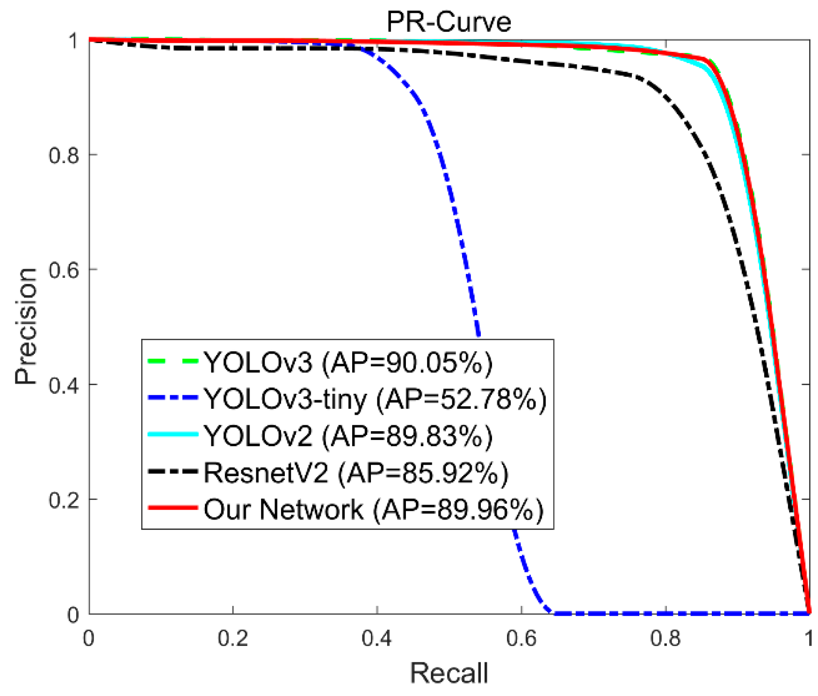

Figure 2.3: The Precision-Recall curves (PR-curves) associated with their proposed network and the four compared networks [53].

Then, an advanced convolutional grid is suggested to gain precise nonconductor string locations in the aerial photo. In the end, a modern defect exploration technique is proposed to explore both one error and multi-defect of an insulator in aerial images. Test findings on a large number of aerial photos illustrate which told procedure is more highly efficient than traditional techniques of detecting defects in an insulator. The researcher stated that Insulator error exploration is a significant function for high-voltage transference line examination. Hence, conventional approaches are usually free from the shortage of precision and robustness. Furthermore, these techniques can only explore one defect in the insulator but cannot explore a multi-defect.

[54] improved a precision energy line exploration technique utilizing convolutional and organized characteristics. Initial methods that use conventional filters can be unsuccessful in taking the whole energy lines owing to blatant backgrounds. So, the researchers created a convolutional neural grid to gain pyramids reactions from each stratum. The wealthy feature maps were combined to make an incorporation result. Then we got the organized information containing width, length, direction, and surface from the roughness feature map. To obtain a discovery with clear context, we mix the fusion result with structured data. The suggested technique adopted organized primary data to execute precision and practical exploration. Moreover, it produced two energy lines in groups owing to the shortage in the general range. The technique is assessed on the energy line database and performs brilliantly compared to traditional methods. Figure 2.4 represents an example of images containing some defects in the power transmission network associated with the dataset.

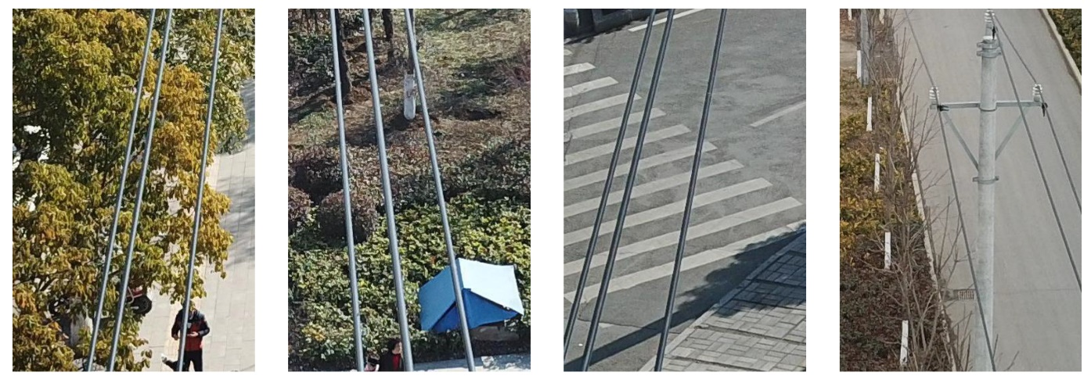

Figure 2.4: An example of images containing defects in the power transmission network linked to the dataset.

For controlling the constraints of visual techniques in weak spots, [55] suggested dealing with the issue of energy line exploration and modeling depending on LiDAR. The PL2DM, energy Line LiDAR-depend exploration, and simulation were modern methods to explore energy lines. The energy line final simulation is gained by combining many line parts, utilizing their collinearity characteristics. In the horizontal direction, the energy lines are simulated as a straight line and in the vertical direction as a catenary curve. Utilizing an actual database, the algorithm illustrated promising findings both in terms of outputs and treatment period, adding real-time object-depend perception abilities for other treatment strata.

[56] developed a paper to suggest a novel mechanical defect discovery method. In the beginning, the vibration signs of HVCBs are gathered using a designed procuration system, and we can eliminate the noise of signals using a smooth threshold de-noising technique. Then, the experimental wave transform was used to dissolve the signs into sets of physical patterns. After that, the enhanced period-frequency entropy technique is utilized to gain the properties of the wave signals. In the end, a regression neural grid is used for determining four kinds of wave signs of HVCBs, whereas a loop traversal technique enhances the softening factor δ of GRNN. The tests of the research illustrate that by applying this best classifier for defect discovery, the suggested defect exploration technique achieved the best performance and the realization percentage ratio of obscure specimens is more than 95%, and the signal characteristics gained by the ITFE technique are more important than of conventional TFE technique.

The opinion of [57] is that it is of high importance to conduct defect detection of HVCBs. To precisely determine the running phases of HVCBs, a new mechanical detection describing techniques of HVCBs depend on multi characteristics entropy incorporation, and a combined classifier is suggested. MFEF includes the decomposition of shaking signals from HVCBs into different substantial pattern functions utilizing differential mode decomposition and the computation of multi-characteristics entropy by combining 3 Shannon entropies. The researchers used concept component analysis to decrease the distance of the multi-characteristics entropy and acquire an efficient combination of characteristics for choosing the characteristic vector. The diagnostics of an anonym defect in HVCBs is done utilizing support vector data description practices using natural-state and specific defect specimens. According to this basis, the determination and sortation of the well-known phases are realized utilizing the SVM. 3 defects (i.e., smooth spring invalid defect, closing spring force reduced defect, opening spring force reduced defect) were modeled on an actual SF6 HVCB to examine the probability of the suggested technique. The diagnosis precisions of the anonym defect are more than 87% when each of the three defects is supposed to be the antonym defect. According to comparing between tests, the results illustrated that SVM was unable to explore the unspecified defects and that one-class SVM gave the minor capability to analyze the anonym defect than SVDD. The usage of the MFEF technique offered a precision of 100%, whereas the usage of a single-characteristic approach offered a precision of up to 75%. These findings affirmed that the suggested techniques for collecting MFEF with a combined classifier are more effective and strong than conventional techniques.

Figure 2.5 represents a schematic of the major research approach implemented in their work.

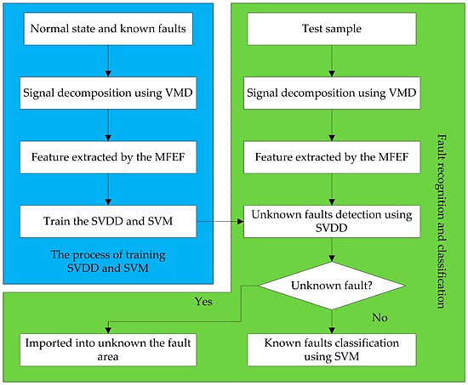

Figure 2.5: The proposed and implemented research method adopted in the work of [57].

The energy line point clouds were cleared due to their geometrical classification in regional distance point cloud sections and were then divided into polygons using conditional Euclidean clustering. To know the removing hazards effectively and efficiently, [58] suggested an auto clearance irregularity exploration technique using LiDAR points gathered by unmanned aerial vehicle. The scholars proposed an auto clearance anomaly exploration technique using LiDAR point clouds combined with (UAV) method. The terrain points were sorted out in the initial stage using a two-stage terrain filter. The towers were explored in the non-terrain issues using a characteristics map technique. The energy line point clouds were obtained owing to their geometric scattered in local distance point clouds sections. They were then divided into polygons using conditional Euclidean clustering after segmenting the ROW point clouds into distances depending on the pylon exploration findings. The 3D catenary curve mode is described as utilizing a vertical catenary curve, and the level line was usually supplied for the energy line point cloud sections, leading to an algorithmic model of the energy line’s separated specimen points. The dimension between the energy line and the non-energy facility items in the ROW was finally computed using a clearance calculation method that converts the point-to-catenary curve dimension measurements to minimal dimension computation relying on differential equations. To determine the clearance distortion in the ROWs, the measured clearance values were contrasted with the security threshold. The effectiveness and precision of the recommended method were examined utilizing a large-scale UAV power line examination system in conjunction with a Liar point clouds database. The discovery results were discussed using qualitative optical analysis, quantitative hand values in unprocessed point clouds, and an on-site scope survey. The experiments show that the method for automatically detecting clearance anomalies proposed in this paper effectively identifies filtration risks such as tree encroachment and clearance values.

The mechanical defections of elevated-voltage circuit breakers usually occur over running for a long time, so extracting the fault characteristics and determining the defect kind have become a major problem in ensuring the energy supply’s safety. Depending on the wavelet packet analysis technique and random forest algorithm, an efficient determination system was improved in this study by [59]. At the initial stage, the wavelet packet period-frequency power ratio was utilized as the input vector for the classifier mode in the characteristics chosen operation. After that, a forest classifier was used to detect the HVCB defect, evaluate the significance of the characteristic variable and enhance the distinct space. In the end, the method was investigated depending on realistic HVCB shaking signals by taking six ideal defect classes. It was shown from experimental results that the classification precision of the suggested technique with the essential characteristic space was up to 93.33% and up to 95.56% with the enhanced input characteristic vector of a classifier. This leads to the successful distinctive enhancement process, and the suggested diagnosis algorithm has greater effectiveness and strength than conventional methods.

## 2.3 LITERATURE REVIEW SUMMARY

The critical contributions addressed in the previous paragraphs of this chapter can be summarized in Table 2.1.

Table 2.1: The significant results and relevance of all publications reviewed in the second chapter.

|  |  |  |  |  |
| --- | --- | --- | --- | --- |
| **#** | **Author(s)** | **Year** | **Paper Title** | **Major Contributions** |
| **1** | Hou, P., Ma, H., & Ju, P. | 2022 | Intelligent Diagnosis Method for Mechanical Faults of High-Voltage Shunt Reactors Based on Vibration Measurements | The study provid that the suggested way succussed in diagnosing various kinds and levels of HVSR mechanical defects, and the determination precision ratio was higher than 98%. The excellent realization precision of the suggested technique is a benefit for the state exploration and practical field of the HVSRs. |

Table 2.1: The significant results and relevance of all publications reviewed in the second chapter. “tables continued”

|  |  |  |  |  |
| --- | --- | --- | --- | --- |
| **2** | Jawad, R. S., & Abid, H. | 2022 | Fault Detection in HVDC System with Gray Wolf Optimization Algorithm Based on Artificial Neural Network | To prove the effectiveness of the suggested technique, the precision, Jaccard, F1 result, and sensitivity were computed and gained, and all the results achieved values higher than 97%. In the end, according to the model findings, it was evident that this technique can be a proper technique for defect exploration in HVDC systems. |
| **3** | Thus, V. C., & Lee, H. S. | 2022 | Partial Discharge (PD) Signal Detection and Isolation on High Voltage Equipment Using Improved Complete EEMD Method | This research offered improved enhancement in the decreasing noise and the PD exploring procedure specified using statistical analysis. Consequently, the signal decomposition utilizing the suggested technique is a beneficial instrument for diagnosing PD on elevated voltage instruments. |

Table 2.1: The significant results and relevance of all publications reviewed in the second chapter. “tables continued”

|  |  |  |  |  |
| --- | --- | --- | --- | --- |
| **4** | Wang, Y., Zheng, D., & Jia, R. | 2022 | Fault diagnosis method for MMC-HVDC based on Bi-GRU neural network | Expanded model experiments illustrated that the suggested technique meets the velocity demands of MMC-HVDC preservation (2 ms) and the precision percentage ratio up to 99.99%. Moreover, the method is not influenced by noise and has more considerable probabilities for suitable employment. |
| **5** | Al Mtawa, Y., Haque, A., & Halabi, T. | 2022 | A Review and Taxonomy on Fault Analysis in Transmission Power Systems | Depending on the researchers’ comprehensive review, the study helped identify various methods and active fault detection approaches that can provide effective means of error and problem identification in the transmission power grid with higher levels of accuracy, reliability, flexibility, and effectiveness. |

Table 2.1: The significant results and relevance of all publications reviewed in the second chapter. “tables continued”

|  |  |  |  |  |
| --- | --- | --- | --- | --- |
| **6** | Wang, Q., Yu, Y., Ahmed, H. O., | 2020 | Open-circuit fault detection and classification of modular multilevel converters in high voltage direct current systems (MMC-HVDC) with long short-term memory (LSTM) method | It was noted that the LSTM technique was helpful in exploring defects with 100% precision and assorting several shortcomings and offering hopeful defect classification performance. The LSTM technique could gain higher categorization precision concerning the middle of experimenting data ratio, although it requires more practice duration. |
| **7** | Ghashghaei, S., & Akhbari, M | 2021 | Fault detection and classification of an HVDC transmission line using a heterogenous multi‐machine learning algorithm. | Depending on simulations and mathematical analysis, it was found that the suggested novel algorithm provided remarkable degrees of effectiveness and accuracy. Also, it was efficient in exploring and recognizing various types of interior defects and exterior defects along the HVDC transmission network. |

Table 2.1: The significant results and relevance of all publications reviewed in the second chapter. “tables continued”

|  |  |  |  |  |
| --- | --- | --- | --- | --- |
| **8** | Muniappan, M. | 2021 | A comprehensive review of DC fault protection methods in HVDC transmission systems | Their comprehensive review revealed various vital aspects and critical ideas associated with novel methods and practical tactics in terms of accurate fault detection and precise error identification in the HVDC transmission system with significant rates of reliability, performance, and effectiveness. |
| **9** | Fahim, S. R., Sarker, S. K., Muyeen, S. M., Das, S. K., & Kamwa, I. | 2021 | A deep learning based intelligent approach in detection and classification of transmission line faults. | The efficiency of the suggested CNSF simulation is enhanced using four several TL topologies affirming the simulation’s adaption to a topology variation in reaction to meant control conduct or the switching procedures owing to repeated defects. More evaluation of the simulation’s performance versus noise and great resistance defects were attained. Furthermore, the line parameter changes were achieved to affirm the extraordinary accuracy of the suggested model. |

Table 2.1: The significant results and relevance of all publications reviewed in the second chapter. “tables continued”

|  |  |  |  |  |
| --- | --- | --- | --- | --- |
| **10** | Wang, Q., Yu, Y., Ahmed, H. O., Darwish, M., & Nandi, A. K. | 2020 | Fault detection and classification in MMC-HVDC systems using learning methods. | It was monitored that the suggested CNSF model results in a precision of 99% versus the noises and more than 97% versus the outstanding resistance defects. |
| **11** | Qi, J., Gao, X., & Huang, N. | 2020 | Mechanical fault diagnosis of a high voltage circuit breaker based on high-efficiency time-domain feature extraction with entropy features | It was confirmed that the novel technique has the benefits of great feature extraction effectiveness and a more considerable precision rate of defect determination. |
| **12** | Raza, A., Benrabah, A., Alquthami, T., & Kamal, M. | 2020 | A review of fault diagnosing methods in power transmission systems. | This literature review revealed different types and classifications of various beneficial techniques and active methods that can be implemented and adopted for detecting faults in the power transmission network. |

Table 2.1: The significant results and relevance of all publications reviewed in the second chapter. “tables continued”

|  |  |  |  |  |
| --- | --- | --- | --- | --- |
| **13** | Aker, E., Othman, M. L., Veerasamy, V., Aris, I. B., Wahhabi, N. I. A., & Hizam, H. | 2020 | Fault detection and classification of shunt compensated transmission line using discrete wavelet transform and naive bayes classifier | The findings gained found that the suggested NB classifier achieves better performance than both MLP and the Bayes classifier. in which precision grade, misclassification grade, kappa statics, mean inaccuracy, and root mean square error (RMSE). |
| **14** | Ullah, I., Khan, R. U., Yang, F., & Wuttisittikulkij, L | 2020 | Deep learning image-based defect detection in high voltage electrical equipment | The suggested technique relying on the RF is accurate and depicts it as effective for defect exploration in elevated voltage electrical instruments. |
| **15** | Vinogradov, A., Bolshev, V., Vinogradova, A., Jasiński, M., Sikorski, T., Leonowicz, Z., ... & Jasińska, E | 2020 | Analysis of the power supply restoration time after failures in power transmission lines. | The identified energy supply restoration period (5.28h) is identical to the values of statistical analysis of the inspected energy supply firm. The technical techniques of electrical grid automation were calculated to minimize the time needed for energy feed restoration. These values were sorted according to the time intervals they minimized. |

Table 2.1: The significant results and relevance of all publications reviewed in the second chapter. “tables continued”

|  |  |  |  |  |
| --- | --- | --- | --- | --- |
| **16** | Han, J., Yang, Z., Zhang, Q., Chen, C., Li, H., Lai, S., ... & Chen, R. | 2019 | A method of insulator faults detection in aerial images for high-voltage transmission lines inspection. | Conventional approaches are usually free from the shortage of precision and robustness. Furthermore, these techniques can only explore one defect in the insulator but are not able to explore a multi-defect. |
| **17** | Zhang, H., Yang, W., Yu, H., Zhang, H., & Xia, G. S | 2019 | Detecting power lines in UAV images with convolutional features and structured constraints | The technique is assessed on the energy line database and offers a brilliant performance by comparing it to traditional methods. |
| **18** | Azevedo, F., Dias, A., Almeida, J., Oliveira, A., Ferreira, A., Santos, T., ... & Silva, E | 2019 | Lidar-based real-time detection and modeling of power lines for unmanned aerial vehicles | Utilizing an actual database, the algorithm illustrated hopeful findings each in terms of treatment period and outputs, providing real-time object-depend perception abilities for other strata of treatment |

Table 2.1: The significant results and relevance of all publications reviewed in the second chapter. “tables continued”

|  |  |  |  |  |
| --- | --- | --- | --- | --- |
| **19** | Li, B., Liu, M., Guo, Z., & Ji, Y. | 2018 | Mechanical fault diagnosis of high voltage circuit breakers utilizing EWT-improved time-frequency entropy and optimal GRNN classifier | The research tests illustrate that the suggested defect exploration technique achieved the best performance by applying this best classifier for defect discovery. The realization percentage ratio of obscure specimens is more than 95%. Also, the signal characteristics gained by the ITFE technique are fundamental further than the conventional TFE technique. |
| **20** | Wan, S., Chen, L., Dou, L., & Zhou, J. | 2018 | Mechanical fault diagnosis of HVCBs based on multi-feature entropy fusion and hybrid classifier | The results illustrated that SVM could not explore the unspecified defects, and the 1-class support vector machine gave the least capability to explore the anonym defect than SVDD. The usage of the MFEF technique offered a precision of 100%, whereas the usage of a single-characteristics technique offered a precision of up to 75%. These findings affirmed that the suggested techniques of collecting MFEF with a combined classifier are consequently more effective and strong than conventional techniques. |

Table 2.1: The significant results and relevance of all publications reviewed in the second chapter. “tables continued”

|  |  |  |  |  |
| --- | --- | --- | --- | --- |
| **21** | Chen, C., Yang, B., Song, S., Peng, X., & Huang, R. | 2018 | Auto clearance anomaly detection for transmission line corridors utilizing UAV-Borne LIDAR data | The results illustrated that SVM could not explore the unspecified defects, and the 1-class support vector machine gave the least capability to explore the anonym defect than SVDD. The usage of the MFEF technique offered a precision of 100%, whereas the usage of a single-characteristics technique offered an accuracy of up to 75%. These findings affirmed that the suggested techniques of collecting MFEF with a combined classifier are consequently more effective and strong than conventional techniques. |

Table 2.1: The significant results and relevance of all publications reviewed in the second chapter. “tables continued”

|  |  |  |  |  |
| --- | --- | --- | --- | --- |
| **22** | Hristoforou. | 2018 | Advanced Non-Destructive Testing in Steels | It was shown from experimental results that the classification precision of the suggested technique with the essential characteristic space was up to 93.33% and up to 95.56% with the enhanced input characteristic vector of a classifier. This leads to the typical enhancement process booming, and the suggested diagnosis algorithm has greater effectiveness and strength than conventional ways. |

## 2.4 CHAPTER SUMMARY

Based on reviewing and highlighting various critical benefits and substantial impacts of innovative methods and creative techniques which are practical and active in detecting multiple types and forms of electrical faults, issues, and errors across the HV transmission power network, it can be inferred that employing those tactics and modern methods would be remarkably helpful and effective in identifying complex and challenging problems in the electrical power network with higher degrees of performance, accuracy, reliability, and speed. According to those ideas and critical aspects addressed in the second chapter, chapter three will provide an analysis of a real case study representing the HV electrical power network in Turkey.

# 3. RESEARCH METHODOLOGY

## 3.1 CHAPTER GOAL

This chapter represents the primary research approach implemented and followed in this work to validate the substantial effectiveness and pivotal roles of modern and creative detection techniques in identifying different categories of faults and problems that may occur suddenly across the high-voltage electrical power network, resulting in significant issues and challenging obstacles for Turkish citizens and electrical engineers. The dependent and independent variables are also examined and discussed in this chapter.

## 3.2 THE RESEARCH APPROACH

This master’s research follows some investigation steps and critical study procedures to achieve the central goal of this study, reflected in validating the beneficial impacts of modern mechanisms in identifying different issues and problematic barriers that may occur abruptly in various areas along the high-voltage electrical power grid.

Firstly, the research will rely on a thorough review in which several advantageous merits and practical features of modern approaches and innovative procedures can be adopted and implemented globally to handle variant modes of faults and diverse sorts of issues by virtue of an accurate, high-performance, reliable and quick detection process. Then, a case study will be chosen representing a high-voltage electrical power grid in Turkey that faces some faults and challenging issues that require investigation and identification to help the maintenance team and electrical engineers track, monitor, and overcome those problems flexibly and quickly. Then, a numeric Python code will be developed and designed to help carry out vital numerical analysis, simulation process, and investigations of intelligent ML and DL algorithms in detecting complex electrical problems in the high-voltage power grid with considerable levels of reliability, efficiency and accuracy. After this step, the mathematical findings will be validated and verified depending on a group of ML experts, electrical engineers, and DL professionals. Finally, conclusions and recommendations will be proposed and developed to help the global society execute some additional work and research efforts to enhance the performance of those modern techniques associated with DL and ML principles. Figure 3.1 indicates the research approach of this study.

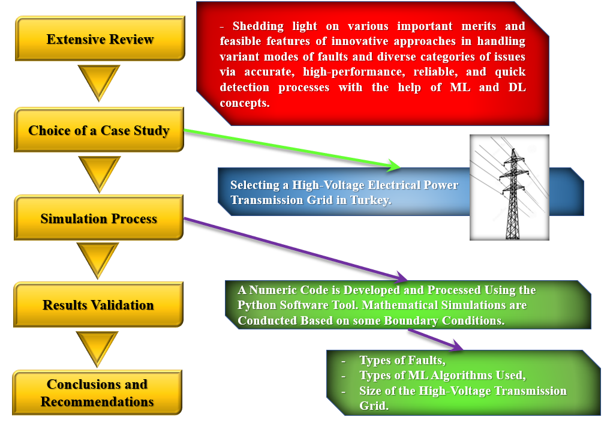

Figure 3.1: Details on the research approach adopted in this work.

## 3.3 DATA COLLECTION METHODS

The main types of data collection approaches that are adopted in this thesis include two vital methods, which are:

1. Primary data collection, and
2. Secondary data collection.

More details on the principles and analytical procedures applied in those two approaches can be explained and described in Table 3.1.

Table 3.1: The critical techniques executed in the primary and secondary data collection processes in this work.

|  |  |  |  |
| --- | --- | --- | --- |
| No. | The Data Collection Tactic | Main Procedure Executed | Helpful Techniques/ Database(s) |
| 1 | Primary Data Collection | Analysis and investigation of diverse categories of faults and problems across the high-voltage electrical power grid in Turkey with the help of ML and DL principles and intelligent algorithms using a numeric code developed and simulated in Python software. | Numerical Simulations in Python Software |
| 2 | Secondary Data Collection | Highlighting the major benefits of modern detection techniques and shedding light on creative and practical ML and DL principles that can help distinguish complicated fault issues and errors in the high-voltage electrical grid with remarkable levels of accuracy, reliability, and performance. | Different vital concepts and ideas will be collected from peer-reviewed articles and modern academic publications, recent conference proceedings, PhD dissertations, and master’s theses. |

It is worth mentioning that the articles discussed and addressed in this research will range mostly between 2018 and 2023, according to their date of publishing. However, a few papers will have slightly older years of publishing in this work.

## 3.4 THE RESEARCH DATASET DESCRIPTION

The dataset associated with the high-voltage electrical power network located in Turkey contains different types of attacks and defects in the power transmission grid that may affect the operation and performance of this power grid. The dataset is collected between (2000) and (2016). The significant attacks related to the high-voltage power transmission grid in Turkey can be summarized into the following categories:

1. Intentional attacks,
2. Power outages (including current and voltage interruptions),
3. Cyber or other types of attacks that may affect the operation and effectiveness of the electrical power transmission process in the Turkish network.

Figure 3.2 represents a statistical database associated with the number of intentional attacks between 2000 and 2016.

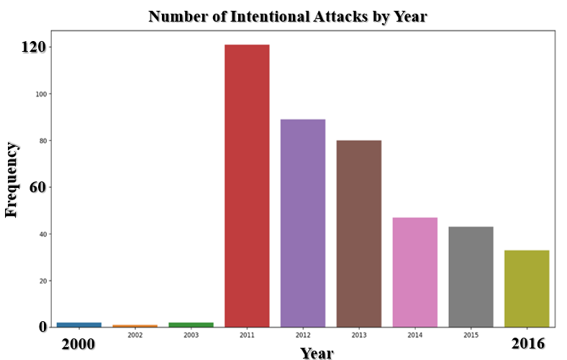

**Figure 3.2:** Details on the research dataset associated with the number of intentional attacks between 2000 and 2016 in the electrical power transmission network.

It can be indicated from the statistical data represented in Figure 3.2 that the maximum number of intentional attacks occurred in 2011, followed by 2012 and 2013, corresponding to a frequency of approximately 120, 85, and 80 attacks, respectively. Other types of attacks pertaining to the high-voltage electrical power transmission grid can be represented in the number of intentional cyber attacks in the tramsmissio power network based on the type of intentional cyber attack, as illustrated in Figure 3.3.

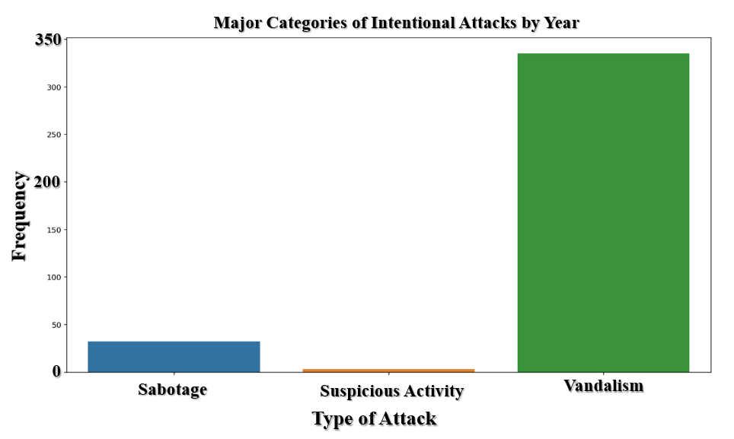

**Figure 3.3:** Details on the research dataset pertaining to the number of intentional attacks in the electrical power transmission network based on the category of attack.

It can be deduced from the database represented in Figure 3.3 that the type of intentional cyber attack that recorded the highest number of cyber-attacks was the vandalism type, corresponding to a frequency of just below 350 episodes. In contrast, the lowest number of intentional cyber attacks that influenced the transmission power grid was suspicious activities, corresponding to a frequency of fewer than ten attacks. Also, Figure 3.4

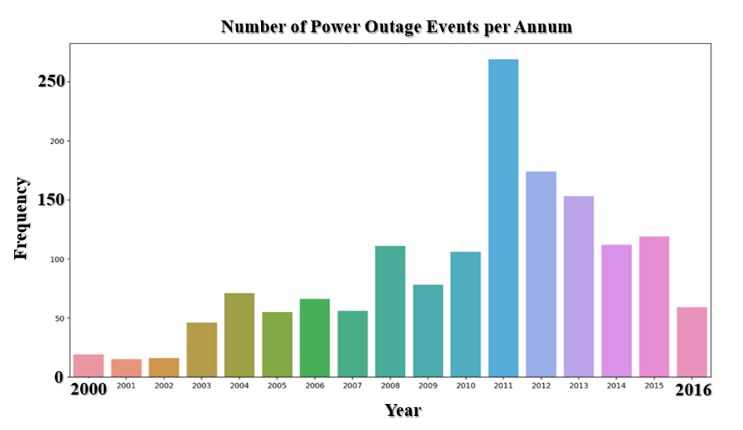

**Figure 3.4:** Details on the research dataset linked to the number of power outage events between 2000 and 2016 in the electrical power transmission network.

It is concluded from the dataset represented in Figure 3.4 that the year 2011 witnessed a significant number of power outage events, corresponding to a frequency of approximately 260 power outage circumstances. On the other hand, the years 2000, 2001, and 2002 recorded the minimum number of power outage frequencies, corresponding to values of roughly 20 power outage events.

Figure 3.5 illustrates details on the research dataset linked to the number of power outage events according to the duration in the electrical power transmission system.

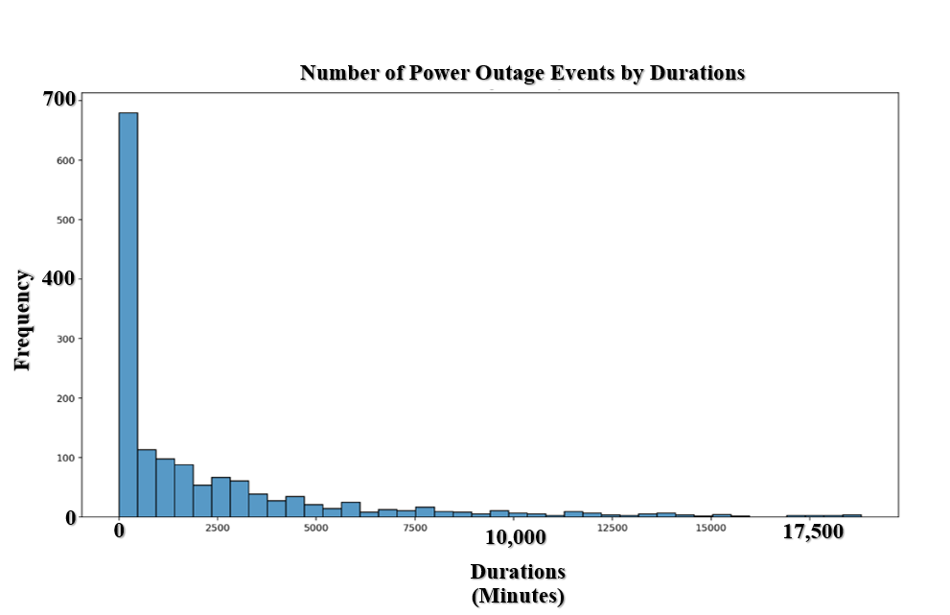

**Figure 3.5:** Details on the research dataset linked to the number of power outage events according to the duration in the electrical power transmission network.

It can be observed from the information described in Figure 3.5 that the electrical power outage in the electrical power grid did not occur and stayed for a longer duration of minutes. For example, the data in this figure indicates that the frequency of (Zero) durations in the transmission power grid is very high compared with other circumstances in which the power outage was very low. This fact explains that most of the time, the electrical power transmission process was performing well and functioning effectively without recorded problems. However, there were, for instance, roughly 75 power outage events with an overall duration of 2,500 minutes for all the events. Nonetheless, all these electrical power outage events are still very rare compared with the normal operating conditions and regular functioning of the transmission process. Also, Figure 3.6 describes some details on the research dataset linked to the number of power outage events according to the season in the electrical power transmission network.

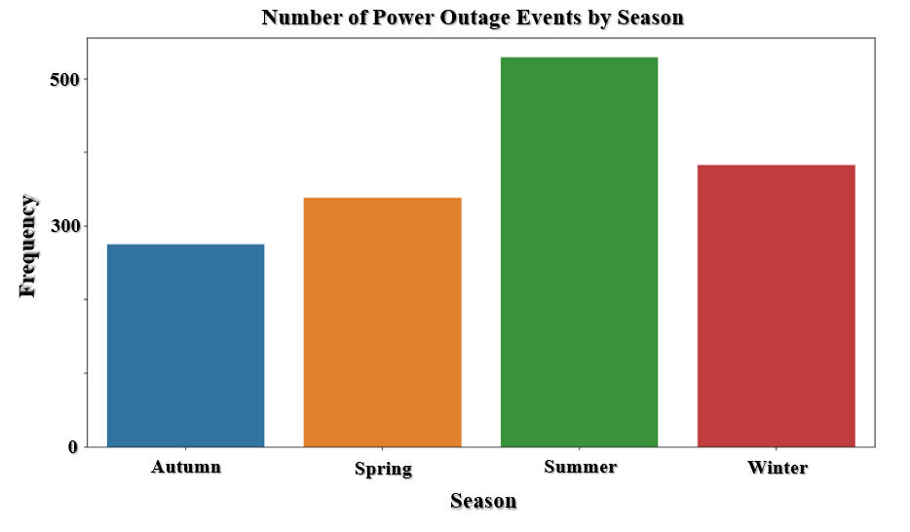

**Figure 3.6:** Details on the research dataset linked to the number of power outage events according to the season in the electrical power transmission network.

It is noted from the research information linked to the dataset in Figure 3.6 that the maximum number of power outage events occurred in the summer season, corresponding to a frequency of around 500 events. On the other hand, the lowest number of power outage circumstances recorded a value of just below 300 events, which took place in autumn. Furthermore, Figure 3.7 indicates some statistical data from the dataset regarding the number of power outage events according to the month in the electrical power grid.

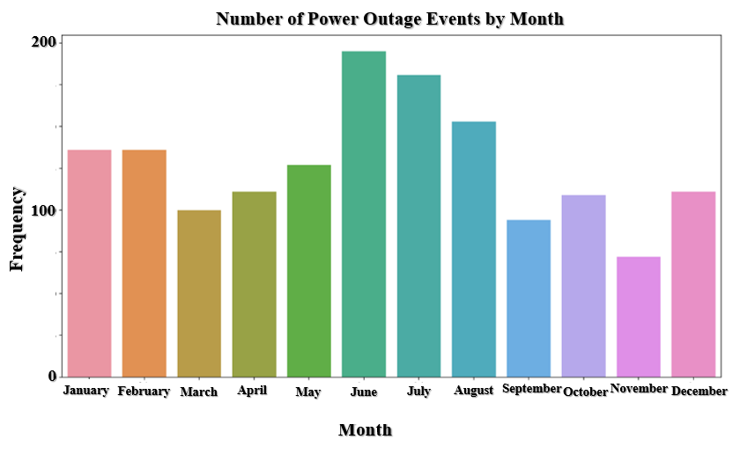

**Figure 3.7:** Details on the research dataset linked to the number of power outage events according to the month in the electrical power grid.

It is inferred from Figure 3.7 that the most significant frequency of electrical power outages associated with the power transmission system happened in June, corresponding to a number of just below 190 events. At the same time, the minimum number of power outages that occurred according to the month was in November, reaching an amount of approximately 80 occasions. Besides, Figure 3.8 depicts some details of the research dataset linked to the number of power outage events according to the month in the electrical power grid.

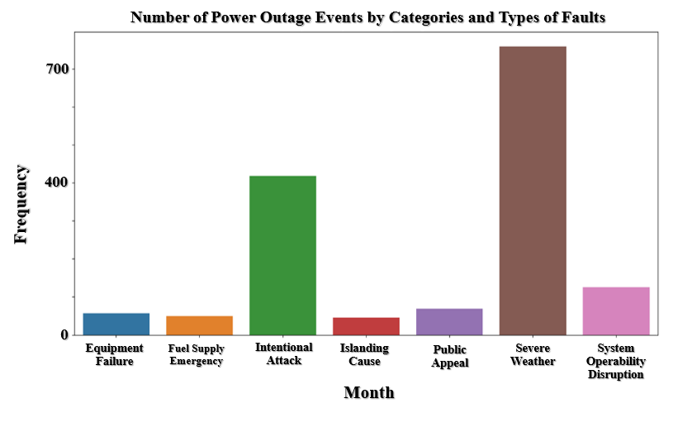

**Figure 3.8:** Details on the research dataset linked to the number of power outage events according to the month in the electrical power grid.

It can be concluded from the dataset represented in Figure 3.8 that the most considerable quantity of power outages in the electrical transmission system occurred because of severe weather events, corresponding to a number of 700 events. On the other hand, the lowest amount of faults and power outages took place due to equipment failure, fuel supply emergencies, and islanding problems. Those three causes contributed to a frequency associated with power outages of less than 50 events.

## 3.5 INTELLIGENT ML MODELS USED IN THIS WORK

To validate the functional role of ML principles in detecting different power outages and electrical faults in the high-voltage transmission system, some intelligent ML algorithms were implemented. Those innovative ML models include the following schemes:

1. Gradient Boosting Classifier (GBC),
2. Modified GBC (MGBC),
3. Light Gradient-Boosting Machine (LGBM Classifier),
4. Modified LGBM (MLGBM),

The following paragraphs will describe in more detail some information about the intelligent GBC and LGBM models that operate on the ML principles.

### 3.5.1 Description of GBC

GBC can be defined as “An innovative and practical ML model through which classification purposes and regression applications can be achieved actively.” A GBC ML model is remarkably functional in making accurate and high-performance prediction processes and detection of new information based on the definition of the historical dataset. GBC depends on the ensemble of weak detection and prediction schemes, which is shown in the classification diagram in Figure 3.9. Those ML schemes are generally associated with Decision Trees (DTs) [60]–[64].

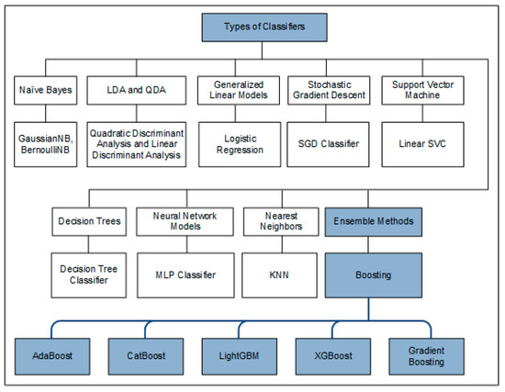

Figure 3.9: The gradient boosting and light gradient boosting algorithms classification under the ensemble methods [65].

Furthermore, Figure 3.10 illustrates the working principles of GBC.

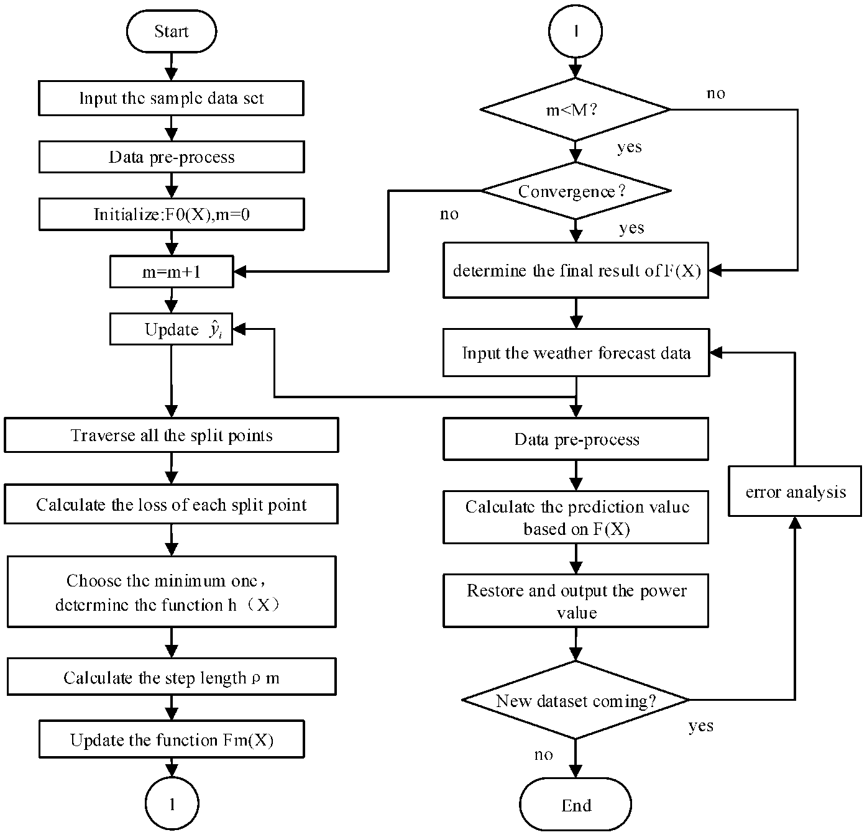

Figure 3.10: The decision tree associated with GBC implementation in different prediction and detection applications using ML principles [64].

### 3.5.2 Illustration of LGBM

LGBM classifier can be described as “A powerful, reliable, and robust ML technique that outpaces other ML algorithms in terms of performance and effectiveness. It is associated with Gradient Boosting (GB) and DT that operate on ML principles to make training and learning, helping the efficiency and robustness of prediction and detection processes to be improved and enhanced [66]–[68]. [69] conducted an analysis investigating the performance of the LGBM classification algorithm using some formulas and mathematical correlations. The scholars reported that group P is defined to comprise the necessary training data to make an active prediction. This group can be expressed in the following formula:

|  |  |
| --- | --- |
| $$P=\{\left(x_{1},y_{1}\right),\left(x_{2},y_{2}\right),…, {(x}_{n},y_{n})\}$$ | (3.1) |

Where $x$ indicates the data samples. $y$ denotes the class labels. In the LGBM classifier, $F(x)$ is employed as an evaluated function. The optimization function associated with LGBM is used to minimize the expected value of the loss function, which can be given by:

|  |  |
| --- | --- |
| $$\hat{F}=argminE_{x,y}[L(y,F(x))]$$ | (3.2) |

In order to reduce the loss function, an iterative formula is adopted and utilizes a line search option in the LGBM classifier. This formula can be illustrated by:

|  |  |
| --- | --- |
| $$F_{a}\left(x\right)=F_{a-1}\left(x\right)+ξ_{a}h_{a}(x)$$ | (3.3) |

In addition, the LGBM classifier related to the ensemble approaches can be attained and described using the weighted combination scheme, which is described in the following formula:

|  |  |
| --- | --- |
| $$F_{m}\left(x\right)=\sum_{m=1}^{m}{β_{m}h_{m}(x)}$$ | (3.4) |

Where m indicates the maximum amount of iterations, $h_{m}$ represents the base decision tree employed in the LGBM model.

Figure 3.10 idicates the decision tree and operating principles of the LGBM model.

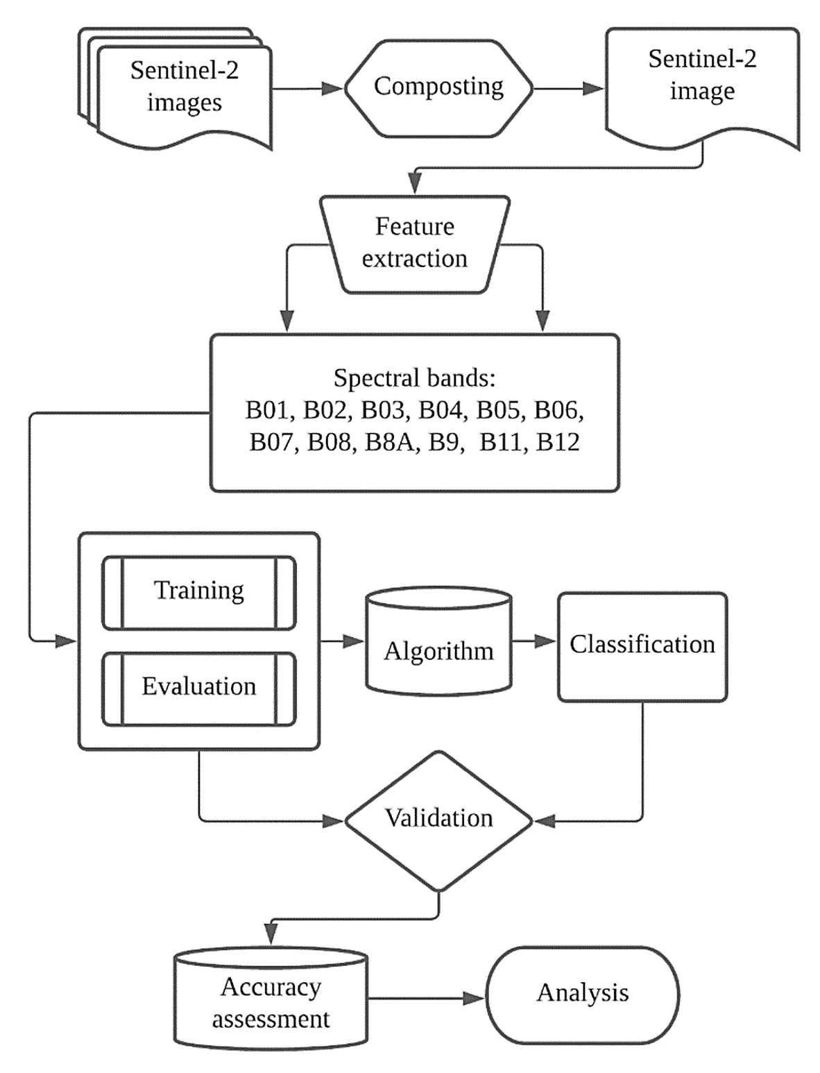

Figure 3.11: The decision tree and operating principles of the LGBM model [70].

## 3.6 PERFORMANCE EVALUATION OF THE ML ALGORITHMS USED IN THIS WORK

To assess and examine the performance, reliability, effectiveness, and trustworthiness associated with the four ML algorithms implemented in this master’s thesis, some examination metrics and evaluation approaches were applied and adopted in this study. The main performance evaluation methods employed are:

1. Accuracy of the Training Process,
2. Accuracy of the Testing Phase.

The accuracy of ML algorithms can be evaluated depending on a mathematical formula, which can be expressed by:

|  |  |
| --- | --- |
| $$Accuracy= \frac{(TP+TN)}{(TP+TN+FP+FN)}×100\%$$ | (3.5) |

Where:

|  |  |  |
| --- | --- | --- |
| $$TP$$ | : | True Positives |
| $$TN$$ | : | True Negatives |
| $$FP$$ | : | False Positives |
| $$FN$$ | : | False Negatives |

## 3.7 CHAPTER SUMMARY

Chapter three presented crucial facts and essential characteristics relating to the intelligent ML algorithms implemented in this work, as discussed and shown in the preceding paragraphs. This chapter also provided a thorough demonstration alongside some weighty mathematical formulas for describing such algorithms. Additionally, a number of assessment methods and evaluation metrics were outlined, along with an explanation of their interrelationships. These evaluation methods were used to evaluate the efficacy and performance of the ML algorithms employed for this master’s thesis. In the following chapter, the preliminary numerical results obtained from the research are described and illustrated after mathematical simulations, numerical analysis, and a custom-written Python program are conducted.

# 4. RESULTS AND DISCUSSIONS

## 4.1 CHAPTER GOAL

This chapter represents the significant findings and vital outputs attained from the processing and analysis of the numerical code developed in the third chapter to explore and examine the practical contributions and relevant impacts of the four ML models in detecting faults and outage events based on the dataset definition.

## 4.2 NUMERICAL SIMULATION OUTPUTS OF THE FIRST MODEL (GBC)

According to the mathematical analysis conducted in this work, the processing of the simulation procedure was achieved with a numeric code, which is indicated in Figure 4.1.

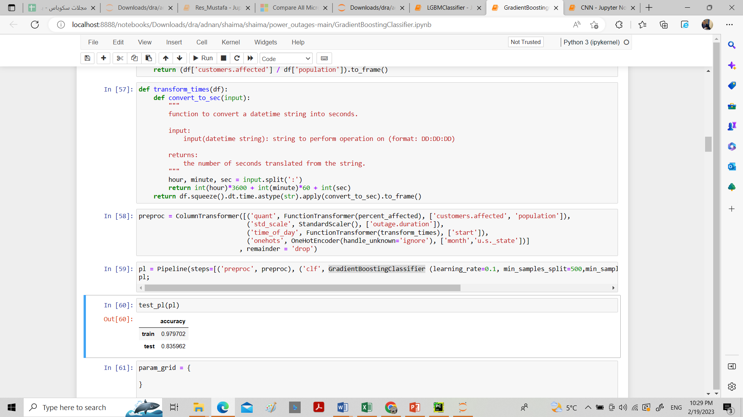

Figure 4.1: The numeric code employed to conduct performance evaluation associated with the GBC model related to training and testing processes.

The performance evaluation associated with accuracy findings related to the training and testing processes of the first model (GBC model) can be represented in Table 4.1.

Table 4.1: The numerical findings of the accuracy evaluation of GBC training and testing processes.

|  |  |  |
| --- | --- | --- |
| No. | Type of Process | Rate of Accuracy (%) |
| 1 | Training of the GBC Model | 97.97% |
| 2 | Testing of the GBC Model | 83.59% |

It can be inferred from the numerical simulation findings associated with the accuracy and performance evaluation pertaining to the training and testing processes of the intelligent GBC algorithm that the precision of the GBC-Training was significantly considerable compared with the accuracy proportion of the testing phase linked to the GBC model. A more graphical illustration related to the evaluation metrics of the first ML algorithm can be shown in Figure 4.2.

Figure 4.2: The examination metrics of the GBC model related to the accuracy.

The following paragraphs will provide more clarification on the accuracy rates of other algorithms.

## 4.3 NUMERICAL SIMULATION OUTPUTS OF THE SECOND MODEL (MGBC)

Referring to the mathematical analysis executed in this research, the processing of the simulation procedure was achieved with a numeric code, which is indicated in Figure 4.3.

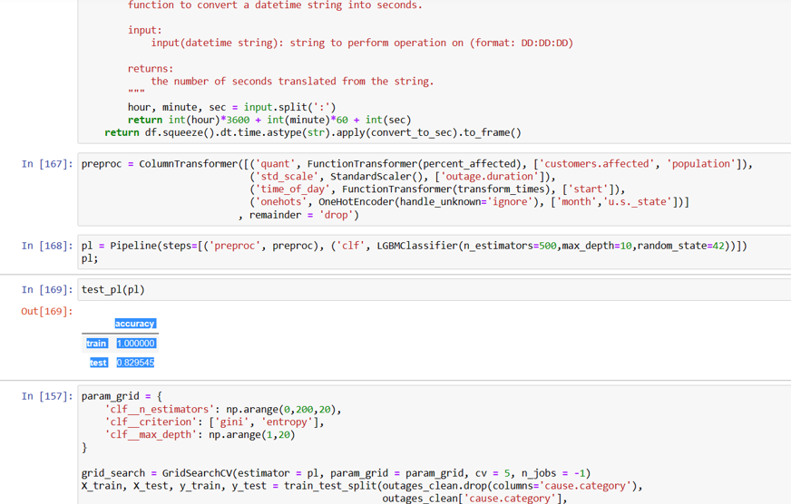

Figure 4.3: The numeric code employed to conduct performance evaluation associated with the MGBC model related to training and testing processes.

The performance assessment regarding the precision results linked to the training and testing phases of the second scheme (MGBC model) can be represented in Table 4.2.

Table 4.2: The numerical findings of the accuracy evaluation of MGBC training and testing processes.

|  |  |  |
| --- | --- | --- |
| No. | Type of Process | Rate of Accuracy (%) |
| 1 | Training of the MGBC Scheme | 97.97% |
| 2 | Testing of the MGBC Scheme | 83.60% |

It can be concluded from the numerical simulation outputs related to the accuracy examination of the training and testing phases associated with the intelligent MGBC scheme that the precision of the MGBC-Training was remarkably more considerable than the accuracy proportion of the testing phase linked to the MGBC model. A clear graphical representation linked to the evaluation metrics of the second ML algorithm can be indicated in Figure 4.4.

Figure 4.4: The examination metrics of the MGBC scheme associated with the accuracy.

## 4.4 NUMERICAL SIMULATION OUTPUTS OF THE THIRD MODEL (LGBM CLASSIFIER)

Depending on the simulation analysis and processing of the numeric code related to the third ML algorithm, which is the LGBM classifier, the results of the accuracy examination were obtained depending on the simulation code that is illustrated in Figure 4.5.

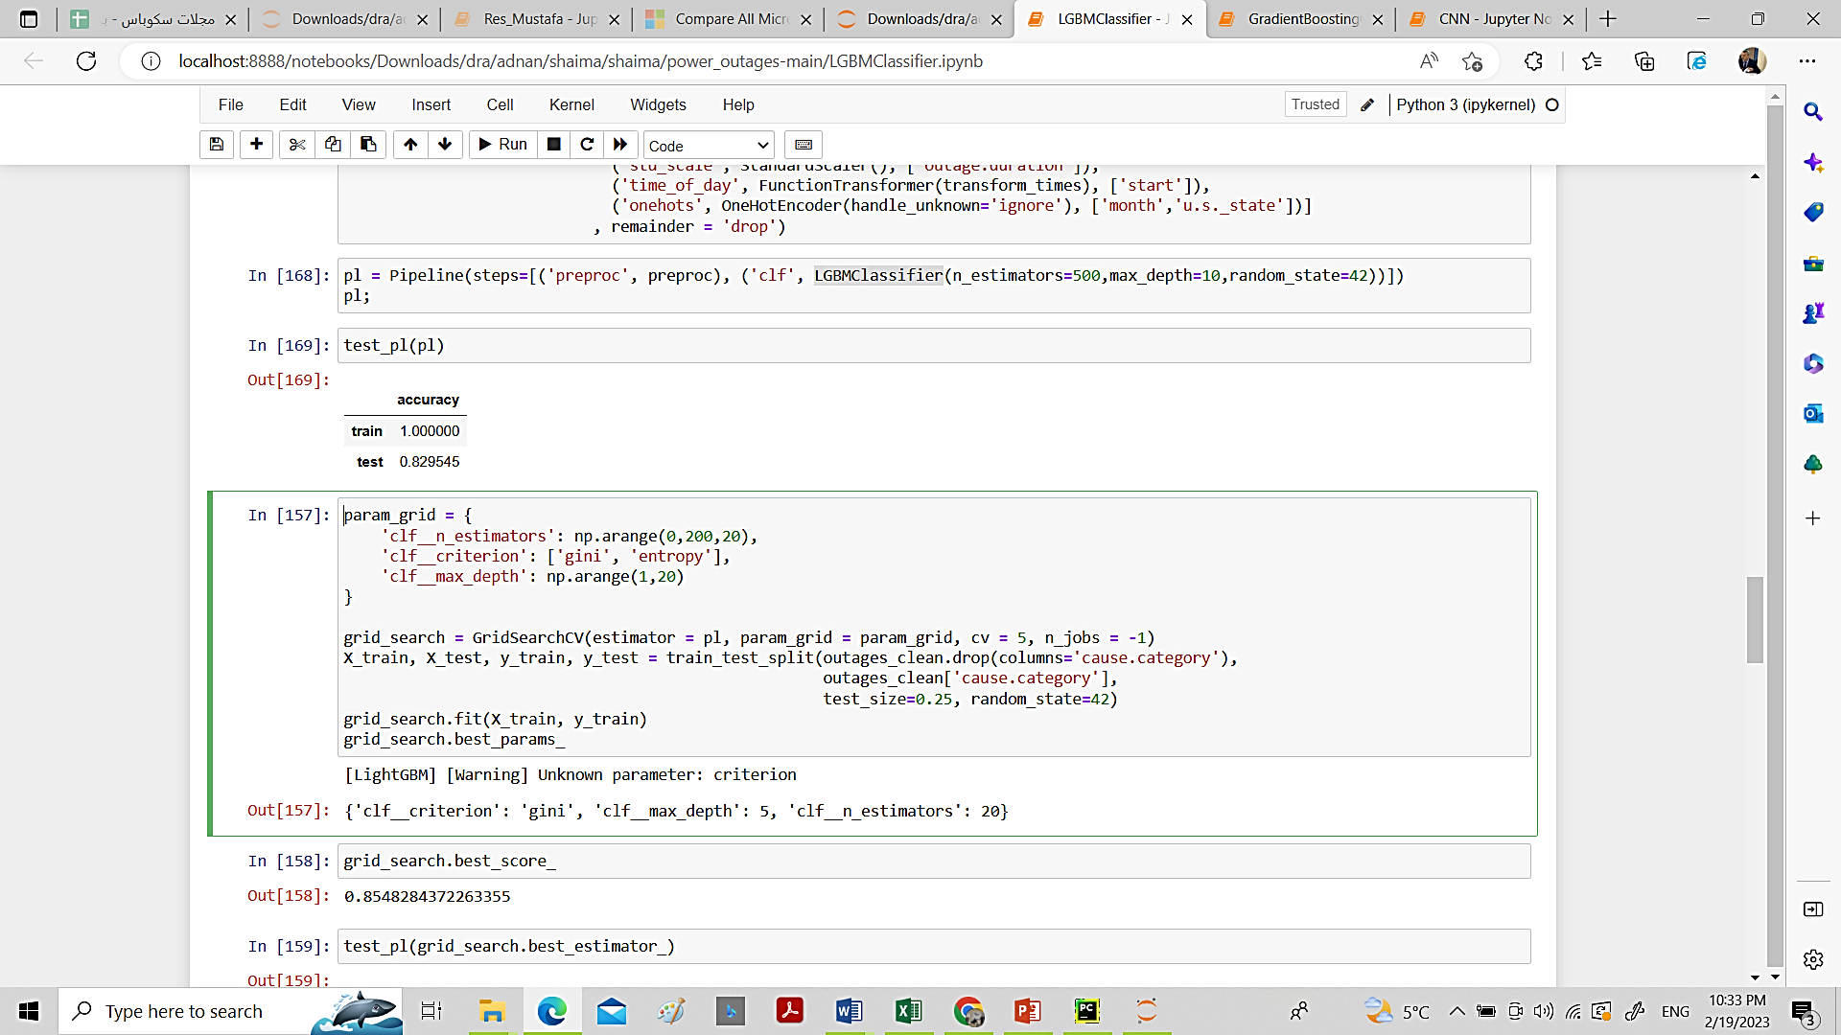

Figure 4.5: The numeric code employed to conduct the performance evaluation for the LGBM classifier related to training and testing processes.

The examination of the performance regarding the precision outputs connected with the training and testing phases of the third scheme (LGBM classifier) can be represented in Table 4.3.

Table 4.3: The numerical findings of the accuracy evaluation of LGBM classifier training and testing processes.

|  |  |  |
| --- | --- | --- |
| No. | Type of Process | Rate of Accuracy (%) |
| 1 | Training of the LGBM Classifier | 100.00% |
| 2 | Testing of the LGBM Classifier | 82.95% |

It can be concluded from the numerical simulation outputs related to the accuracy examination of the training and testing phases associated with the intelligent LGBM classifier that the precision of the LGBM classifier-Training was remarkably more robust than the accuracy ratio of the testing phase linked to the LGBM classifier. A coherent graphical representation related to the evaluation metrics of the third ML algorithm can be indicated in Figure 4.6.

Figure 4.6: The examination metrics of the LGBM classifier associated with the accuracy.

## 4.5 NUMERICAL SIMULATION OUTPUTS OF THE FOURTH MODEL (MLGBM Model)

In accordance with the simulation analysis and processing of the numeric code related to the fourth ML algorithm, which is the MLGBM model, the results of the accuracy examination were attained with the help of the simulation code, which can be illustrated in Figure 4.7.

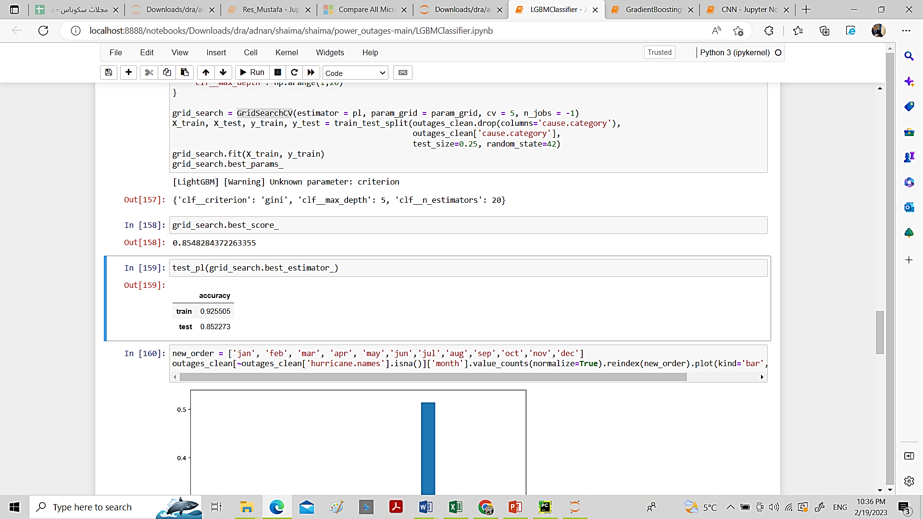

Figure 4.7: The numeric code employed to conduct the performance evaluation for the MLGBM model related to training and testing processes.

The assessment of the performance associated with the precision rates connected with the training and testing phases of the fourth scheme (MLGBM model) can be represented in Table 4.4.

Table 4.4: The numerical findings of the accuracy evaluation of LGBM classifier training and testing processes.

|  |  |  |
| --- | --- | --- |
| No. | Type of Process | Rate of Accuracy (%) |
| 1 | Training of the MLGBM Model | 92.55% |
| 2 | Testing of the MLGBM Model | 85.23% |

It can be indicated from the numerical simulation findings linked to the accuracy assessment of the training and testing phases related to the intelligent MLGBM model that the precision of the MLGBM model-Training was remarkably more robust in comparison with the accuracy ratio of the testing phase linked to the MLGBM model. A coherent graphical representation related to the evaluation metrics of the third ML algorithm can be indicated in Figure 4.8.

Figure 4.8: The examination metrics of the MLGBM model associated with the accuracy.

The following paragraphs indicate a comparative analysis between the four ML algorithms.

## 4.6 COMPARATIVE ANALYSIS BETWEEN THE FOUR EMPLOYED MODELS

To illustrate the clear variation and difference between the four ML algorithms adopted and implemented in this master’s thesis, a comparative analysis was applied to give a comprehensive summary and coherent comparison between those models in terms of their performance associated with the accuracy metric. The comparative analysis results are indicated in Table 4.5.

Table 4.5: The results of the comparative analysis between the four ML algorithms.

|  |  |  |  |
| --- | --- | --- | --- |
| No. | Type of Algorithm | Rate of Accuracy (%) of: | |
| Training | Testing |

Table 4.5: The results of the comparative analysis between the four ML algorithms. “Tables continued.”

|  |  |  |  |
| --- | --- | --- | --- |
| 1 | GBC Technique | 97.97% | 83.59% |
| 2 | MGBC Scheme | 97.97% | 83.60% |
| 3 | LGBM Classifier | 100.00% | 82.95% |
| 4 | MLGBM Model | 92.55% | 85.23% |

It can be deduced from the numerical findings attained from the comparative analysis that the best ML algorithm that provided the best performance in detecting faults, outage events, and electric problems in high-voltage power transmission networks was the LGBM classifier in the training process, corresponding to an accuracy ratio of 100.00%. However, the training process does not reflect the actual performance and reliability of the ML algorithms. Therefore, the testing process can be employed. In this context, the best algorithm for accurately predicting electrical faults in the power transmission networks can be considered the MLGBM model due to the highest accuracy rate (85.23%) compared with the other three ML algorithms used in this work. A graphical representation that clarifies the comparative analysis outputs can be shown in Figure 4.9.

Figure 4.9: The comparative analysis results between the four ML algorithms implemented in this thesis.

## 4.7 DISCUSSIONS

The simulation outputs and mathematical work revealed that ML algorithms could be used with higher degrees of reliability and trustworthiness because of their effective rates of accuracy achieved in identifying the categories of electrical faults and outages. In addition, it was found that the LGBM classifier offered the most considerable accuracy proportion (100.00%). But this value was attained in the training phase. And training process provides no active or actual comparative data regarding the effectiveness of ML algorithms in making a high-performance prediction. Thus, the testing process was done similarly for the four ML algorithms, and it was discovered that the MLGBM model gave the highest accuracy levels, corresponding to a value of 85.23%. Also, the maximum and minimum amounts of accuracy percentages in the training process ranged between 100.00% and 92.55%, corresponding to the LGBM classifier and MLGBM model, respectively. At the same time, the maximum and minimum rates of accuracy associated with the testing phases recorded were 85.23% and 82.95%, knowing that the largest ratio was for the MLGBM model. In comparison, the smallest proportion was for the LGBM classifier. This indicates that the testing results gave oppositive findings to the training phase. The results of this work are consistent with the results of [65], [71]–[74], those who conducted an analysis investigating the accuracy of gradient-boosting algorithms and modified gradient-boosting models in predicting electrical faults with significant rates of accuracy. They found that using gradient boosting schemes that operate depending on ensemble methods, ML approaches, and DT techniques play a critical role in achieving substantial levels of enhancements and effectiveness in predicting electrical faults of power networks.

# 5. CONCLUSIONS AND RECOMMENDATIONS

## 5.1 CHAPTER GOAL

After the research results are illustrated and identified in the fourth chapter, this chapter is designed and written to indicate some critical aspects and ideas that summarize the primary research findings of the numerical simulations carried out in this master’s thesis. Also, recommendations are proposed to help decision-makers and computer engineers adopt ML principles for different real-life applications.

## 5.2 CONCLUSIONS

This work is conducted to examine and evaluate the critical roles and vital relevances of ML algorithms in executing active and practical predictions of electrical faults, outages, threats, and other types of problems in high-voltage power transmission networks. Based on the numerical simulations and mathematical work related to four ML algorithms (Gradient Boosting Classifier (GBC), modified GBC, Light GBC (LGBC), and modified LGBC), the numerical research findings can be summarized in the following points:

1. The LGBM classifier offered the most considerable accuracy proportion (100.00%). But this value was attained in the training phase. And training process provides no actual comparative data regarding the effectiveness of ML algorithms in making a high-performance prediction.
2. The MLGBM model gave the highest accuracy levels, corresponding to a value of 85.23%.
3. The maximum and minimum amounts of accuracy percentages in the training process ranged between 100.00% and 92.55%, corresponding to the LGBM classifier and MLGBM model, respectively.
4. The maximum and minimum rates of accuracy associated with the testing phases recorded were 85.23% and 82.95%, knowing that the largest ratio was for the MLGBM model.
5. The smallest proportion was for the LGBM classifier. This indicates that the testing results gave oppositive findings to the training phase.

## 5.3 RECOMMENDATIONS

In accordance with the numerical research findings obtained from this master’s thesis, this work proposes a number of critical suggestions and vital ideas that could foster the adoption of ML techniques in predicting faults in high-voltage power transmission grids. Those recommendaitons are:

1. To carry out training sessions for computer engineers and junior labor force to learn different vital principles of ML techniques in making accurate predictions,
2. To encourage electrical power plants, electrical networks, and high-voltage power transmission experts to use intelligent ML concepts and ML models to detect and identify faults and outages effe3ctviely and flexibly.

# REFERENCES

[1] C. M. Coman, A. Florescu, and C. D. Oancea, “Improving the Efficiency and Sustainability of Power Systems Using Distributed Power Factor Correction Methods,” *Sustainability*, vol. 12, no. 8, p. 3134, Apr. 2020, doi: 10.3390/su12083134.

[2] K. Wahab, M. Rahal, and R. Achkar, “Economic Improvement of Power Factor Correction: A Case Study,” *Journal of Power and Energy Engineering*, vol. 09, no. 06, pp. 1–11, 2021, doi: 10.4236/jpee.2021.96001.

[3] M. Dehghani *et al.*, “Blockchain-Based Securing of Data Exchange in a Power Transmission System Considering Congestion Management and Social Welfare,” *Sustainability*, vol. 13, no. 1, p. 90, Dec. 2020, doi: 10.3390/su13010090.

[4] A. B. Alhassan, X. Zhang, H. Shen, and H. Xu, “Power transmission line inspection robots: A review, trends and challenges for future research,” *International Journal of Electrical Power & Energy Systems*, vol. 118, p. 105862, Jun. 2020, doi: 10.1016/j.ijepes.2020.105862.

[5] T. Kimoto and H. Watanabe, “Defect engineering in SiC technology for high-voltage power devices,” *Applied Physics Express*, vol. 13, no. 12, p. 120101, Dec. 2020, doi: 10.35848/1882-0786/abc787.

[6] G. Mazzanti, “The Effects of Seasonal Factors on Life and Reliability of High Voltage AC Cables Subjected to Load Cycles,” *IEEE Transactions on Power Delivery*, vol. 35, no. 4, pp. 2080–2088, Aug. 2020, doi: 10.1109/TPWRD.2019.2960618.

[7] J.-R. Roussel, A. Achim, and D. Auty, “Classification of high-voltage power line structures in low density ALS data acquired over broad non-urban areas,” *PeerJ Comput Sci*, vol. 7, p. e672, Aug. 2021, doi: 10.7717/peerj-cs.672.

[8] Electrical MCQ, “Problems Of EHV Transmission Lines,” *Power System*, Nov. 06, 2021. https://www.electricalmcqs.com/2021/11/problems-of-ehv-transmission-lines.html (accessed Jan. 02, 2023).

[9] ElectraNet, “ElectraNet owns and operates high-voltage transmission lines and cables that transport electricity over long distances to where it is needed.,” *South Australian transmission structures and voltages.*, 2023.

[10] B. Sarkar, M. Tayyab, and S.-B. Choi, “Product Channeling in an O2O Supply Chain Management as Power Transmission in Electric Power Distribution Systems,” *Mathematics*, vol. 7, no. 1, p. 4, Dec. 2018, doi: 10.3390/math7010004.

[11] Z. Sadeghi, M. Shahparasti, A. Rajaei, and H. Laaksonen, “Three-Level Reduced Switch AC/DC/AC Power Conversion System for High Voltage Electric Vehicles,” *Sustainability*, vol. 14, no. 3, p. 1620, Jan. 2022, doi: 10.3390/su14031620.

[12] N. Mohd Zainuddin *et al.*, “Review of Thermal Stress and Condition Monitoring Technologies for Overhead Transmission Lines: Issues and Challenges,” *IEEE Access*, vol. 8, pp. 120053–120081, 2020, doi: 10.1109/ACCESS.2020.3004578.

[13] M. P. Hajiabbas and B. Mohammadi-Ivatloo, *Optimization of Power System Problems: Methods, Algorithms and MATLAB Codes*, vol. 262. Germany: Springer Nature, 2020.

[14] A. Elnozahy, K. Sayed, and M. Bahyeldin, “Artificial Neural Network Based Fault Classification and Location for Transmission Lines,” in *2019 IEEE Conference on Power Electronics and Renewable Energy (CPERE)*, Oct. 2019, pp. 140–144. doi: 10.1109/CPERE45374.2019.8980173.

[15] O. A. Alamu, D. A. Pandya, O. Warner, and I. Debacker, “ESP Data Analytics: Use of Deep Autoencoders for Intelligent Surveillance of Electric Submersible Pumps,” in *Day 1 Mon, May 04, 2020*, May 2020. doi: 10.4043/30468-MS.

[16] D. Rosch, S. Ruhe, K. Schafer, and S. Nicolai, “Local anomaly detection analysis in distribution grid based on IEC 61850-9-2 LE SV voltage signals,” in *2019 International Conference on Smart Energy Systems and Technologies (SEST)*, Sep. 2019, pp. 1–6. doi: 10.1109/SEST.2019.8849139.

[17] Y. Zhang, X. Shi, H. Zhang, Y. Cao, and V. Terzija, “Review on deep learning applications in frequency analysis and control of modern power system,” *International Journal of Electrical Power & Energy Systems*, vol. 136, p. 107744, Mar. 2022, doi: 10.1016/j.ijepes.2021.107744.

[18] R. Vaish, U. D. Dwivedi, S. Tewari, and S. M. Tripathi, “Machine learning applications in power system fault diagnosis: Research advancements and perspectives,” *Eng Appl Artif Intell*, vol. 106, p. 104504, Nov. 2021, doi: 10.1016/j.engappai.2021.104504.

[19] O. AlShorman *et al.*, “A Review of Artificial Intelligence Methods for Condition Monitoring and Fault Diagnosis of Rolling Element Bearings for Induction Motor,” *Shock and Vibration*, vol. 2020, pp. 1–20, Nov. 2020, doi: 10.1155/2020/8843759.

[20] G. S. Naganathan, M. Senthilkumar, S. Aiswariya, S. Muthulakshmi, G. Santhiya Riyasen, and M. Mamtha Priyadharshini, “Internal fault diagnosis of power transformer using artificial neural network,” *Mater Today Proc*, Mar. 2021, doi: 10.1016/j.matpr.2021.02.206.

[21] R.-A. Tirnovan and M. Cristea, “Advanced techniques for fault detection and classification in electrical power transmission systems: An overview,” in *2019 8th International Conference on Modern Power Systems (MPS)*, May 2019, pp. 1–10. doi: 10.1109/MPS.2019.8759695.

[22] S. Y. Wong, C. W. C. Choe, H. H. Goh, Y. W. Low, D. Y. S. Cheah, and C. Pang, “Power Transmission Line Fault Detection and Diagnosis Based on Artificial Intelligence Approach and its Development in UAV: A Review,” *Arab J Sci Eng*, vol. 46, no. 10, pp. 9305–9331, Oct. 2021, doi: 10.1007/s13369-021-05522-w.

[23] S. Belagoune, N. Bali, A. Bakdi, B. Baadji, and K. Atif, “Deep learning through LSTM classification and regression for transmission line fault detection, diagnosis and location in large-scale multi-machine power systems,” *Measurement*, vol. 177, p. 109330, Jun. 2021, doi: 10.1016/j.measurement.2021.109330.

[24] S. Chan, I. Oktavianti, V. Puspita, and P. Nopphawan, “Convolutional Adversarial Neural Network (CANN) for Fault Diagnosis within a Power System : Addressing the Challenge of Event Correlation for Diagnosis by Power Disturbance Monitoring Equipment in a Smart Grid,” in *2019 International Conference on Information and Communications Technology (ICOIACT)*, Jul. 2019, pp. 596–601. doi: 10.1109/ICOIACT46704.2019.8938444.

[25] A. Mellit, “Recent Applications of Artificial Intelligence in Fault Diagnosis of Photovoltaic Systems,” 2020, pp. 257–271. doi: 10.1007/978-3-030-43473-1_13.

[26] P. R. Kale, K. A. Dongre, and M. Ahmad, “Machine Learning Approaches in Power System Protection: A Review,” 2021, pp. 707–715. doi: 10.1007/978-981-33-6307-6_73.

[27] J. Hu, Z. Liu, J. Chen, W. Hu, Z. Zhang, and Z. Chen, “A novel deep learning–based fault diagnosis algorithm for preventing protection malfunction,” *International Journal of Electrical Power & Energy Systems*, vol. 144, p. 108622, Jan. 2023, doi: 10.1016/j.ijepes.2022.108622.

[28] A. Muhammad, J. M. Lee, S. W. Hong, S. J. Lee, and E. H. Lee, “Deep Learning Application in Power System with a Case Study on Solar Irradiation Forecasting,” in *2019 International Conference on Artificial Intelligence in Information and Communication (ICAIIC)*, Feb. 2019, pp. 275–279. doi: 10.1109/ICAIIC.2019.8668969.

[29] A. K. Ozcanli, F. Yaprakdal, and M. Baysal, “Deep learning methods and applications for electrical power systems: A comprehensive review,” *Int J Energy Res*, vol. 44, no. 9, pp. 7136–7157, Jul. 2020, doi: 10.1002/er.5331.

[30] O. AlShorman *et al.*, “A Review of Artificial Intelligence Methods for Condition Monitoring and Fault Diagnosis of Rolling Element Bearings for Induction Motor,” *Shock and Vibration*, vol. 2020, pp. 1–20, Nov. 2020, doi: 10.1155/2020/8843759.

[31] M. Khanafer and S. Shirmohammadi, “Applied AI in instrumentation and measurement: The deep learning revolution,” *IEEE Instrum Meas Mag*, vol. 23, no. 6, pp. 10–17, Sep. 2020, doi: 10.1109/MIM.2020.9200875.

[32] Y. E. Karabacak, N. Gürsel Özmen, and L. Gümüşel, “Intelligent worm gearbox fault diagnosis under various working conditions using vibration, sound and thermal features,” *Applied Acoustics*, vol. 186, p. 108463, Jan. 2022, doi: 10.1016/j.apacoust.2021.108463.

[33] M. Jalayer, C. Orsenigo, and C. Vercellis, “Fault detection and diagnosis for rotating machinery: A model based on convolutional LSTM, Fast Fourier and continuous wavelet transforms,” *Comput Ind*, vol. 125, p. 103378, Feb. 2021, doi: 10.1016/j.compind.2020.103378.

[34] A. Mukherjee, P. K. Kundu, and A. Das, “Transmission Line Faults in Power System and the Different Algorithms for Identification, Classification and Localization: A Brief Review of Methods,” *Journal of The Institution of Engineers (India): Series B*, vol. 102, no. 4, pp. 855–877, Aug. 2021, doi: 10.1007/s40031-020-00530-0.

[35] S. Esakimuthu Pandarakone, Y. Mizuno, and H. Nakamura, “A Comparative Study between Machine Learning Algorithm and Artificial Intelligence Neural Network in Detecting Minor Bearing Fault of Induction Motors,” *Energies (Basel)*, vol. 12, no. 11, p. 2105, Jun. 2019, doi: 10.3390/en12112105.

[36] A. Raza, A. Benrabah, T. Alquthami, and M. Akmal, “A Review of Fault Diagnosing Methods in Power Transmission Systems,” *Applied Sciences*, vol. 10, no. 4, p. 1312, Feb. 2020, doi: 10.3390/app10041312.

[37] E. Aker, M. L. Othman, V. Veerasamy, I. bin Aris, N. I. A. Wahab, and H. Hizam, “Fault Detection and Classification of Shunt Compensated Transmission Line Using Discrete Wavelet Transform and Naive Bayes Classifier,” *Energies (Basel)*, vol. 13, no. 1, p. 243, Jan. 2020, doi: 10.3390/en13010243.

[38] H. Zhang, W. Yang, H. Yu, H. Zhang, and G.-S. Xia, “Detecting Power Lines in UAV Images with Convolutional Features and Structured Constraints,” *Remote Sens (Basel)*, vol. 11, no. 11, p. 1342, Jun. 2019, doi: 10.3390/rs11111342.

[39] P. Hou, H. Ma, and P. Ju, “Intelligent Diagnosis Method for Mechanical Faults of High-Voltage Shunt Reactors Based on Vibration Measurements,” *Machines*, vol. 10, no. 8, p. 627, Jul. 2022, doi: 10.3390/machines10080627.

[40] R. S. Jawad and H. Abid, “Fault Detection in HVDC System with Gray Wolf Optimization Algorithm Based on Artificial Neural Network,” *Energies (Basel)*, vol. 15, no. 20, p. 7775, Oct. 2022, doi: 10.3390/en15207775.

[41] V. C. Thuc and H. S. Lee, “Partial Discharge (PD) Signal Detection and Isolation on High Voltage Equipment Using Improved Complete EEMD Method,” *Energies (Basel)*, vol. 15, no. 16, p. 5819, Aug. 2022, doi: 10.3390/en15165819.

[42] Y. Wang, D. Zheng, and R. Jia, “Fault Diagnosis Method for MMC-HVDC Based on Bi-GRU Neural Network,” *Energies (Basel)*, vol. 15, no. 3, p. 994, Jan. 2022, doi: 10.3390/en15030994.

[43] Y. al Mtawa, A. Haque, and T. Halabi, “A Review and Taxonomy on Fault Analysis in Transmission Power Systems,” *Computation*, vol. 10, no. 9, p. 144, Aug. 2022, doi: 10.3390/computation10090144.

[44] Q. Wang, Y. Yu, H. O. A. Ahmed, M. Darwish, and A. K. Nandi, “Open-Circuit Fault Detection and Classification of Modular Multilevel Converters in High Voltage Direct Current Systems (MMC-HVDC) with Long Short-Term Memory (LSTM) Method,” *Sensors*, vol. 21, no. 12, p. 4159, Jun. 2021, doi: 10.3390/s21124159.

[45] M. Muniappan, “A comprehensive review of DC fault protection methods in HVDC transmission systems,” *Protection and Control of Modern Power Systems*, vol. 6, no. 1, p. 1, Dec. 2021, doi: 10.1186/s41601-020-00173-9.

[46] S. R. Fahim, S. K. Sarker, S. M. Muyeen, S. K. Das, and I. Kamwa, “A deep learning based intelligent approach in detection and classification of transmission line faults,” *International Journal of Electrical Power & Energy Systems*, vol. 133, p. 107102, Dec. 2021, doi: 10.1016/j.ijepes.2021.107102.

[47] Q. Wang, Y. Yu, H. O. A. Ahmed, M. Darwish, and A. K. Nandi, “Fault Detection and Classification in MMC-HVDC Systems Using Learning Methods,” *Sensors*, vol. 20, no. 16, p. 4438, Aug. 2020, doi: 10.3390/s20164438.

[48] J. Qi, X. Gao, and N. Huang, “Mechanical Fault Diagnosis of a High Voltage Circuit Breaker Based on High-Efficiency Time-Domain Feature Extraction with Entropy Features,” *Entropy*, vol. 22, no. 4, p. 478, Apr. 2020, doi: 10.3390/e22040478.

[49] A. Raza, A. Benrabah, T. Alquthami, and M. Akmal, “A Review of Fault Diagnosing Methods in Power Transmission Systems,” *Applied Sciences*, vol. 10, no. 4, p. 1312, Feb. 2020, doi: 10.3390/app10041312.

[50] E. Aker, M. L. Othman, V. Veerasamy, I. bin Aris, N. I. A. Wahab, and H. Hizam, “Fault Detection and Classification of Shunt Compensated Transmission Line Using Discrete Wavelet Transform and Naive Bayes Classifier,” *Energies (Basel)*, vol. 13, no. 1, p. 243, Jan. 2020, doi: 10.3390/en13010243.

[51] I. Ullah, R. U. Khan, F. Yang, and L. Wuttisittikulkij, “Deep Learning Image-Based Defect Detection in High Voltage Electrical Equipment,” *Energies (Basel)*, vol. 13, no. 2, p. 392, Jan. 2020, doi: 10.3390/en13020392.

[52] A. Vinogradov *et al.*, “Analysis of the Power Supply Restoration Time after Failures in Power Transmission Lines,” *Energies (Basel)*, vol. 13, no. 11, p. 2736, May 2020, doi: 10.3390/en13112736.

[53] J. Han *et al.*, “A Method of Insulator Faults Detection in Aerial Images for High-Voltage Transmission Lines Inspection,” *Applied Sciences*, vol. 9, no. 10, p. 2009, May 2019, doi: 10.3390/app9102009.

[54] H. Zhang, W. Yang, H. Yu, H. Zhang, and G.-S. Xia, “Detecting Power Lines in UAV Images with Convolutional Features and Structured Constraints,” *Remote Sens (Basel)*, vol. 11, no. 11, p. 1342, Jun. 2019, doi: 10.3390/rs11111342.

[55] F. Azevedo *et al.*, “LiDAR-Based Real-Time Detection and Modeling of Power Lines for Unmanned Aerial Vehicles,” *Sensors*, vol. 19, no. 8, p. 1812, Apr. 2019, doi: 10.3390/s19081812.

[56] B. Li, M. Liu, Z. Guo, and Y. Ji, “Mechanical Fault Diagnosis of High Voltage Circuit Breakers Utilizing EWT-Improved Time Frequency Entropy and Optimal GRNN Classifier,” *Entropy*, vol. 20, no. 6, p. 448, Jun. 2018, doi: 10.3390/e20060448.

[57] S. Wan, L. Chen, L. Dou, and J. Zhou, “Mechanical Fault Diagnosis of HVCBs Based on Multi-Feature Entropy Fusion and Hybrid Classifier,” *Entropy*, vol. 20, no. 11, p. 847, Nov. 2018, doi: 10.3390/e20110847.

[58] C. Chen, B. Yang, S. Song, X. Peng, and R. Huang, “Automatic Clearance Anomaly Detection for Transmission Line Corridors Utilizing UAV-Borne LIDAR Data,” *Remote Sens (Basel)*, vol. 10, no. 4, p. 613, Apr. 2018, doi: 10.3390/rs10040613.

[59] S. Ma, M. Chen, J. Wu, Y. Wang, B. Jia, and Y. Jiang, “Intelligent Fault Diagnosis of HVCB with Feature Space Optimization-Based Random Forest,” *Sensors*, vol. 18, no. 4, p. 1221, Apr. 2018, doi: 10.3390/s18041221.

[60] M. H. L. Louk and B. A. Tama, “Dual-IDS: A bagging-based gradient boosting decision tree model for network anomaly intrusion detection system,” *Expert Syst Appl*, vol. 213, p. 119030, Mar. 2023, doi: 10.1016/j.eswa.2022.119030.

[61] N. Ahmed *et al.*, “Machine learning based diabetes prediction and development of smart web application,” *International Journal of Cognitive Computing in Engineering*, vol. 2, pp. 229–241, Jun. 2021, doi: 10.1016/j.ijcce.2021.12.001.

[62] C. Zhang, Y. Zhang, X. Shi, G. Almpanidis, G. Fan, and X. Shen, “On Incremental Learning for Gradient Boosting Decision Trees,” *Neural Process Lett*, vol. 50, no. 1, pp. 957–987, Aug. 2019, doi: 10.1007/s11063-019-09999-3.

[63] M. Yao, Y. Zhu, J. Li, H. Wei, and P. He, “Research on Predicting Line Loss Rate in Low Voltage Distribution Network Based on Gradient Boosting Decision Tree,” *Energies (Basel)*, vol. 12, no. 13, p. 2522, Jun. 2019, doi: 10.3390/en12132522.

[64] J. Wang, P. Li, R. Ran, Y. Che, and Y. Zhou, “A Short-Term Photovoltaic Power Prediction Model Based on the Gradient Boost Decision Tree,” *Applied Sciences*, vol. 8, no. 5, p. 689, Apr. 2018, doi: 10.3390/app8050689.

[65] S. Rahman, M. Irfan, M. Raza, K. Moyeezullah Ghori, S. Yaqoob, and M. Awais, “Performance Analysis of Boosting Classifiers in Recognizing Activities of Daily Living,” *Int J Environ Res Public Health*, vol. 17, no. 3, p. 1082, Feb. 2020, doi: 10.3390/ijerph17031082.

[66] M. Saldanha, G. Sanchez, C. Marcon, and L. Agostini, “Configurable Fast Block Partitioning for VVC Intra Coding Using Light Gradient Boosting Machine,” *IEEE Transactions on Circuits and Systems for Video Technology*, vol. 32, no. 6, pp. 3947–3960, Jun. 2022, doi: 10.1109/TCSVT.2021.3108671.

[67] J. Nayak, B. Naik, P. B. Dash, A. Souri, and V. Shanmuganathan, “Hyper-parameter tuned light gradient boosting machine using memetic firefly algorithm for hand gesture recognition,” *Appl Soft Comput*, vol. 107, p. 107478, Aug. 2021, doi: 10.1016/j.asoc.2021.107478.

[68] A. A. Taha and S. J. Malebary, “An Intelligent Approach to Credit Card Fraud Detection Using an Optimized Light Gradient Boosting Machine,” *IEEE Access*, vol. 8, pp. 25579–25587, 2020, doi: 10.1109/ACCESS.2020.2971354.

[69] S. M. H. Mahmud *et al.*, “PreDTIs: prediction of drug–target interactions based on multiple feature information using gradient boosting framework with data balancing and feature selection techniques,” *Brief Bioinform*, vol. 22, no. 5, Sep. 2021, doi: 10.1093/bib/bbab046.

[70] D. A. McCarty, H. W. Kim, and H. K. Lee, “Evaluation of Light Gradient Boosted Machine Learning Technique in Large Scale Land Use and Land Cover Classification,” *Environments*, vol. 7, no. 10, p. 84, Oct. 2020, doi: 10.3390/environments7100084.

[71] W. Ding, Q. Chen, Y. Dong, and N. Shao, “Fault Diagnosis Method of Intelligent Substation Protection System Based on Gradient Boosting Decision Tree,” *Applied Sciences*, vol. 12, no. 18, p. 8989, Sep. 2022, doi: 10.3390/app12188989.

[72] N. Sapountzoglou, J. Lago, and B. Raison, “Fault diagnosis in low voltage smart distribution grids using gradient boosting trees,” *Electric Power Systems Research*, vol. 182, p. 106254, May 2020, doi: 10.1016/j.epsr.2020.106254.

[73] E. Aguilar Madrid and N. Antonio, “Short-Term Electricity Load Forecasting with Machine Learning,” *Information*, vol. 12, no. 2, p. 50, Jan. 2021, doi: 10.3390/info12020050.

[74] S. O. Tehrani, M. H. Y. Moghaddam, and M. Asadi, “Decision Tree based Electricity Theft Detection in Smart Grid,” in *2020 4th International Conference on Smart City, Internet of Things and Applications (SCIOT)*, Sep. 2020, pp. 46–51. doi: 10.1109/SCIOT50840.2020.9250194.

# APPENDIX A

**NUMERICAL CODE EMPLOYED IN THE SIMULATION PROCESS OF FAULT DETECTION IN THE HIGH-VOLTAGE ELECTRICAL POWER NETWORK (1: GBC Model)**

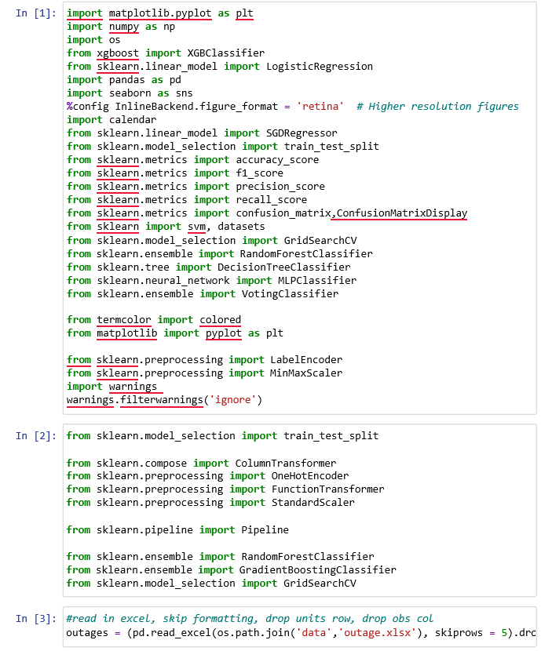

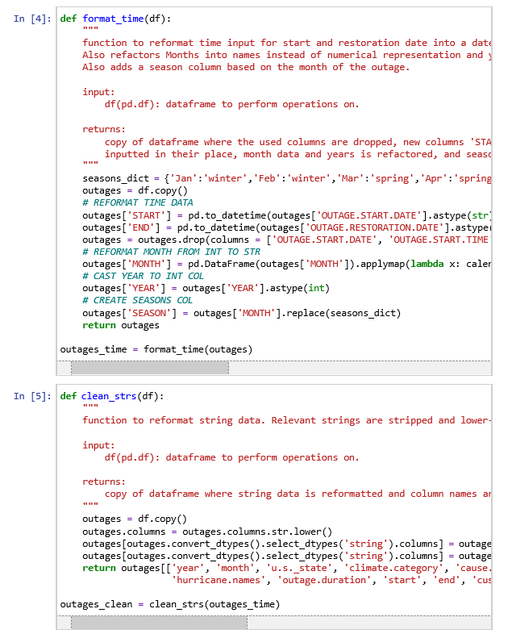

# APPENDIX B

**NUMERICAL CODE EMPLOYED IN THE SIMULATION PROCESS OF FAULT DETECTION IN THE HIGH-VOLTAGE ELECTRICAL POWER NETWORK (2: LGBM Model)**

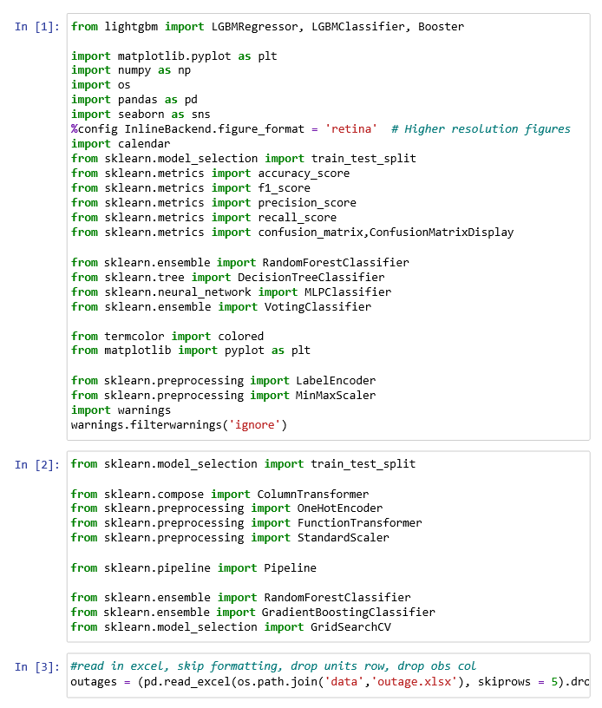

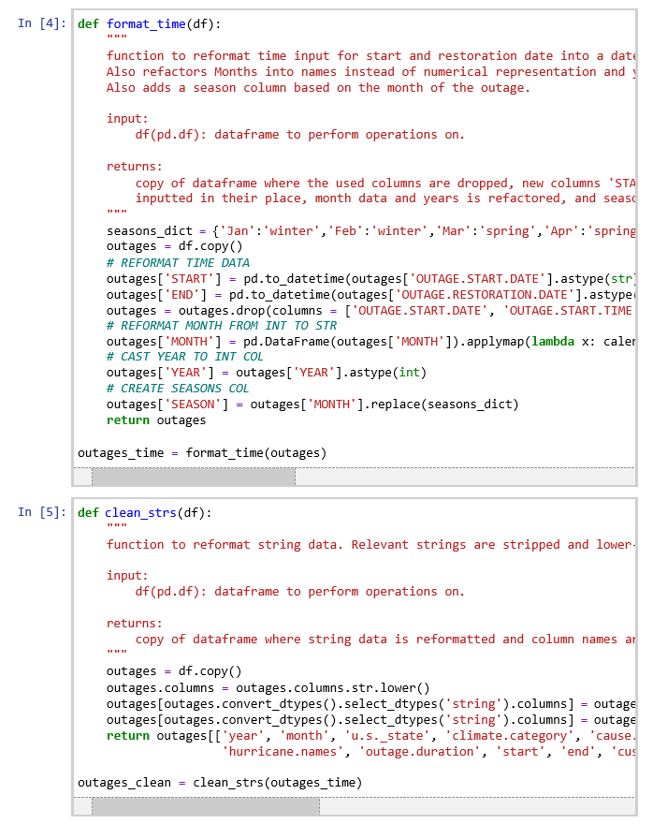

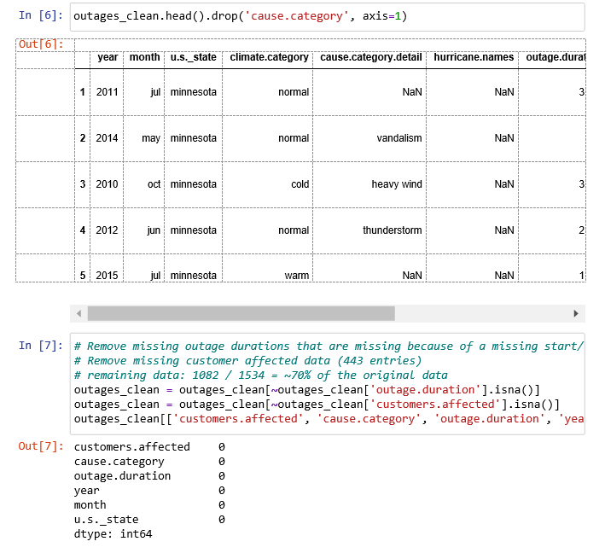

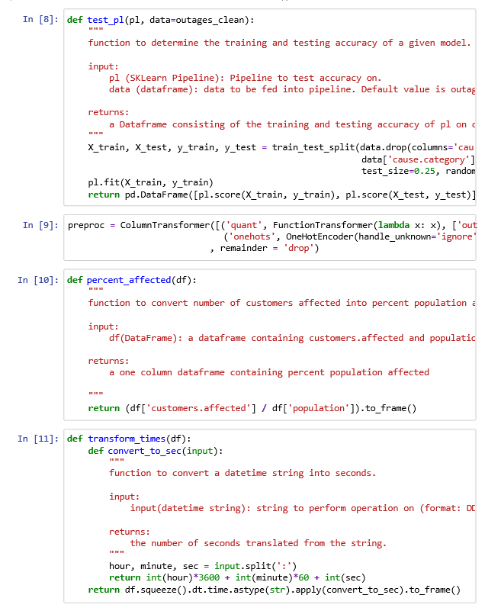

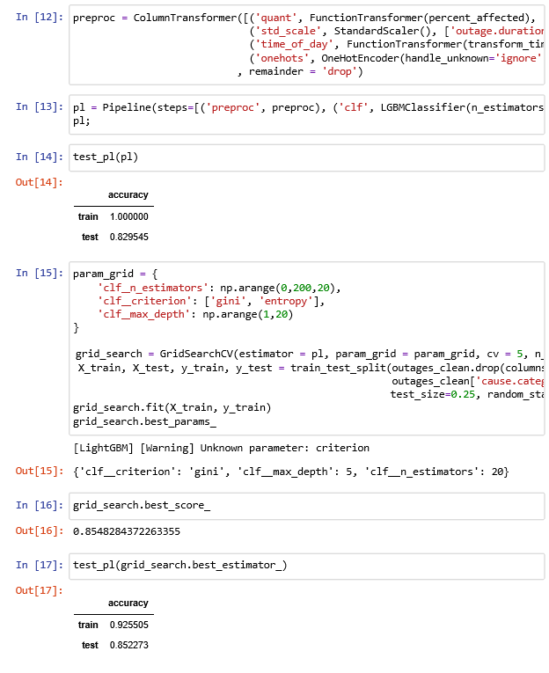

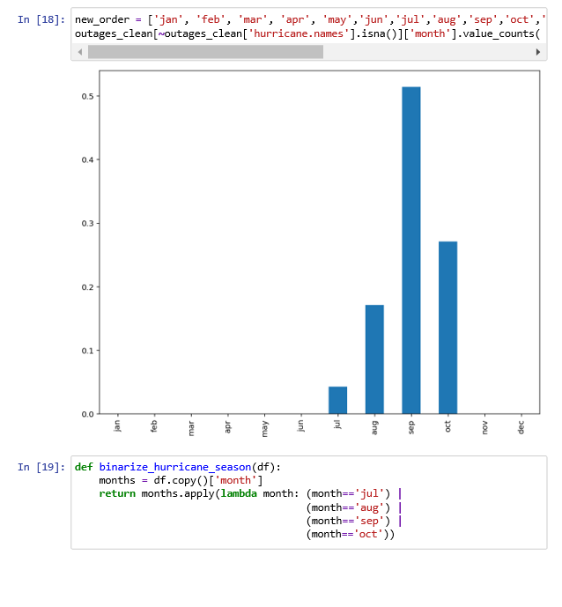

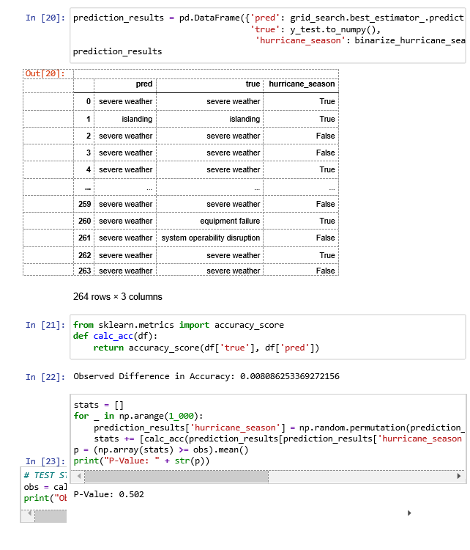

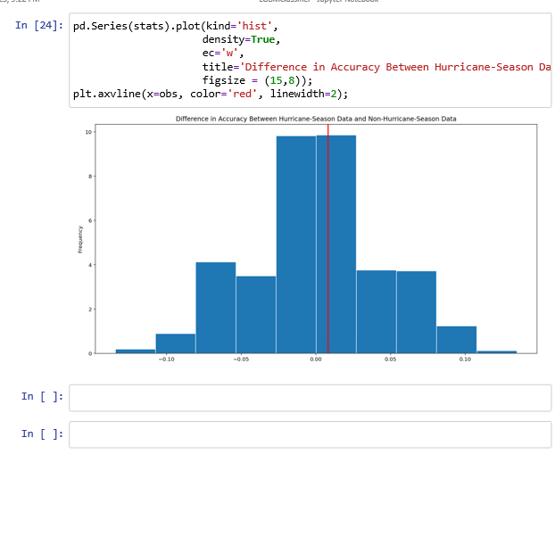

# APPENDIX C

**NUMERICAL CODE EMPLOYED IN THE SIMULATION PROCESS OF FAULT DETECTION IN THE HIGH-VOLTAGE ELECTRICAL POWER NETWORK (3: MGBC)**

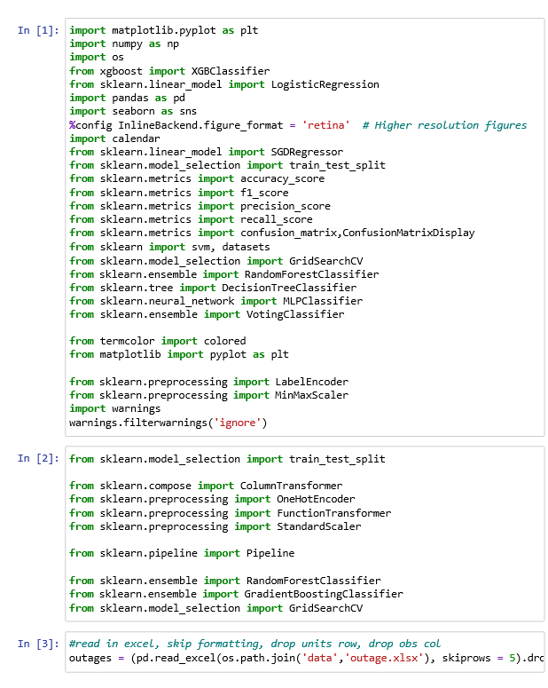

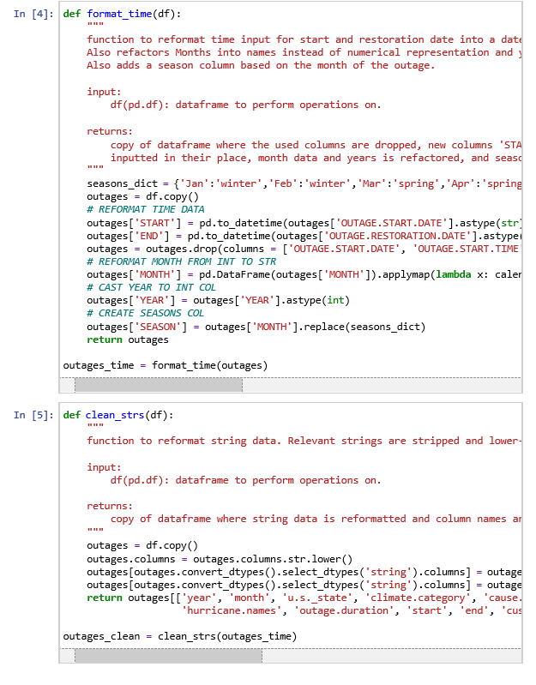

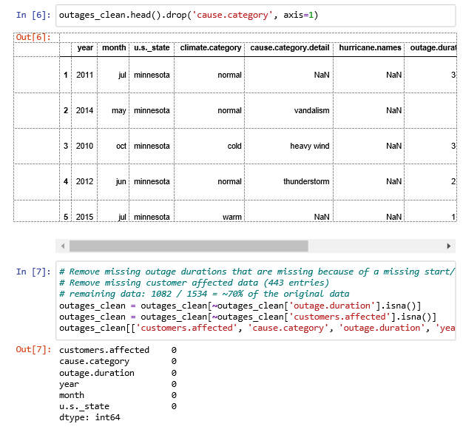

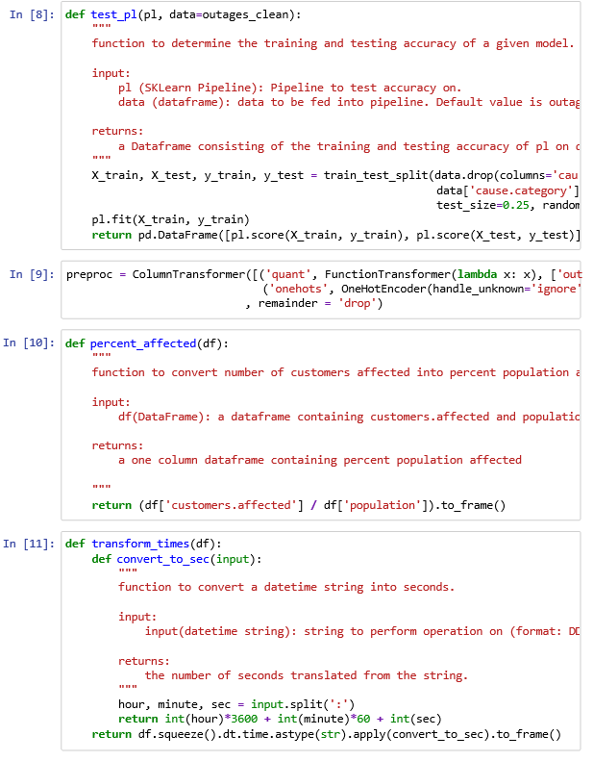

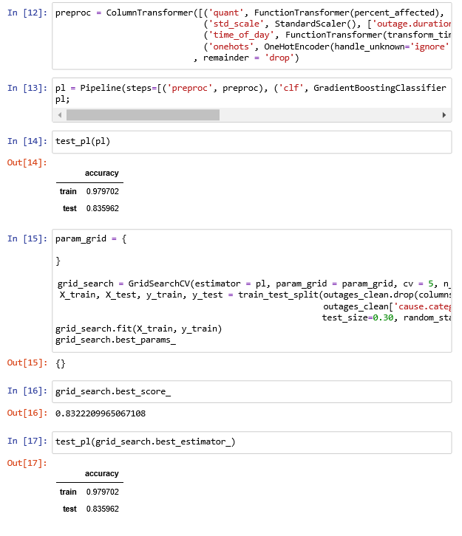

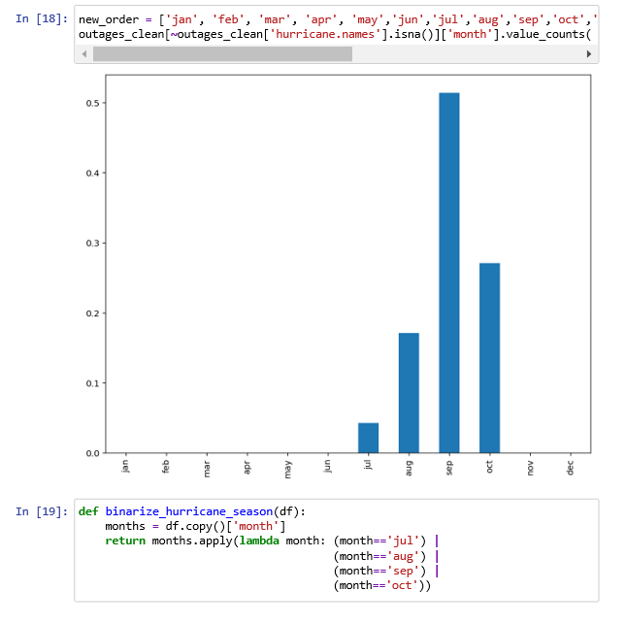

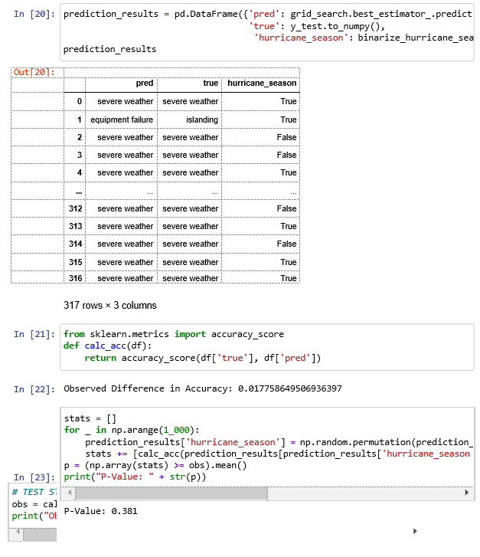

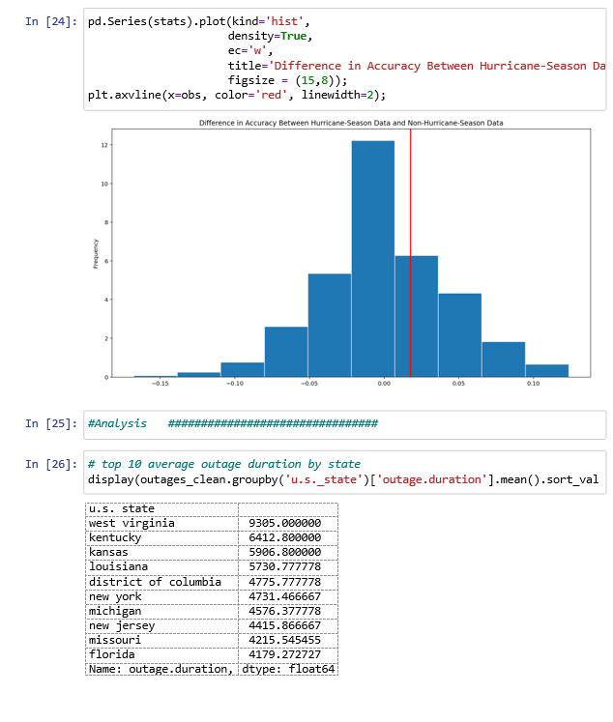

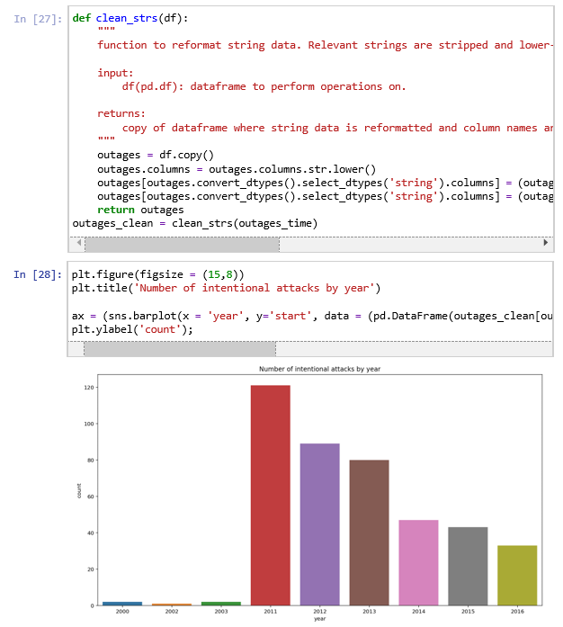

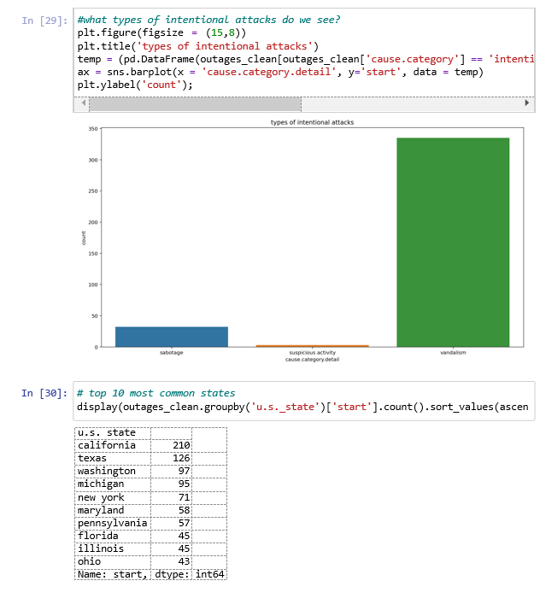

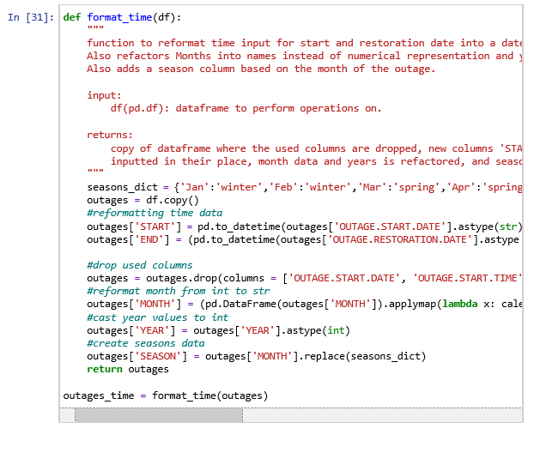

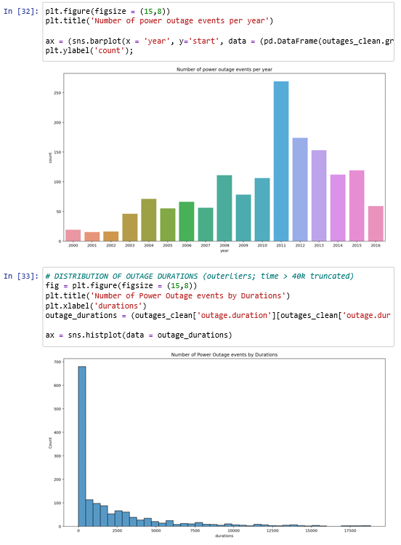

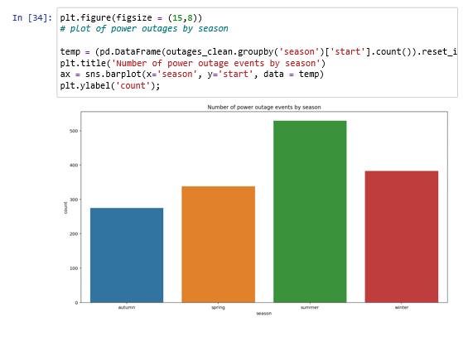

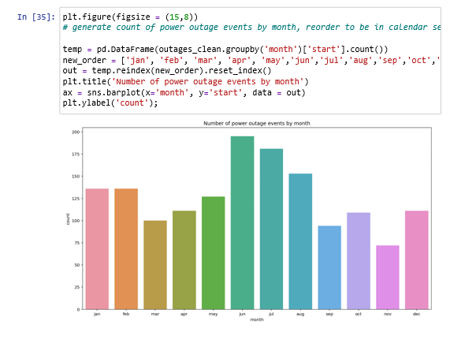

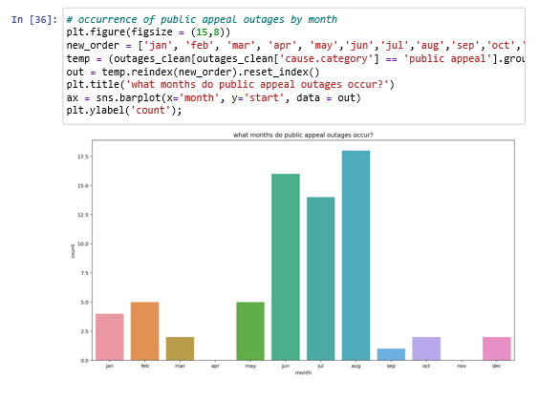

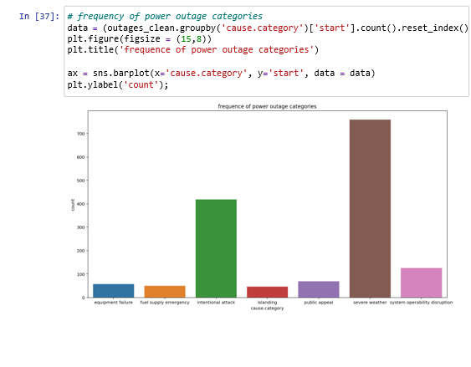

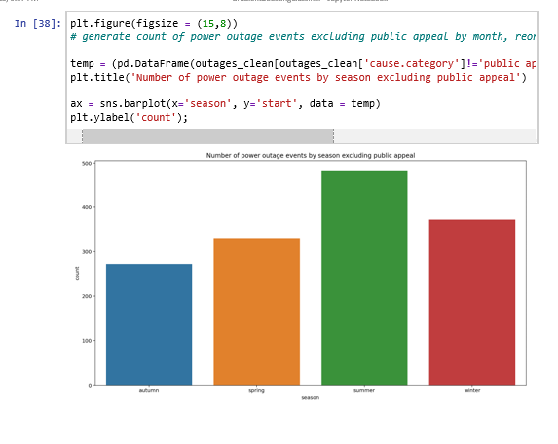

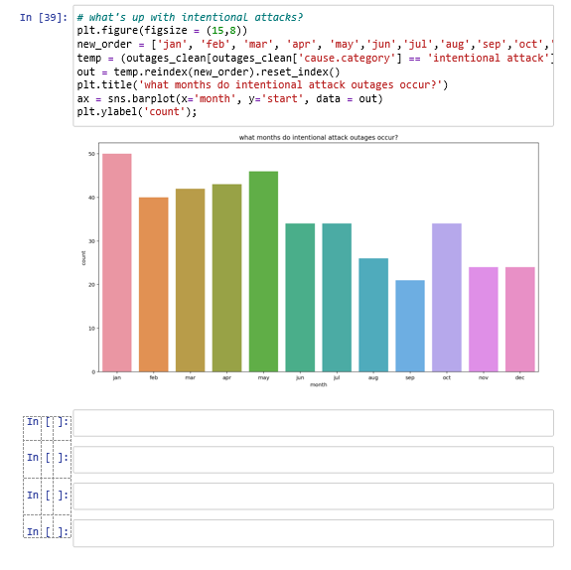

# APPENDIX D

**NUMERICAL CODE EMPLOYED IN THE SIMULATION PROCESS OF FAULT DETECTION IN THE HIGH-VOLTAGE ELECTRICAL POWER NETWORK (4: MLGBM)**



