VISUAL REPRESENTATIONS OF THE ANGELS IN ART HISTORY

Laura Sînziana CUCIUC ROMANESCU, Özlem KAYA

Assoc. Prof. Dr., Ovidius University of Constanta, Romania, Faculty of Arts, sinzianaromanescu@icloud.com, ORCID: 0000-0002-3609-2192
Assist. Prof. Dr., Hitit University, Turkey, Faculty of Fine Arts, Design and Architecture, ozlemkaya@hitit.edu.tr, ORCID: 0000-0002-8572-6577

ABSTRACT
Angel figures, which are frequently used in the art of depiction, have an important place in the history of art. Angels, who are intermediaries between God, holy persons and even humans, are winged spiritual beings who have a very important place in bringing news from God, glorifying holy persons and on the day of judgment. These beings are of great importance for religious compositions.
In particular, the depiction of angel figures in different appearances and subjects, regional differences, interactions and chronological consideration of the angel figures depicted in the history of art is a subject worth examining.
In order to find out the origin of the visual representations of angels in the history of art, which are the subject of this article, the eastern and western worlds were considered separately primarily within the framework of polytheistic belief. Later, in monotheistic belief, angels were tried to be examined with their representations reflected in both the holy books and the art of depiction. At the same time, the visual representations of angels are explained with the given examples.
Keywords: visual representations, angels, art of depiction, visual representation of angels, angels in art
Introduction
Depictions of angel figures began to be seen from the 2-3rd century and have existed in everywhere that Christianity spread until today. Angels, whose main tasks are messenger, have been conceived as beings who bring messages from God.
Angel figures have been one of the themes that artists showed the most interest in the context of different techniques and subjects. They were first pictured in the catacombs. Angel figures depicted on frescoes, wall paintings, religious buildings in mosaic technique, manuscripts, weaving, liturgical metalware and jewelry are shown singly or in groups in compositions.
The clergy and artists who want to make these invisible winged beings believable for people should have benefited from the old winged creature descriptions and the images described in the holy books (Old and New Testaments) when they wanted to give an appearance to these beings. Over time, these personifications should become permanent and become the norm.
The relationship between depiction and model is like that between the question of whether the viewer is closer to determining symbolic or literal uniqueness. In Christian art, angels are considered young and have wings. They often have an anonymous appearance and are identified only in the depiction of archangels.
Despite the metaphysical characteristics of angels, painters, mosaic artists and sculptors throughout the early Christian art portrayed angels in human form. First of all, they created an anthropomorphic iconography, since it is mentioned in the sacred texts that they show themselves as human beings. The first surviving example of an anthropomorphic angel depiction is in the Roman Catacombs of Priscilla (3rd century), who only defined God's message carrier as an angel. And the painter depicted this message bearer as a man wearing a tunic and standing firmly on earth (Cherry, 1995; Basegmez, 1989).
This study draws attention to an extremely important point in terms of shedding light on the development of angel figures, which are used extensively in the art of depiction, and in terms of determining the place of the visual representations of angel figures in the history of art. At this point, it is stated with which subjects the visual representations of angels are handled and these depictions are tried to be explained with examples.

Cherubs, Cupids and Other Angels in Art
The word angel comes from the Greek angel and means messenger, messenger of God, the one who creates a connection between heaven and earth, between man and God. Their role is to convert the abyss between God and man into a space of communication. In the Vulgate, Blessed Jerome distinguishes between nuntius and angelus. The first word refers to a messenger, to an earthly messenger, and the other to a heavenly messenger. Theodotion also calls angels by the word strategos, and the Septuagint by archon.
Biblically talking, in pre-exile polytheistic Israel, angels were perceived as deities, later in the exile and post-exilic period (6th century BC) angels were perceived as non-divine beings, subordinate to Yahweh, the only God.
The text in Deuteronomy 32: 8-9 shows that the angels would care for a nation under protection: God…"
The prophet Micah speaks of angels as part of the "heavenly host" (3 Kings 22:19). Later, in the 8th-7th centuries BC, due to the Assyrian influence, the "angelic army" is identified with the stars. In this sense, in Job 38, 6 he identifies the sons of God with the stars.
Angels appear either in non-human form (fire pear - Exodus 3, 2, cloud pillar - Exodus 14, 19–20), or in human form (at Sodom - Genesis 19, before the sorcerer Valaam - Numbers 22) or superhuman (luminous angel - Judges 6, angel with the appearance of shining brass - Ezekiel 40, 3, angel with intense brilliance - Daniel 10, 5–6).
The nature of angels was considered from the beginning above human understanding. Both Holy Scripture and the Holy Fathers have tried to describe this nature.
Theodotus, in the second century, called the angels "fire of the mind, understanding spirit" (Stählin, Früchtel, Treu, 1970)) and believed that they had a certain corporeality, different from the human one. Other theologians claimed that angels have in the composition of their nature, like the soul, equal proportions of air and fire. Macarius the Great states that angels have ineffable bodies, accepting a certain corporeality, while Gregory of Nyssa excludes any connection with the matter of the nature of angels (Grigorie of Nyssei, 1857-1866), and Gregory of the Nazis states that angels have pure spirituality (Grigorie of Nazians, 1857-1866). Along with the Cappadocian fathers, Dionysius the Areopagite and St. John of Damascus supported the absolute spirituality of the angels.
Artistic representations of angels are infinite, is we are allowed to use this word, but this paper will focus on some representative segments on this topic, basically divided between Biblical and non-Biblical representations of these Celest creatures.
Cute children with small cheeks and wings that use bows and arrows to make people fall in love may be romantic, but they are in no way related to biblical angels. Known as either cherubs or cupids, these characters are popular in art and illustration also. These cute "angels" are actually nothing like the biblical angels of the same name: cherubim. Just as falling in love can be confusing, so too is the history of how cherubs and cupbearers came to be confused with biblical angels.
Cupid represents love in ancient mythology and it is quite clear where its association with love comes from. According to ancient mythology, Cupid is the god of love in ancient Roman mythology (just like Eros in Greek mythology). Cupid was the son of Venus, the Roman goddess of love, and was often described in art as a young man with a bow, ready to shoot arrows at people to make them fall in love with others. Cupid was quite bad, if we can say so, and enjoyed playing tricks on people to play with their emotions.
During the Renaissance, artists began to expand the way they illustrated all sorts of subjects, including love and mystical ecstasy (Mare, 2008). The famous Italian painter Raphael (Emison, 2002), (Thickstun, 2001) and other artists of that time created characters called "putti" (BrézéSurname, 2014), who looked like babies or small children. These characters represented the presence of pure love around people and often have wings like angels.
Meanwhile, we can say that people began to refer to images of Putti (BrézéSurname, 2014) and Cupid as "cherubs" because of their association with the glorious feeling of being in love.
Their appearances are also completely different. While cherubs and folk art cups look like little babies, biblical cherubs appear as powerful exotic creatures with multiple faces, wings, and eyes. Cherubim and cupids are often described as floating in the clouds, but the cherubim in the Bible appear surrounded by the bright light of God's glory (Ezekiel 10: 4).
There is also a stark contrast between their serious activity. The little cherubs and cupids simply have fun playing tricks and making people feel warm and steady with their cute and playful antique. But cherubim are masters of hard love. They are accused of doing God's will, whether they like it or not.

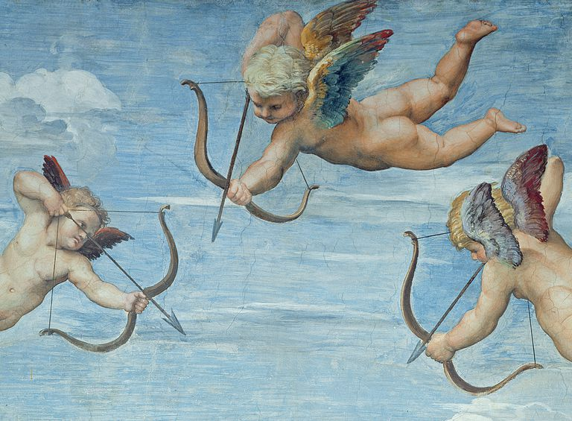
Fig.1. Cupids, The fresco 'The Triumph of Galatea' by Raphael, painted 1512-1514; source of image: https://www.learnreligions.com/cherubs-and-cupids-angels-of-love-124005.

Angelic precursor representations
We talk here about non Christian representations that, both aesthetic and symbolic, can be considered imagines of angelic-like figures in different religions and beliefs.

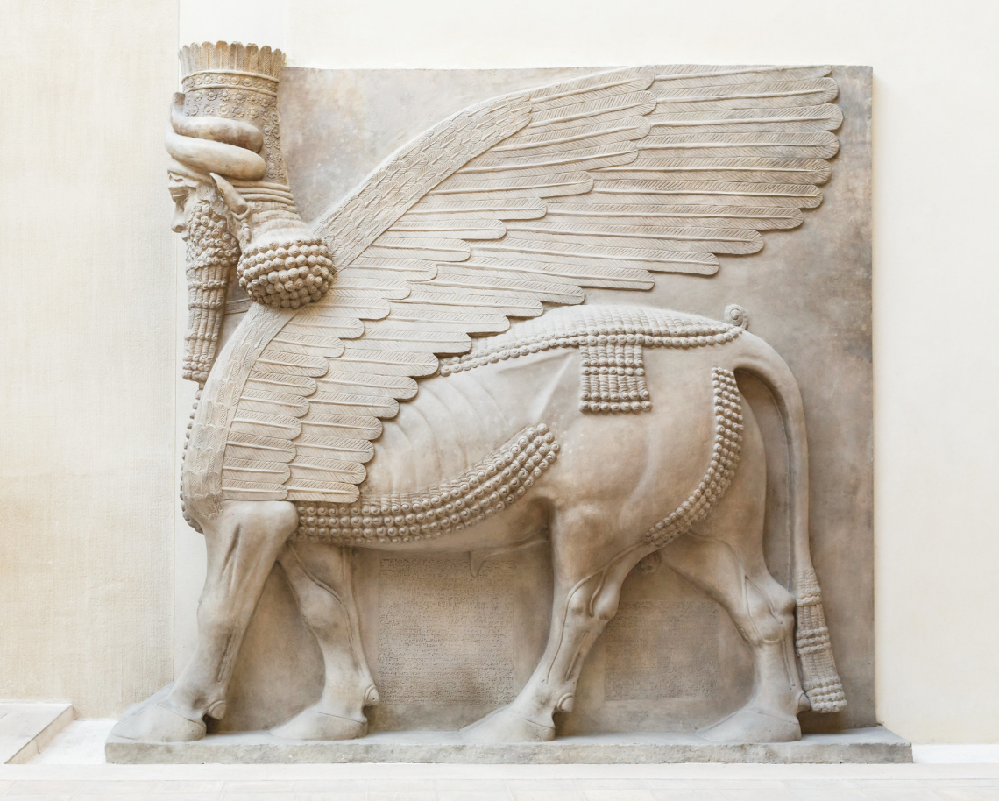
Fig.2. Lamassu (MoMA, 2006) from the Neo-Assyrian period, Reign of Sargon II (721-705 BCE) – a protective deity known as the „winged bull”, a hybrid creature; source of image: https://mymodernmet.com/angel-art-history/.

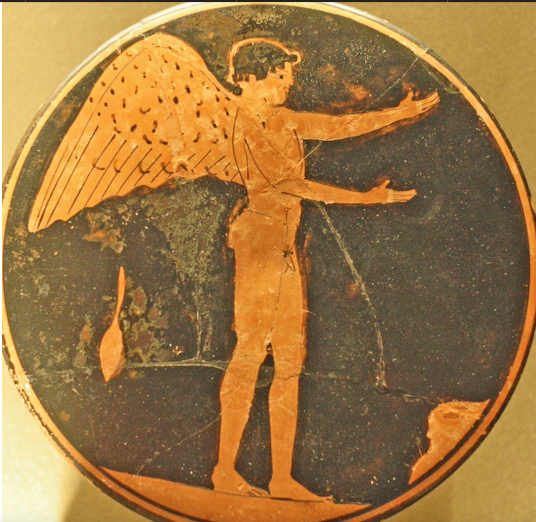
Fig.3. Eros, god of Love – Ancient Greece, c. 470 BC–450 BC; source of image: The Louvre via Wikimedia Commons.
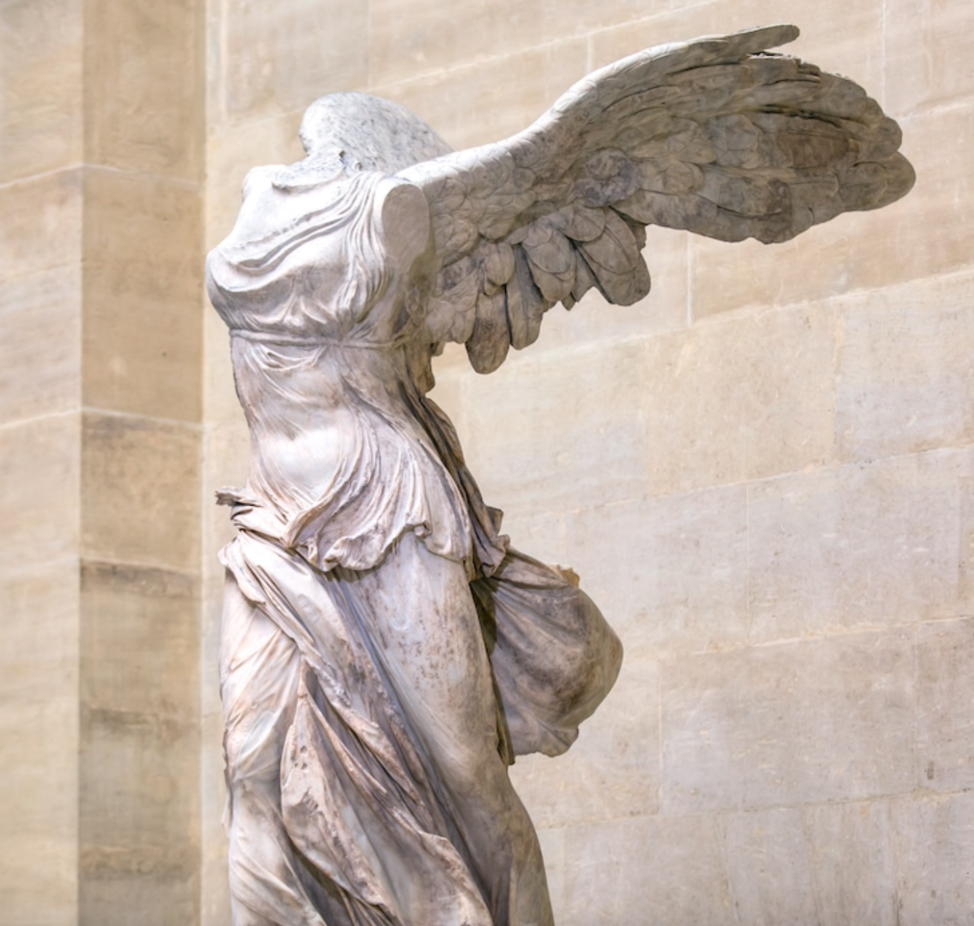
Fig.4. The Winged Victory of Samothrace – Ancient Greece – artwork created to commemorate a sea battle represents Nike, the Greek godess of Victory; source of image: https://mymodernmet.com/angel-art-history/.

Representation of angels in Christian art
The representations of the angels are symbolic and allusive, as their representation belongs to a spiritual reality that cannot be fully known. In addition, they are immaterial in nature and leave no miraculously printed images or relics. To them the representation of the Savior is based on His Incarnation. The representations of the saints are also based on their historical existence.
Angels appear painted in both literary and symbolic sense. Symbolically, angels appear represented in anthropomorphic form, like winged young men. Unlike the other angels, the archangels also have their names inscribed on icons. Cherubim and seraphim are identified by their numerous wings and eyes.
The earliest representation of an angel in human form appears in the third century, in the catacomb of Priscilla (Jones, 1908).
In a literary sense, the angels appear in the form of the pillar of cloud and fire as they are described in the book of Exodus. In the Christian Topography (Winstedt, 1909), written in the 6th century by Cosmas Indicopleustes (Winstedt, 1905), the cloud and a column of fire are literally rendered (Nicol, 1963).
The wings of the angels represented the speed of the fulfillment of God's mission, their immateriality, and their transcendence. In this sense, Saint John Chrysostom says: “What do the powers show us through these wings? The height and thinness, and the lightness and sharpness of their nature. That is why the Archangel Gabriel descends in flight: not because the wings are limbs of disembodied powers, but because they descend from above and then return to where they were sent ” (St. Ioan Gură de Aur, 1857-1866).
The Savior Jesus Christ is sometimes depicted as an angel, with wings and no beard, crucifix and almond. The artists based their work on what the prophet Isaiah said: "For to us a child is born, to us a Son is given, and his name is called Angel of great counsel" (Isaiah 9: 6). St. John the Baptist is also represented as an angel. The Mother of God, also called the Queen of Angels, is also represented as a winged angel under the influence of the winged Christ icon.

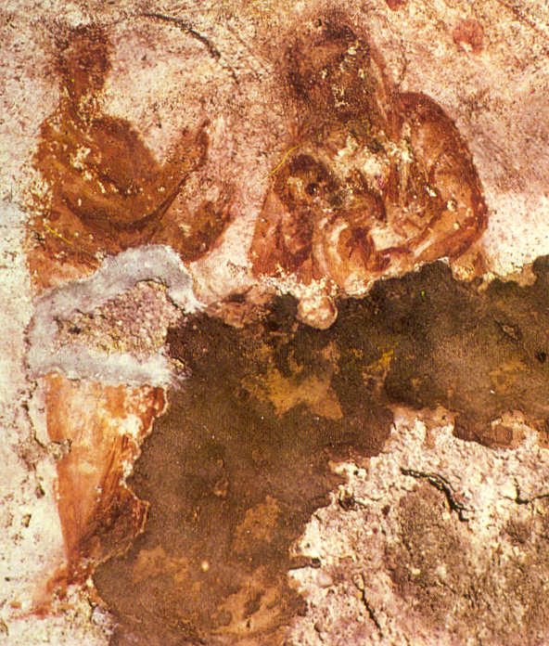
Fig.5. Catacomb of Priscilla, Rome - possible representation of Virgin Mary and baby Jesus with an Angel; source of image: https://en.wikipedia.org/wiki/Catacomb_of_Priscilla#/media/File:Madonna_catacomb.jpg.

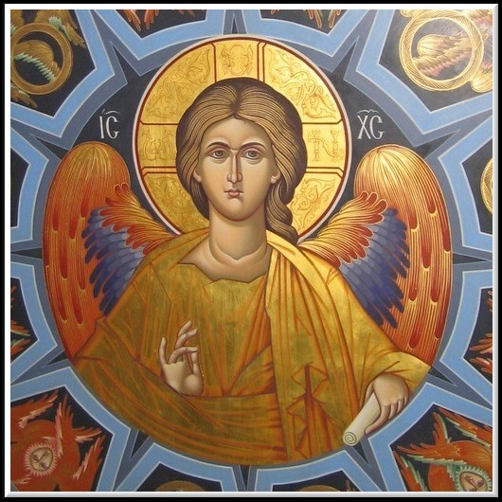
Fig.6. Image of Jesus Christ as an Angel; source of image: https://www.crestinortodox.ro/sarbatori/sfintii-mihail-gavriil/iisus-hristos-inger-142539.html.
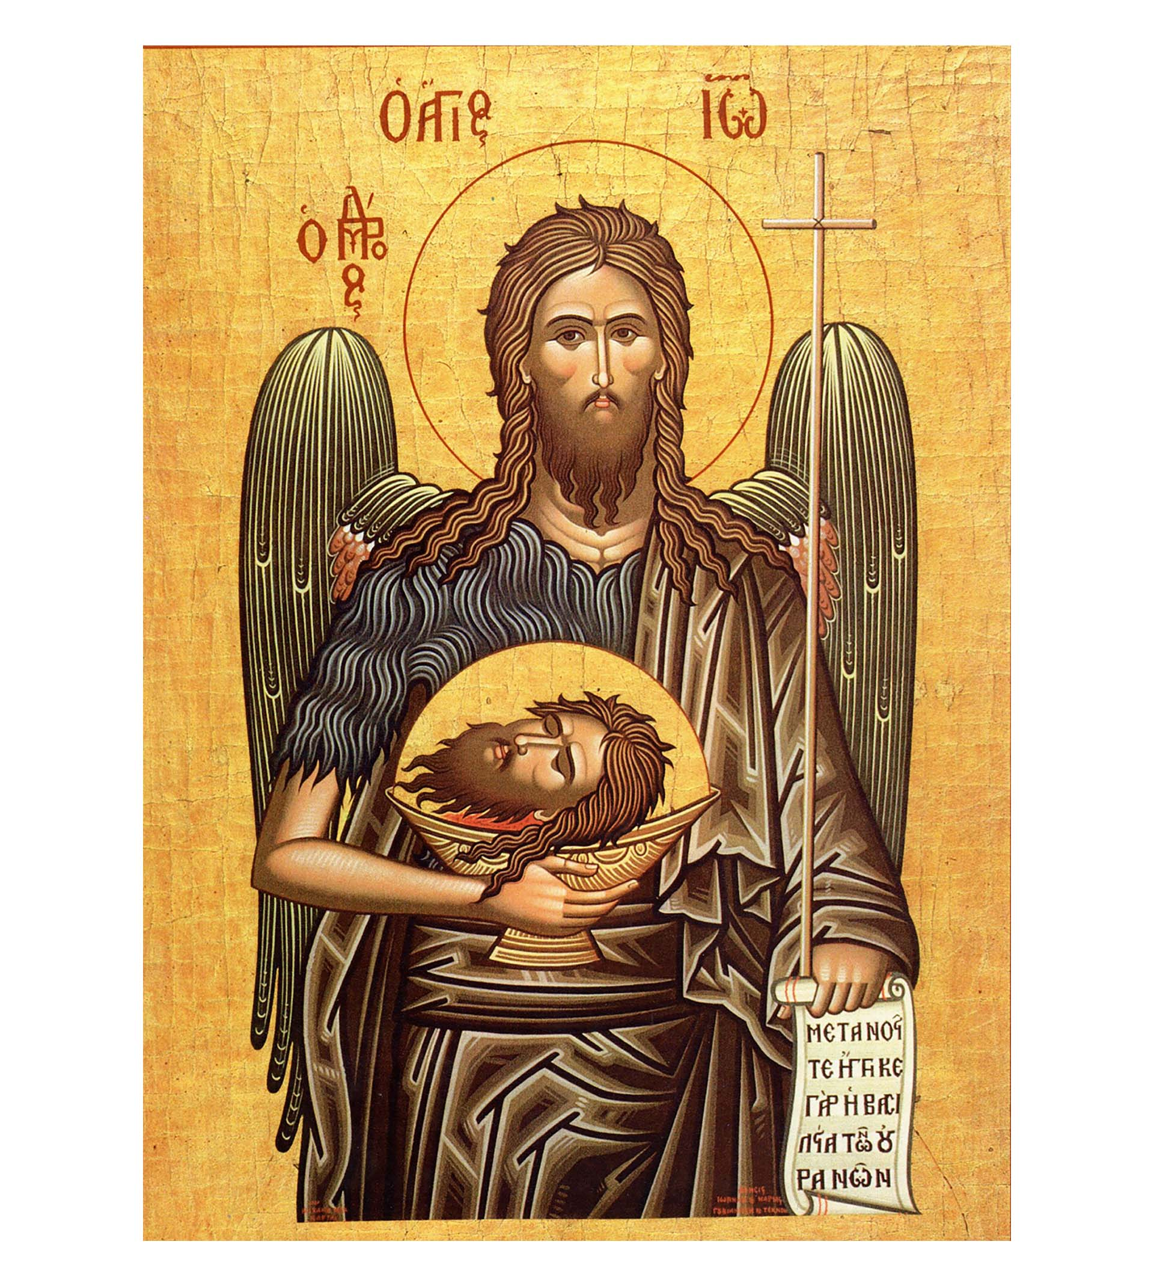
Fig.7. Image of John the Baptist as an winged angel; source of image: https://colportaj.ro/produs/icoana-litografiata-cu-sfantul-ioan-botezatorul-11155/.

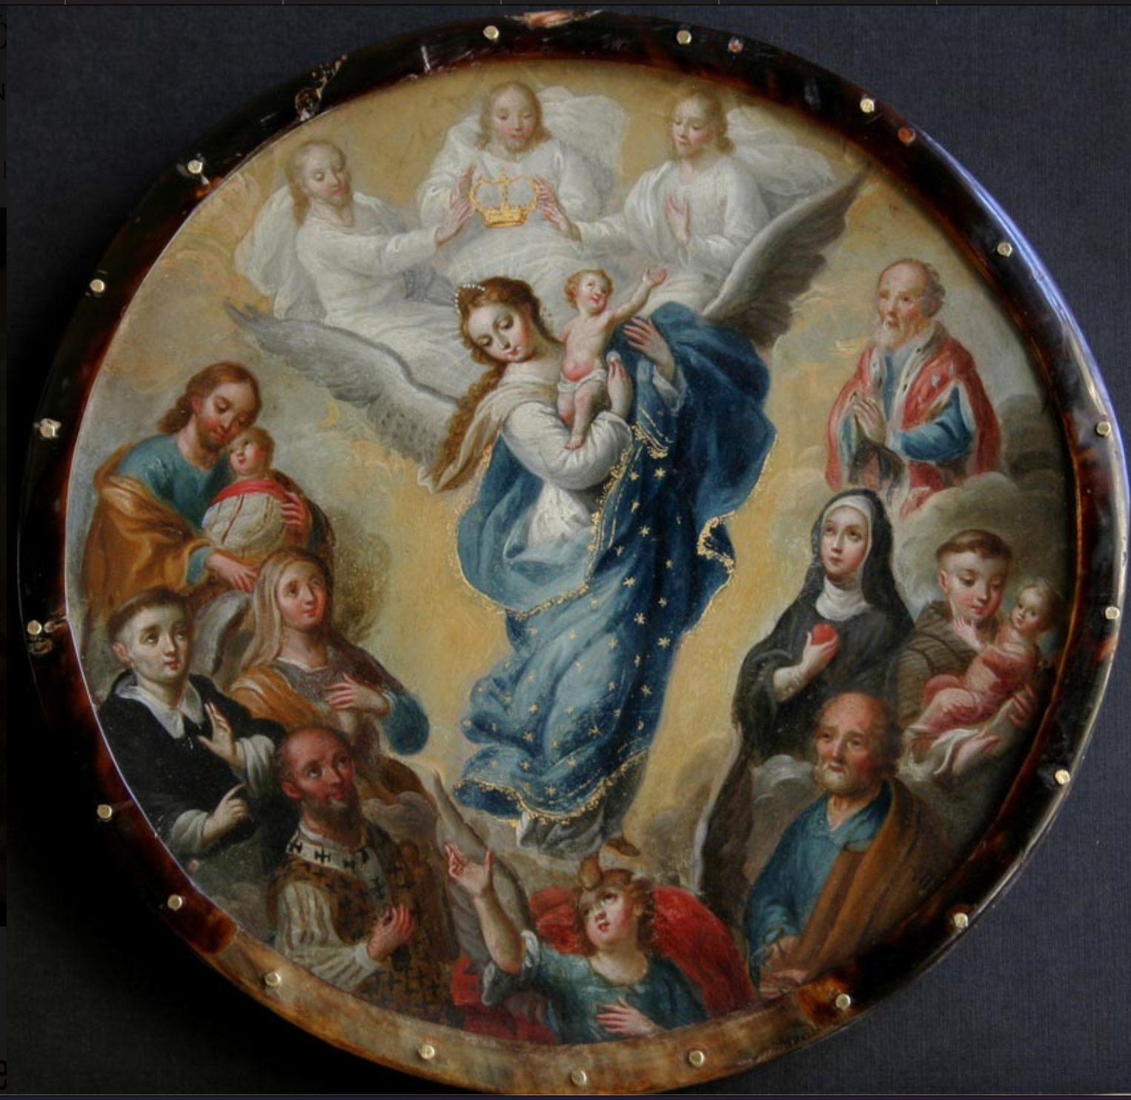
Fig.8. Virgen del Apocalipsis, XVIII century, anonymous; source of image: https://museoblaisten.com/Obra/1587/Escudo-de-monja-virgen-del-Apocalipsis.
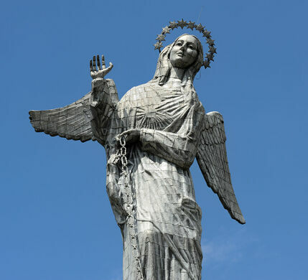
Fig.9. Winged Virgen de El Panecillo, Quito, Ecuador; source of image: https://www.atlasobscura.com/places/virgen-de-el-panecillo.

Cherubim Angels
The Cherubim guards the glory of God, keeps records, helps people to grow spiritually. They are a group of angels recognized in both Judaism and Christianity. Cherubs guard the glory of God both on earth and on his throne in heaven, work on the recordings of the universe, and help people grow spiritually, giving them God's mercy for them and motivating them to pursue more holiness in their lives.
There are two representations of the cherubim. According to Byzantine tradition, the cherubim, the second angelic group according to the angelology, have three pairs of wings that surround a human face. There are numerous eyes on the wings, suggesting the ubiquitous light of knowing God. In iconography, in this first representation the cherubim were often confused with the first angelic crowd, that of the seraphim, but they were colored red, an allusion to the Hebrew meaning of their name.
Under the influence of Western painting after the 15th century, when cherubs began to appear as a human head carried by a single pair of wings, post-Byzantine painting also borrowed this formula. In this second type of representation, the cherub is depicted with an angelic face, with regular androgynous features, long hair, curly spilled on the shoulders and halo in the form of a flat disc. The head is attached directly to a pair of large, wide-open wings.

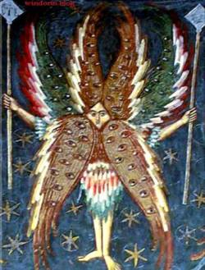
Fig.10. Image of a Cherub, we can see the eyes on the wings; source of image: http://angelinspir.ro/heruvimii-570.html.

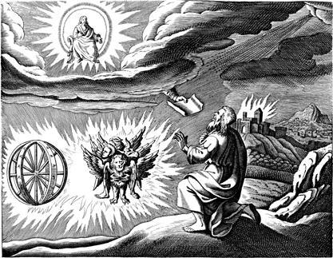
Fig.11. Traditional representation of Ezekiel's vision, with cherubim and chariots of fire; source of image: https://www.wikiwand.com/ro/Heruvim.

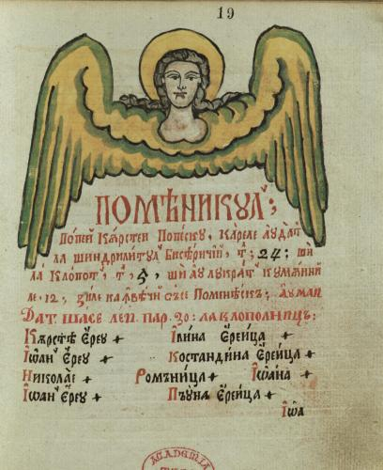

Fig.12. Frontispiece without border, frontally representing a cherub. Angelic head, with regular and effeminate features, long, curly hair spilled on the shoulders and flat-disc halo. The character has a pair of large, wide-open wings: source or image: miniature from Costești Monastery, 1834-1886, http://byzantion.itc.ro/web/Imagine//809.jpg-809.

Seraphim Angels
From the nine angelic orders, the seraphim are the highest one. In Scripture, these heavenly beings are mentioned only once in the Old Testament in the prophet Isaiah (Bussagli, 2007).
According to this description, the seraphim are represented with six wings: two raised above the head, two in parts and two covering the legs. The wings are usually red. Their face is not covered, being painted as that of a young man with curly hair.

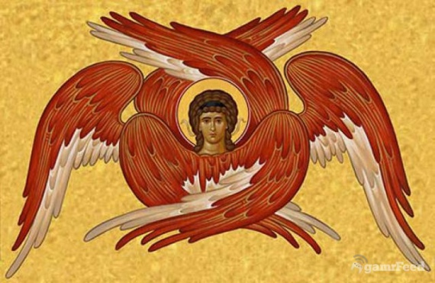
Fig.13. Seraphim; source of image: https://icoana.net/blog/serafimii-in-iconografie.
Ophanim Angels/ Troni
The ophanim angels are a group of angels in Judaism who are known for their wisdom. They never sleep, because they are constantly busy guarding God's throne in heaven. The ophanim is most commonly called thrones (and sometimes "wheels").
Their name comes from the Hebrew word "ophan," which means "wheel," due to the Torah and the Bible's description in Ezekiel 1: 15-21 as having their spirits wrapped inside the wheels that moved with them wherever they went.
The wheels of the ophanim are covered with eyes, which symbolizes the constant awareness of what is going on around them and how well these activities align with God's will.

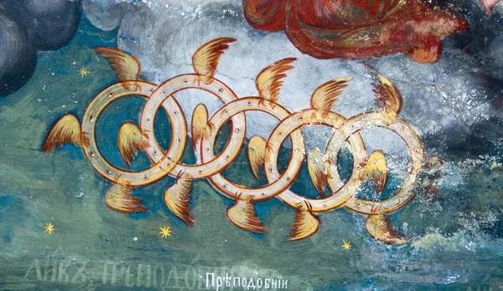
Fig.14. Ophanim Angels; source of image: https://angelology.fandom.com/wiki/Ophanim?file=Ophanim.jpg.

Archangels and Angels
As a very short presentation, the Holy Archangels are the leaders of the angelic hosts, are seven in number, and stand before the throne of the glory of God, as St. John the Evangelist himself says: Him '' (Revelation 1: 4). And these angels are: Michael (Ins), Gabriel, Raphael, Uriil, Salatiil, Gudiil and Varahiil. Each Archangel has a certain divine mission to fulfill. Their iconography is large and rich, both in colours and symbols. We all know that Archangel Michael is the captain of the heavenly army and the Archangel Gabriel is the one from the Holly Annunciation.
The iconography of Angels and Archangels in genral, because not all people are familiar with the Angel yerarchi in Heaven ( the Nine ranks of Angels) starting with the creations is both rich and beautiful...we can find an aboundance of pure colors and light, of gold and precious tones and materials in different techniques (for example mosaic, Byzantine icons, fresca). We can see representations beiond the reality, angels with blue faces and wings, colorfull representations of angels wings being a fascinating topic also (for example, the representations of Archangel Gabriel made by Fra Angelico (Finocchio) from Pre Renaissance, see the oustanding Western illuminated manuscipts). In our opinion, all these representations have the power to transport our minds in a world of beauty, of light and colour...in a visual and aestetic Haeven.
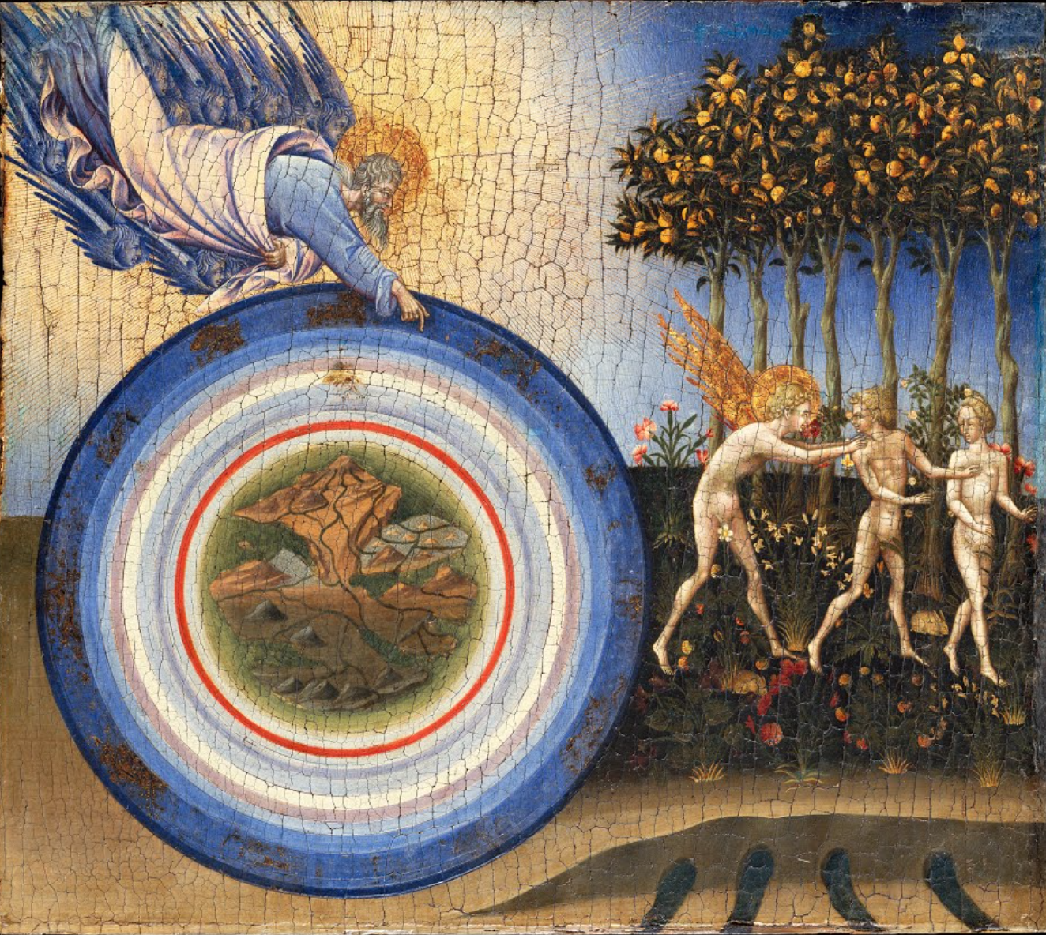
Fig.15. The Creation of the World and the Expulsion from Paradise, Giovanni di Paolo; source of image: https://artsandculture.google.com/asset/the-creation-of-the-world-and-the-expulsion-from-paradise-giovanni-di-paolo-giovanni-di-paolo-di-grazia/zQFzELEHTGQOGw.

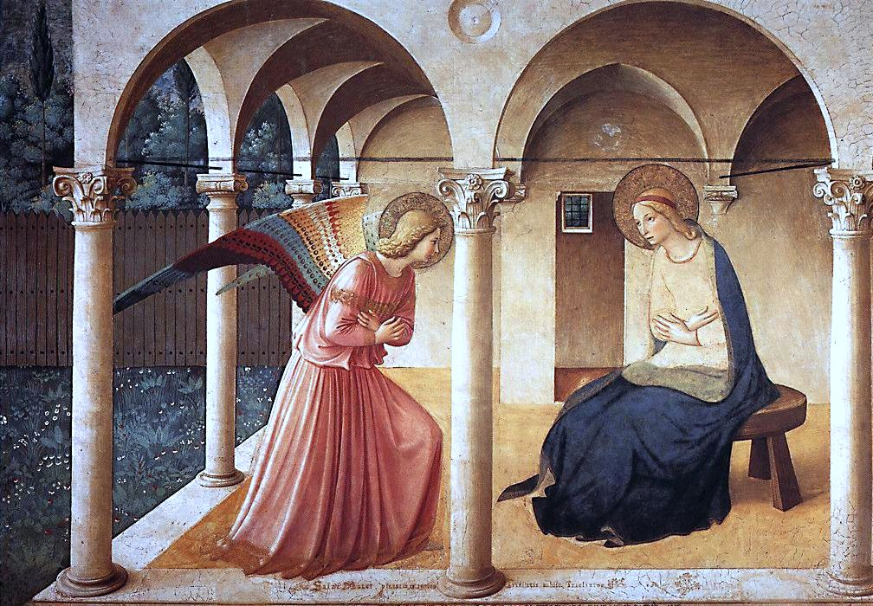
Fig.16. The Annunciation, Fra Ancelico; source of image: https://upload.wikimedia.org/wikipedia/commons/1/1b/ANGELICO%2C_Fra_Annunciation%2C_1437-46_%282236990916%29.jpg.

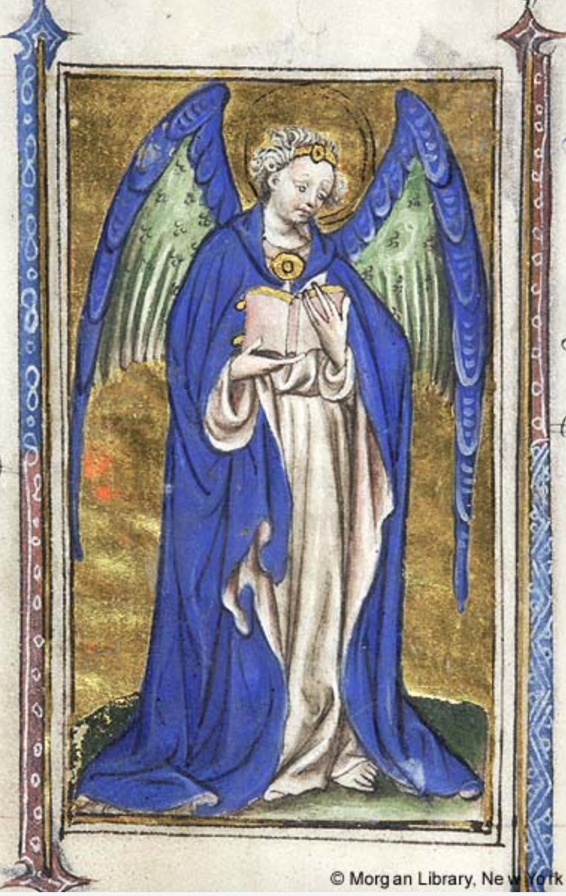
Fig.17. Nimbed guardian angel, Book of Hours, Netherlands, perhaps Delft, 1415-1420
MS M.866 fol. 112v; source of image: http://ica.themorgan.org/manuscript/page/56/76934.

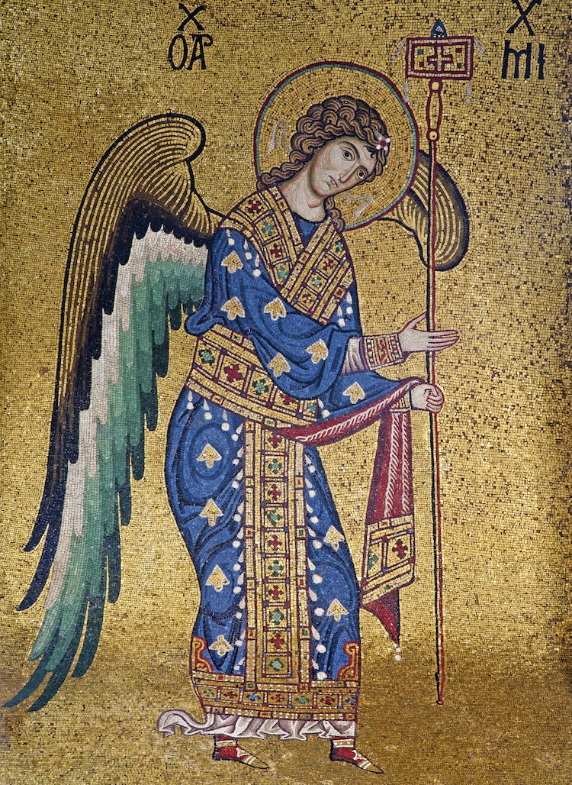
Fig.18. Mosaic of the Archangel Michael (13th century) from Church of Santa Maria dell' Ammiraglio; source of image: https://mymodernmet.com/angel-art-history/.
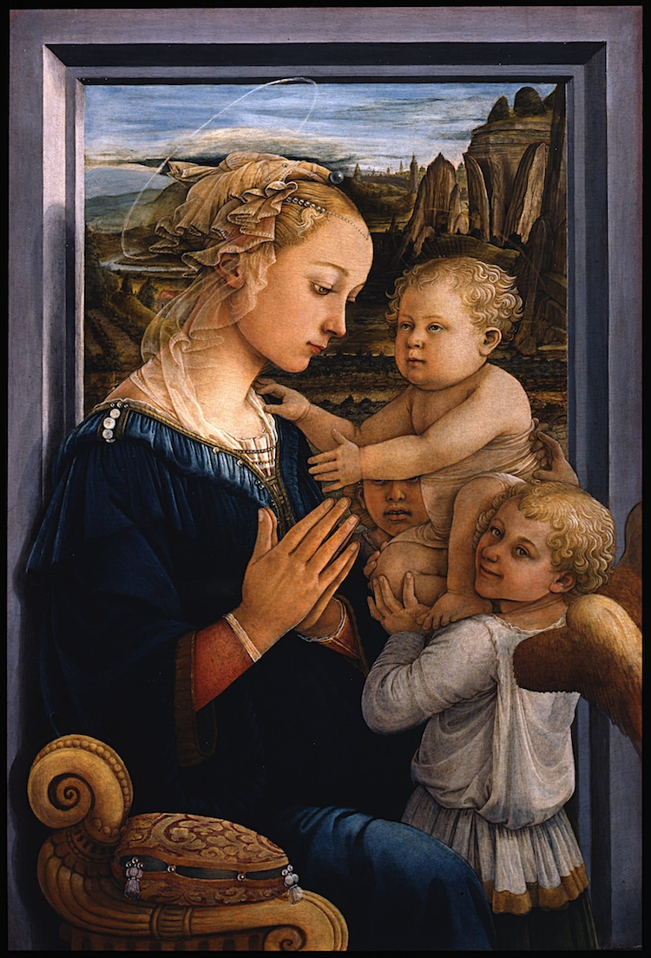
Fig.19. Fra Filippo Lippi, “Madonna With Child and Two Angels,” ca. 1460-1465;source of image: Public domain, via Wikimedia Commons.
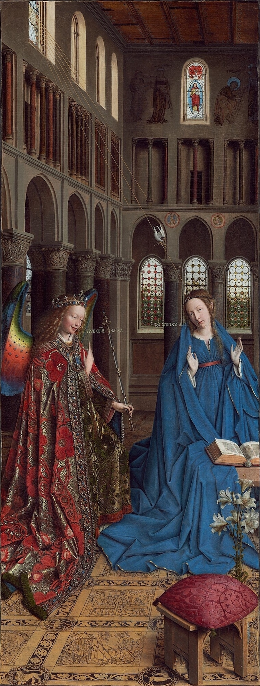
Fig.20. Jan Van Eyck, “The Annunciation,” c. 1434-1436; source of image: Public domain, via Wikimedia Commons.

Conclusion
The subject of angels in ar tis a rich source of inspiration for artists and, as we can see from above examples, the representations are different and unique, following or not cannonical relicious cutums. We saw that each historical era has his own specific, the Middle Ages being, for example, totally different that the Renessance, where the image of angels is more human-like (sometimes real women and children were posing for the paintings with Virgin Mary and Holy Child).
The purpose of this paper was not to present the representations of angels in art history only cronological, but more in a visual way that allow the reader to enter this beautiful world. The images and words presented here are just an infime part of what angels iconography consist of but we hope that, by offering diverse exemoles from different periods of history, we made this topic close to mass readers.
Making the general public/reader understanding the visual arts and the importance of educational aestetic is a goal that we aim to achieve with each paper we research and develop.

References
***, Insight on the Scriptures, Watch Tower Society, 393–394.
Basegmez, S. (1989). İkonalar, İstanbul: Yapı Kredi Yayınları.
Brézé, Nathalie de (2014). From Putti to Angels: The Celestial Creatures in Otto Vaenius’ Paintings and Emblems, https://brill.com/view/book/edcoll/9789004262010/b9789004262010_028.xml?lang=en.
Bussagli, Marco (2007) Angeli. Origini, Storie e Immagini delle Creature Celeste, Mondadori, Milano, p. 386.
Cherry, J. (1995). Mythical Beasts, British Museum Press, London.
Emison, Patricia (2002). Raphael's Dresden cherubs// Zeitschrift Fur Kunstgeschichte, 2 : Cilt 65. pp. 242-250.
Faller, Stefan Alfred (2011). The World According to Cosmas Indicopleustes – Concepts and Illustrations of an Alexandrian Merchant and Monk// Transcultural Studies. 1 : Cilt 2. pp. 193-232.
Finocchio, Ross (2021). Fra Angelico (Guido di Pietro) (ca. 1395–1455) http://www.metmuseum.org/toah/hd/fang/hd_fang.htm.
Grigorie al Nyssei (1857-1866). Oratio catechetica magna, VI, în Patrologia cursus completus, Series graeca, ed. J.P. Migne, Paris, vol. 45, col. 28 AB.
Grigorie of Nazians (1857 - 1866). Orationes, XLV, 5, in Patrologia cursus completus, Series graeca, ed. J.P. Migne, Paris, vol. 36, col. 629 B.
Jones, H. Stuart (1908), THE CATACOMB OF PRISCILLA AND THE PRIMITIVE MEMORIALS OF ST PETER// The Journal of Theological Studies, 35. pp. 436-441.
Mare, Estelle Alma (2008). El Greco’s Representation of Mystical Ecstasy// Acta Theologica, 1 : Cilt 1. pp. 108-127.
MoMA (2002). Human-Headed Winged Lion (Lamassu), 19 9 2021. - https://library.saylor.org/handle/1/237.
Nicol, D. M. (1936) La topographie chrétienne de Cosmas Indicopleustès: théologie et science au VIe siècle. By Wanda Wolska. (Bibliothèque Byzantine, Études, 3). Pp. xvi + 330 + 15 plates. Paris: Presses Universitaires de France, 1962. NF. 40.00 [Dergi] // The Journal of Ecclesiastical History, 2 : Cilt 14. pp. 219-220.
St. Ioan Gură de Aur (1857 - 1866), In Isaiah Dominum (Is. 6, 1) homiliae 1–6, II, in Patrologia cursus completus, Series graeca, ed. J.P. Migne, Paris, vol. 56, col. 137.
Stählin, O, Früchtel, L, Treu, U. (1970). Excerpta ex scriptis Theodoto, în Stromata Buch VII und VIII. Excerpta ex Theodoto. Eclogae propheticae. Quis dives saluetur. Fragmente, GCS (Die griechischen christlichen Schriftsteller der ersten drei Jahrhunderte) vol. 17, 2d ed. O. Stählin, L. Früchtel şi U. Treu, Berlin, p. 110.
Thickstun, Margaret Olofson (2001). Raphael and the Challenge of Evangelical Education // Milton Quarterly, 4 : Cilt 35. pp. 245-257.
Winstedt, E. O. (1905), NOTES FROM COSMAS INDICOPLEUSTES// The Journal of Theological Studies, 22. pp. 282-285.
Winstedt, Eric Otto (1909). The Christian Topography of Cosmas Indicopleustes, Cambridge University Press.

