Heart Disease Prediction Using Machine learning
Mohamed ALI YOUSSOUF ¹ , Fuat TÜRK ²
¹ . Çankırı Karatekin University, Faculty of Engineering, Computer Engineering, Çankırı / Turkey

² Kırıkkale University, Faculty of Engineering, Computer Engineering, Kırıkkale / Turkey

Abstract
Heart disease is a high-risk disease worldwide. Early diagnosis and treatment can improve the chances of survival, but it can be difficult to diagnose heart disease early. Machine learning techniques have the potential to improve the diagnosis of heart disease by providing doctors with more accurate and timely information. In this paper, we propose a comparative study of different ML algorithms for heart disease prediction. We evaluated the performance of Logistic Regression, Random Forest, K-nearest neighbors, and Ensemble learning methods on a publicly available dataset of heart disease patients. We found that the ensemble learning methods, including boosting, bagging, and stacking, achieved the highest accuracy, with accuracies of 96%, 98.4%, and 98.1%, respectively.
Keywords: Heart Disease Prediction, Random Forest, Logistic Regression, KNN, Ensemble Learning.

1. Introduction
Today, heart disease is one of the most critical human security issues. Heart disease is one of the leading causes of death worldwide [ 1]. According to the World Health Organization (WHO), heart disease accounts for an average of 17.9 million deaths, which is approximately 32% worldwide in 2022. The number of cardiac cases, which is the focus of this study, shows more than 75% of the cases are from low and middle-income countries. In addition, one-third of all human deaths worldwide are under 70 years old and are related to heart disease, 85 % of all cardiovascular diseases deaths are due to heart attacks and strokes. (WHO, 2022) [2].
In Turkey, approximately 250 thousand people are diagnosed with cardiovascular disease every year, and it is stated that approximately 150 thousand of them die. prof. Dr. Bilal Boztosun says, "This situation requires us to be very careful about heart diseases as a society"[3] The most important cardiac diseases include family history, diabetes, high cholesterol, smoking and obesity [4]. Manually calculating the probability of getting heart disease is a risk factor that is difficult to rely on. In order to solve difficult problems, a variety of machine learning techniques have been developed recently [5, 6].
Machine learning, while widely used in the medical field, is primarily used to predict heart disease. To diagnose diseases, many researchers have been interested in using machine learning as it helps minimize diagnosis time and demonstrates accuracy and efficiency. In fact, machine learning techniques can be used to identify various diseases, but heart diagnosis is the focus of this study because heart disease is currently the leading cause of death. Successful diagnosis of heart disease is very helpful in saving lives [7]. Machine learning (ML) plays an important role in disease prediction [8].
2. Materials and Methods
2.1. Dataset collection
Heart disease dataset were collected from January 2019 to May 2019 at Zin Hospital in Erbil, Iraq. This dataset has the following attributes: age, sex, heart rate, systolic blood pressure, diastolic blood pressure, blood glucose leve, CK-MB and troponin negative or positive outputs. The gender column of data is normalized. Male=1, female=0. As for the output, positive=1 and negative=0 [9]
2.2. Ensemble Learning
1.Boosting
Boosting is a machine learning technique that combines a set of weak learners into a strong learner. Weak learners are models that are only slightly better than random guessing. By combining a large number of weak learners, boosting can create a strong learner that is much more accurate than any individual weak learner.
There are many different boosting algorithms, but they all work in a similar way. Some of the most popular boosting algorithms include:
- AdaBoost
- Gradient boosting
- XGBoost
but we used AdaBoost in this paper.
AdaBoost is one of the oldest boosting algorithms. It works by iteratively adding weak learners to a model. Each weak learner is trained on a weighted sample of the data, where the weights are assigned based on the performance of the previous weak learners.
2. Bagging
Bagging is a machine learning ensemble learning method aimed at improving the accuracy and stability of predictive models. Bagging involves resampling multiple subsets of the training data, training a base model on each subset, and aggregating each model's predictions to produce a final prediction.
Random Forest is a popular implementation of bagging
3. stacking
Stacking is a powerful approach because it allows base models to compensate for each other's weaknesses, exploiting their respective strengths. This can lead to better overall predictive performance.
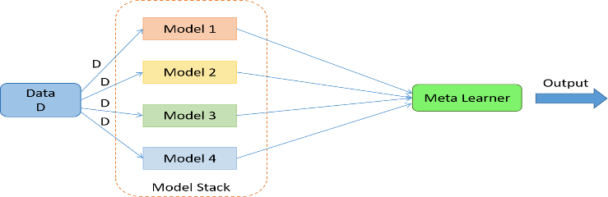
Figure1. Ensemble Stacking

3. Results and Discussion
3.1. Performance metrics with ensemble learning algorithms.
Table 1. The accuracy of the ensemble learning
models | Accuracy %
Boosting | 0,97
Bagging | 0,984
Stacking | 0,981
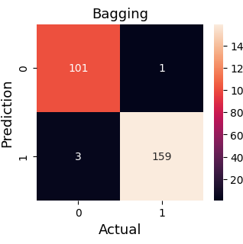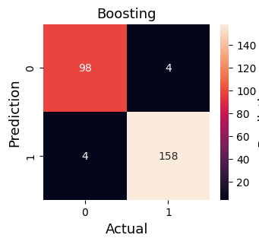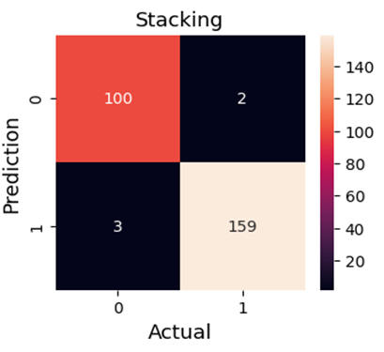
Figure 1. Confusion matrix of ensemble learning

3.2. Evaluation results
As a result of the data obtained from the existing figures and tables, it can be recommended to use ensemble learning (Boosting, Bagging, Stacking) in the detection of heart disease. Here, studies can be carried out to increase the detection rates of ensemble learning with low accuracy values. At this stage, the selection of hyperparameters, and updates may be recommended. As a result of these processes, I think that ensemble learning methods can be used to improve the diagnosis of heart disease.
4. CONCLUSION
This comparative study evaluated different machine learning algorithms for heart disease prediction. Ensemble learning methods, including boosting, bagging and stacking, achieved the highest accuracy rates, with inaccuracies of 96%, 98.4% and 98.1% respectively. These results highlight the potential of machine learning techniques in improving the diagnosis of heart disease. Among the ensemble learning methods, bagging demonstrated the highest accuracy.
References
[1] M.Sanz, A. Marco delCastillo, S.Jepsen et al., “Periodontitis and cardiovascular diseases: consensus report,” Journal of Clinical Periodontology, vol. 47, no. 3, pp. 268–288, 2020.
[2]WorldHealthOrganization.https://www.who.int/health-topics/cardiovascular-diseases#tab=tab_1 . 2022.
[3]web:https://medipol.com.tr/kurumsal/haberler/medyada-medipol/turkiyede-her-25-dakikada-bir-kisi-kalp-damar-hastaliklarindan-oluyor
[4]J.Nahar, T. Imam, K. S. Tickle, and Y.-P. P. Chen, “Associationruleminingtodetectfactorswhichcontributetoheart disease in males and females,” Expert Systems with Applications, vol. 40, no. 4, pp. 1086–1093, 2013.
[5] A.-H. Abdel-Aty, H. Kadry, M. Zidan et al., “A quantum classiﬁcation algorithm for classiﬁcation incomplete patterns based on entanglement measure,” Journal of Intelligent and Fuzzy Systems, vol. 38, no. 9, pp. 1–8, 2020.
[6] A. Sagheer, M. Zidan, and M. M. Abdelsamea, “A novel autonomous perceptron model for pattern classiﬁcation applications,” Entropy, vol. 21, no. 8, p. 763, 2019.
[7] M. Aljanabi, H. Qutqut, and M. Hijjawi, “Machine learning classiﬁcation techniques for heart disease prediction: a review,” International Journal of Engineering and Technology, vol. 7, pp. 5373–5379, 2018.
[8] T. Obasi and M. O. Shaﬁq, “Towards comparing and using machine learning techniques for detecting and predicting heart attack and diseases,” in Proceedings of the 2019 IEEE InternationalConferenceonBigData(BigData),pp.2393–2402, Los Angeles, CA, USA, April 2019.
[9] Rashid, Tarik A.; Hassan, Bryar (2022), “Heart Attack Dataset”, Mendeley Data, V1, doi: 10.17632/wmhctcrt5v.1

