**Synthesis of Graphene Oxide by Hummers Tour Method and Reduced Graphene Oxide by Chemical Reduction Method**

***Haluk KORUCU1 [C:\Users\Abdullah\AppData\Local\Microsoft\Windows\INetCache\Content.Word\ORCID-iD_icon-16x16.gif](https://orcid.org/0000-0001-6763-3249)Esra YILMAZ MERTSOY1***

***1 Department of Chemical Engineering, Faculty of Engineering, Çankırı Karatekin University, Uluyazı, Çankırı 18100, Turkey***

|  |
| --- |
| **Abstract**  The purpose of this work was to compare the effectiveness of synthetic graphene oxide synthesis using the Hummers Tour technique from graphite and reduced graphene oxide synthesis using sodium boron hydride and ascorbic acid in the Chemical reduction method from synthesized graphene oxide. FTIR structure characterization, BET surface area measurement, Zeta Potential, and particle size distribution investigations were carried out for the synthesis of reduced graphene oxide and graphene oxide. The graphene oxide and reduced graphene oxide synthesis is successful, as can be seen from the FTIR graphs. The graphene oxide sample shows a BET surface area improvement rate of 76.64%. Because graphene oxide is hydrophilic, it can be readily dissolved in water, which has improved its Zeta Potential property by 114%. This provided a sample of reduced graphene oxide with a 41% increase in rag size due to the synthesis of sodium boron hydride. Sodium boronhydride performed better than ascorbic acid in manufacturing reduced graphene oxide. However, ascorbic acid is even better when its reduction performance is evaluated in terms of expenses and eco-friendly manner. |
| Keywords: Graphene Oxide,Reduced Graphene Oxide, Hummers TOUR Method, Chemical reduction method |

1. **Introduction**

Graphene oxide (GO) is commonly synthesized through methods such as the Hummers' method. In this approach, natural graphite is oxidized with a mixture of strong acids, typically sulfuric acid and potassium permanganate. The resulting graphene oxide contains oxygen-containing functional groups such as hydroxyl, epoxy, and carboxyl, imparting hydrophilicity to the material [1]. GO serves as a precursor for various applications due to its dispersibility in water and the ease with which it can be functionalized. However, for certain applications where enhanced electrical conductivity and reduced oxygen content are crucial, GO is further subjected to a reduction process to produce reduced graphene oxide (rGO) [2].

The reduction of graphene oxide is often achieved through chemical or green reduction methods. Chemical reduction commonly employs agents like hydrazine or hydroiodic acid to remove oxygen groups and restore graphene-like properties [3]. On the other hand, green reduction methods utilize environmentally friendly agents such as ascorbic acid or green tea extract, offering a safer and more sustainable approach. These reduction processes lead to the formation of reduced graphene oxide with improved electrical conductivity while retaining some of the inherent properties of graphene, making it suitable for applications in sensors, energy storage devices, and other advanced technologies [4].

In the literature, studies using hydrazine and hydrazine hydrate for the reduction of graphene oxide have been conducted. However, these chemicals are known to be highly toxic and explosive, requiring extensive precautions when used in large quantities. Therefore, there is a search for a more environmentally friendly and non-toxic reducing agent to convert graphene oxide to reduced graphene oxide. L-ascorbic acid (L-AA), with its mild reduction capability and non-toxic nature, is used as the primary reducing agent for converting graphene oxide to reduced graphene oxide. Importantly, compared to traditional reducers used in GO reduction, such as hydrazine and hydrazine hydrate, L-AA itself and its oxidized products are environmentally friendly [5] In the reduction process, ascorbic acid serves as a mild and environmentally friendly reducing agent for GO. Its non-toxic nature and ability to efficiently reduce graphene oxide while minimizing environmental impact make it an attractive choice. Additionally, ascorbic acid introduces oxygen-containing functional groups, enhancing the hydrophilicity and reactivity of the resulting reduced graphene oxide (rGO). Sodium borohydride, another green reducing agent, is employed in the reduction of GO to rGO. It offers advantages in terms of being a mild and selective reducing agent. The reduction process with sodium borohydride generates fewer by-products and is less environmentally harmful compared to traditional methods using hazardous chemicals [6].

In this study, graphene oxide synthesis using the Hummers method and subsequent chemical reduction using ascorbic acid and sodium borohydrate were performed. The reduced graphene oxide samples were analyzed by different characterization techniques such as zeta potential measurement and particle size distribution analysis, FTIR analysis, surface area measurement.

1. **Materials and Methods**

This work will use the produced graphene oxide sample to carry out reduced graphene oxide production and graphene oxide synthesis from graphite using the Hummers method. Ascorbic acid and sodium boron hydride will be used in the chemical reduction process to create reduced graphene oxide. All synthesized materials will undergo surface area analysis using the BET technique and structure characterization by FTIR spectrum scanning. The graphite Hummers Tour method involved circulating water in a double-walled glass reactor to maintain a temperature of 5°C. Ten grams of graphite samples were combined with 30 grams of KMnO4 100 milliliters of H2SO4 and 10 milliliters of H3PO4. The mixture was then left to work for sixteen hours. After raising the reaction temperature to 95°C and mixing for six hours, 100 milliliters of distilled water was added to the combinations. The mixture was allowed to cool at the end of the reaction period, and 10 milliliters of H2O2 and 10 milliliters of HCl acid were added to them to stop the process. Until the Ph was 3, each experimental solution was cleaned using the decantation method. The samples underwent the final steps of centrifugation, washing, and oven drying at 60°C. After adding five grams of sodium boronhydride and ascorbic acid to two grams of manufactured graphene oxide sample, tests were carried out for twenty-four hours at ninety degrees Celsius in order to synthesize reduced graphene oxide. After the experiment was over, the samples were cleaned one last time with ethyl alcohol and acetone until their pH reached 7. After that, they were dried in a vacuum oven set at 70 °C. The quality standards that were established for the characterization of samples of reduced and graphene oxide are listed in Table 2.1.

**Table 2.1** Quality criteria of the graphene oxide and reduced graphene oxide

|  |  |  |  |  |  |
| --- | --- | --- | --- | --- | --- |
| **Quality Criteria** | **Symbol** | **Explanation** | **Information** | **The goal for GO** | **The goal for RGO** |
| **1** | FTIR | Characatarizaton of the structure | Functional groups |  |  |
| **2** | PB | Particle Size | Feature improvement | Larger is better | Larger is better |
| **3** | ZP | Zeta Potential | Stable distribution | Smaller is better | Larger is better |
| **4** | BET | Surface Area | Degree of porosity | Larger is better | Larger is better |
|  |  |  |  |  |  |
|  |  |  |  |  |  |
|  |  |  |  |  |  |

1. **Results and Discussion**

Figure 3.1 The FT-IR analysis pattern in the synthesized graphene oxide samples shows that the vibration peak C=O at 1721 cm-1, the vibration and deformation peaks of the O-H groups 3391 cm-1 and 1410 cm-1, the stress peak C-O at 1221 cm-1, the stress peak C-O at 1046 cm-1, and the stress peak C=C at 1680 - 1620 do not belong to the graphite structure [9]. In contrast, when observed in cm-1, it was found that in the synthesis of reduced graphene oxide, for sodium boron hydride and ascorbic acid, the peaks formed by the synthesis of graphene oxide have largely disappeared and take on an appearance similar to that of graphite. The FTIR analysis results indicate that the synthesis of reduced graphene oxide utilizing sodium boron hydride and ascorbic acid by the chemical reduction method, as well as the synthesis of graphene oxide from graphite by the Hummers-TUOR method, have both been successful [6].

O-H

C=O

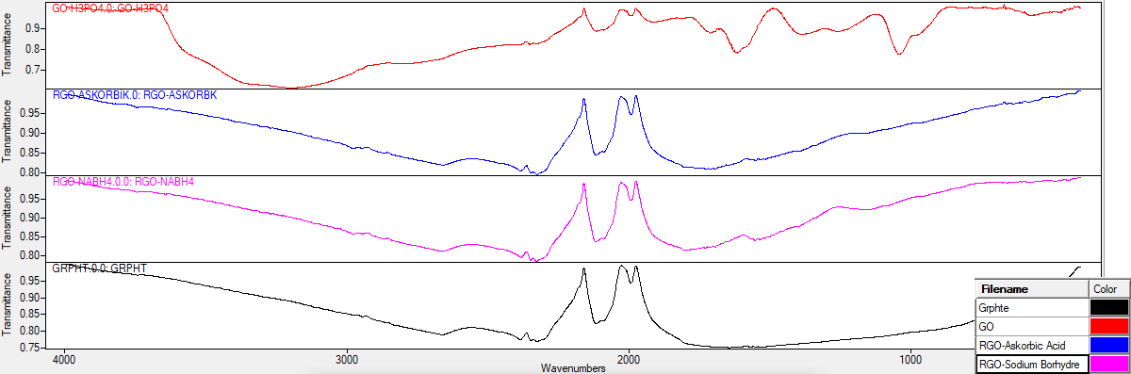

C=C

C-O-C

C-O

**Fig 3.1.** FTIR images of graphite samples of different purity

BET surface area measurements of graphite, graphene oxide, and reduced graphene oxide samples are shown in Figure 3.2.The synthesis mechanism of reduced graphene oxide and graphene oxide is predicted to improve surface areas from graphite. The maximum surface area is desired in the manufacture of reduced graphene oxide and graphene oxide.Surface areas increased during the synthesis of graphene oxide from graphite, but decreased during the production of reduced graphene oxide in comparison to graphene oxide. The creation of a porous structure is responsible for the huge surface area; however, contaminants may have closed the pores in the decreased graphene oxide samples, preventing an increase in surface area from being seen.

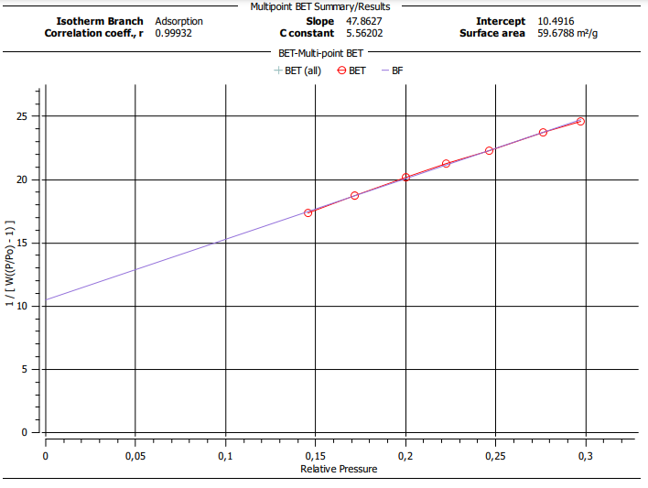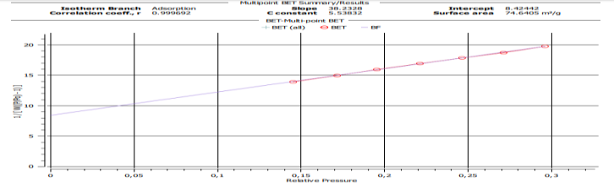 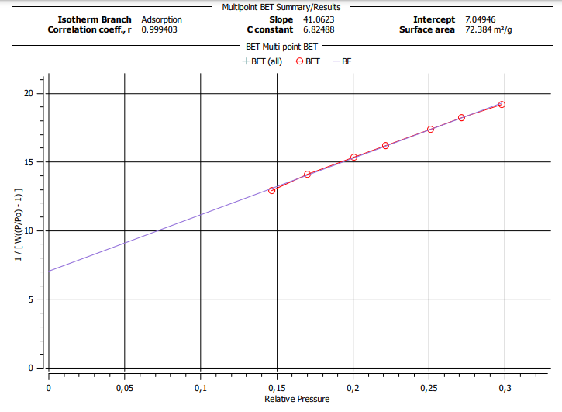 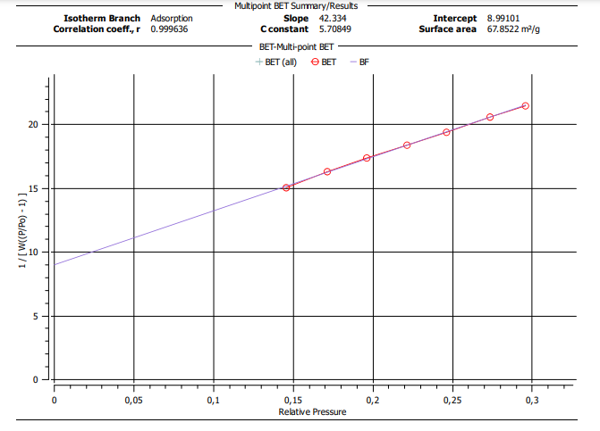

rGO-Sodyum BoroHyrde

67,85 m2/g

72,38 m2/g

rGO-Ascorbic Acid

74,64 m2/g

59,68 m2/g

Grphite

Graphene Oxide

**Fig 3.2.** BET images of experimental samples

 

Graphene Oxide

Grphite

ZP=-41,0m V

PS=538nm

PS=483nm

ZP=-19,2 m V

 

rGO-Ascorbic Acid

rGO-Sodium BoroHyrde

ZP=-28,4 mV

PS=395,58nm

ZP=-21,1 m V

PS=285,09nm

**Fig 3.3.** Zeta sizer and Particle size results of experimental samples

Figure 3.3 displays the findings from the investigation of particle size and Zeta Potential. The zeta potential values have decreased negatively as a result of graphene oxide's hydrophilic and water dispersible characteristics. However, the reduced graphene oxide structure, which is inimical to water, results in a negative increase in Zeta Potential values. Graphene oxide and reduced graphene oxide exhibit opposite-directional properties in their Zeta Potential target values. Because of this, the zeta potential value of graphene oxide was used to calculate recovery rates rather than graphite as the reference criterion for the synthesis of reduced graphene oxide. Better results in terms of particle size values were obtained in the sample of sodium boron hydride and in the production of reduced graphene oxide. Reduced graphene oxide production is anticipated to perform better than graphene oxide and graphite due to the particle size and surface area. The recovery rates are provided in Table 3.1 with reference to the synthesized graphite sample of graphene oxide samples.

**Table 3.1** Recovery rates between graphene oxide and reduced graphene oxide samples

|  |  |  |  |  |  |  |  |  |
| --- | --- | --- | --- | --- | --- | --- | --- | --- |
|  | **Answers** | **Refa**  **Grphite** | **GO** | **rGO-Askorbic Acid** | **rGO-Sodium Bprhydre** | **Recovery Rate GO- (%)** | **Recovery Rate rGO- Askorbic Acid (%)** | **Recovery Rate rGO- Sodium Bprhydre (%)** |
|  | BET (SA-m2/g) | 59,68 | 74,64 | 67,85 | 72,38 | 25b | 13,7 | **21,3** |
| ZP ( ZP-mV) | -19,2 | **-41** | **-28,4** | **-21,1** | 113,5 | 30,7 | **48.5** |
| ZP (PS-nm) | 483 | 538 | 396 | 285 | -11.4 | 18 | **41** |
|  |  |  |  |  |  |  |  |

*Calculation of the % recovery rate of the experiment performed reference graphite*

*b ((74,64-59,68) / 59,68)\*100 =25.06(plus value means improvement)*

Because of this, the zeta potential value of graphene oxide was used to calculate recovery rates rather than graphite as the reference criterion for the synthesis of reduced graphene oxide. Better results in terms of particle size values were obtained in the sample of sodium boron hydride and the production of reduced graphene oxide. Reduced graphene oxide production is anticipated to perform better than graphene oxide and graphite due to the particle size and surface area. The recovery rates are provided in Table 3.1 regarding the synthesized graphite sample of graphene oxide samples. While a little rise in the synthesis of graphene oxide has been observed, a drop in particle size values is anticipated in the synthesis of reduced graphene oxide and graphene oxide from graphite. The analysis's findings demonstrated the effectiveness of both the chemical reduction approach and the Hummers method for synthesizing graphene oxide. Ascorbic acid is more advantageous for use due to its cost-effective and environmentally friendly nature, even if sodium boron hydride yields more successful outcomes with reduced graphene oxide.

**Acknowledgment**

This research was carried out with the support of the Scientific Research Project (MF081123B33) funded by Çankırı Karatekin University. Authors thank to Çankırı Karatekin University, Scientific Research Project Management Unit (ÇAKÜ-BAP).

**References**

[1] Hummers WS Jr, Ofeman RE (1958) Preparation of graphitic oxide. J Am Chem Soc 80:1339–1339

[2] De Silva K.K.H., Huang H.H., Yoshimura M. 2018. Progress of reduction of graphene oxide by ascorbic acid., Applied Surface Sicence 447,338-346

[3] Kanishka Desilva K.H., Huang H.H. and Yoshimura M., 2018. Progress of reduction of graphene oxide by ascorbic acid, Applied Surface Sceince 447,338-346

[4] F. Farjadian *et al.*, “Recent Developments in Graphene and Graphene Oxide: Properties, Synthesis, and Modifications: A Review,” *ChemistrySelect*, vol. 5, no. 33, pp. 10200–10219, 2020, doi: 10.1002/slct.202002501.

[5] Surekha, G., Krishnaiah, K. V., Ravi, N., & Suvarna, R. P. (2020, March). FTIR, Raman and XRD analysis of graphene oxide films prepared by modified Hummers method. In Journal of Physics: Conference Series (Vol. 1495, No. 1, p. 012012). IOP Publishing.

[6] Das, B., Kundu, R., & Chakravarty, S. (2022). Preparation and characterization of graphene oxide from coal. Materials Chemistry and Physics, 290, 126597.